Natural hybrid posterities - problem for the existence of the Acipenseridae family species in nature.
WSCS General Assembly 2012 & Mini Scientific Symposium, March 12,Tulceaq Romania
Angel Tsekov, Nikolay Cekov
Plovdiv University "Paisii Hilendarski", Faculty of Biology, Department of "Ecology and Environmental Protection", 24 “Tzar Asen” Str., Plovdiv, Bulgaria; e-mail: a_tsekov@abv.bg; nikolay.cekov@abv.bg
The excess exploitation of the natural posterities of many species towards which humanity has a lasting interest in providing the necessary food resources, leads to the endangered status of their existence. Real examples in this aspect are the species from the Acipenseridae family. Species that from a historical point of view have been contemporaries of the dinosaurs are currently not only drastically reduced in number but also becoming extinct. Despite the efforts of the Convention on International Trade with Endangered Species of the Wild Fauna and Flora - CITES, to protect sturgeons, the number of natural populations of the remaining species of the family has reached abnormal reproductive values. The reduction in this number causes the lack of presence of specimens from both sexes of the same species - male and female in the area of the spawning sites. This leads to the following problems:
- reduced opportunities for the regular obtaining of heterogeneous posterities of one species;
- increasing the possibility of inbreeding, resulting in reduction of the species genetic diversity;
- changes in the resistance of posterities to traditional disease-causing agents;
- increasing the possibility of obtaining fertile interspecies hybrid forms - genetic extinction of the species;
- outcome - extinction of the species in the wild.
Each of these problems affects the natural populations of these species both individually and in complex with the rest.
The obtaining of natural hybrid posterities in species with similar hereditary mechanism would not show substantial effect on the purity of the hereditary material in species with a normal number of natural populations. The normal size of the population of the species maintains the genetic purity in its heterogeneity. With the reduced number of populations of species with similar hereditary material, however, there is a real danger for the genetic extinction of these species that have existed for millions of years. (Dobrovolov et. al. 2005; Ene and Suciu 2001; Tsekov et.al. 2008)
Material and methods:
During the period 2005 - 2010 in Bulgarian territorial waters of the Black Sea and the Danube River the following interspecies hybrids of sturgeons were caught:
Hybrid № 1. One specimen caught in October 2005 in the Danube River - 654 km near the village of Gorni Vadin. The specimen is weighing 130 g.
Hybrid № 2. Five specimens caught during the winter months of 2006 in the Black Sea – city of Varna, Galata cape. The specimens are weighing from 260 g to 450 g.
Hybrid № 3. Four specimens caught in February-March 2006 in the Black Sea near the city of Varna and the town of Sozopol. In April that same year, another specimen caught in the Danube River, near the town of Oryahovo (678 km). The specimens are weighing from 350 g to 470 g.
Hybrid № 4. One specimen caught in November 2010 in the Danube River near the town of Oryahovo (678 km), together with 12 Sterlet specimens. The specimen is weighing 580 g.
Electrophoretic studies by two methods were performed on materials from these hybrids (blood and skeletal muscle):
- Horizontal starch gel electrophoresis by the method of Smithies (1955), in
modification of Dobrovolov (1973);
- Isoelectric focusing (IEF) on thin polyacrylamide ampholine gel with pH-gradient 3.5-10.

Results and Discussion
The conducted electrophoretic studies allow the following characteristic of the referred hybrids:
Hybrid № 1 When caught was defined as Ship sturgeon (Ac. nudiventris), but the starch gel electrophoresis showed also a heredity of Russian sturgeon (Ac. gueldenstaedti) - second or third generation (Fig № 1).
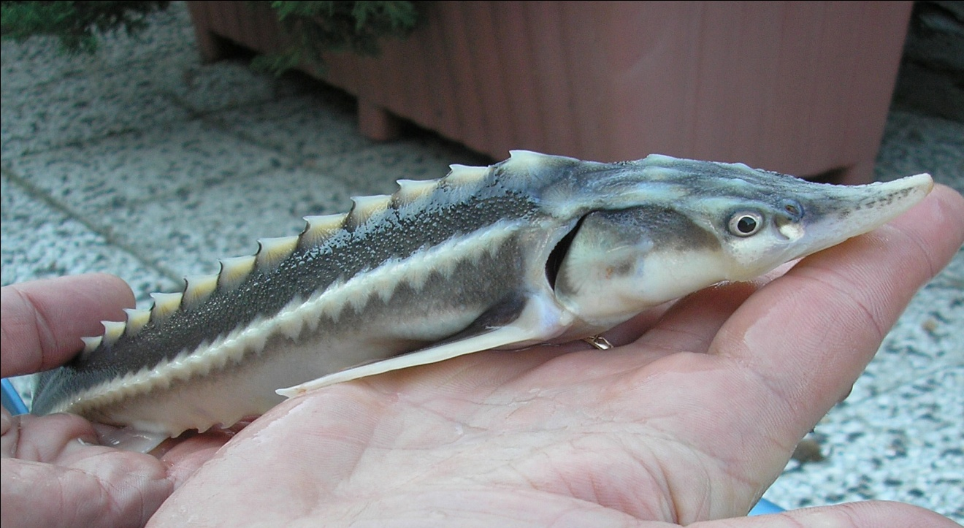
Fig № 1 (hybrid № 1)
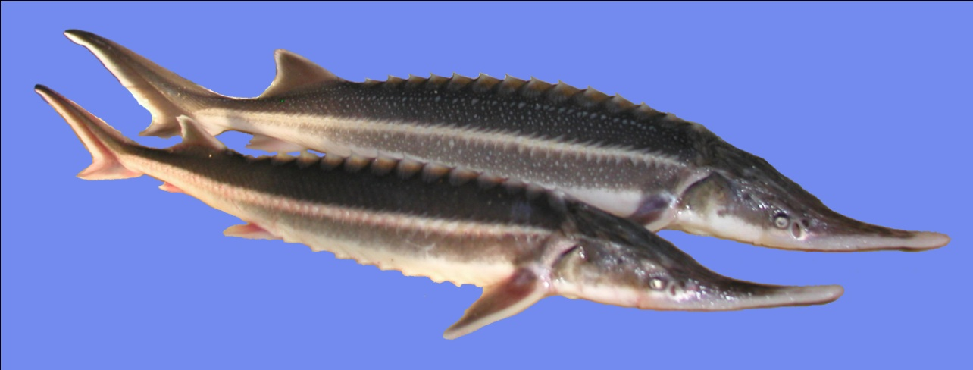Hybrid № 2 The IEF of hemoglobin shows heredity of Ac. stellatus and Ac. ruthenus (Fig № 2).

Fig № 2 (hybrid № 2)
Hybrid № 3 The isoelectroforetic study shows heredity of Huso huso and Ac. ruthenus (bester) - also caught in the region of Varna, 2006.
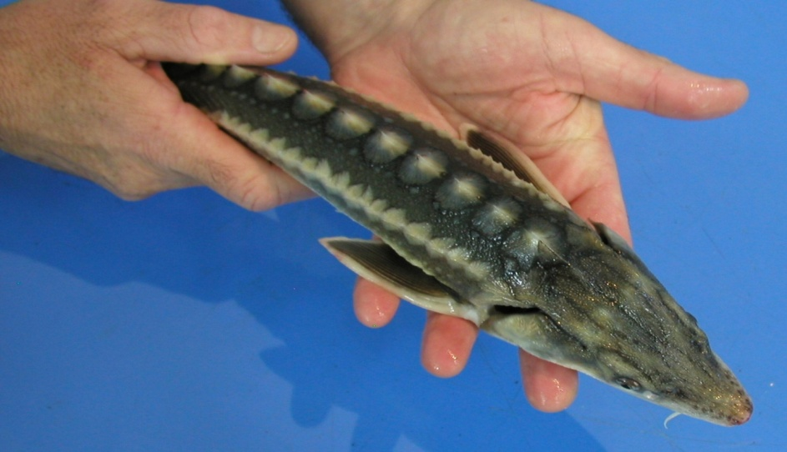
Fig № 3 (hybrid № 3)
Hybrid № 4 With morphological signs of Russian sturgeon (Ac. gueldenstaedti) and Sterlet (Ac. ruthenus) - caught the autumn of 2010 in the Danube River along with Sterlet specimens.
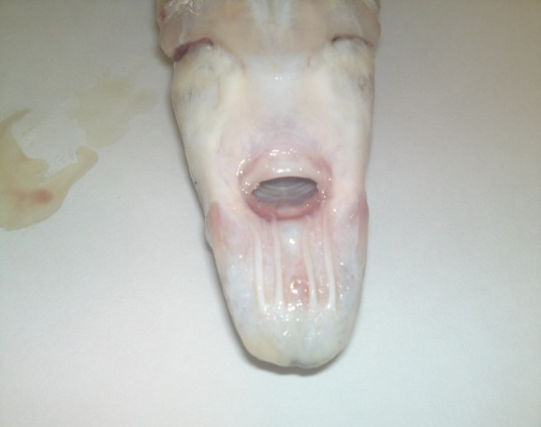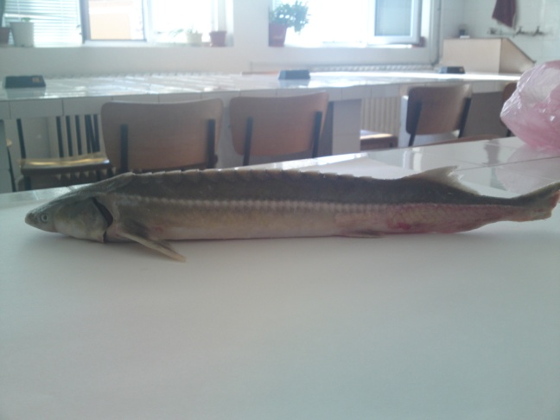
Fig № 4 (hybrid № 4)

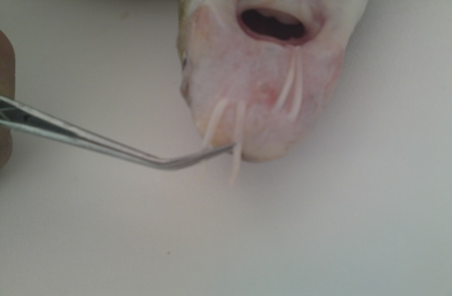
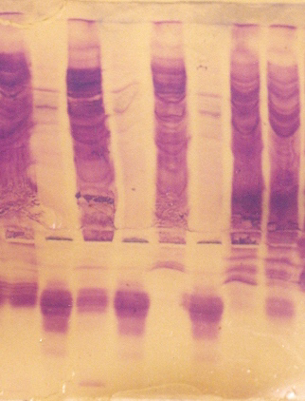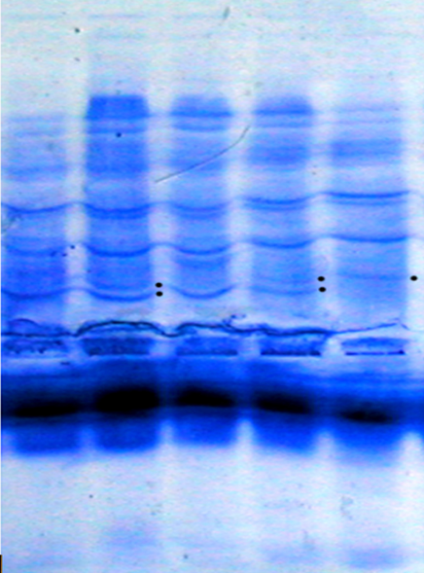
1 2 3 4 5 6 7 8 1 2 3 4 5
Fig № 5 Electropherogram of serum Fig № 6 IEF of hemoglobin: 1 and 3 –
proteins: 1 – Russian sturgeon; 2, 4 Sterlet; 2 and 4 – Hybrid № 2; 5 –
and 6 – Hybrid № 1; 3 – Sterlet; 5 – Stellate sturgeon.
Stellate sturgeon; 7 – Hybrid (Russian
Sturgeon x Siberian sturgeon) and 8 –
Siberian sturgeon.

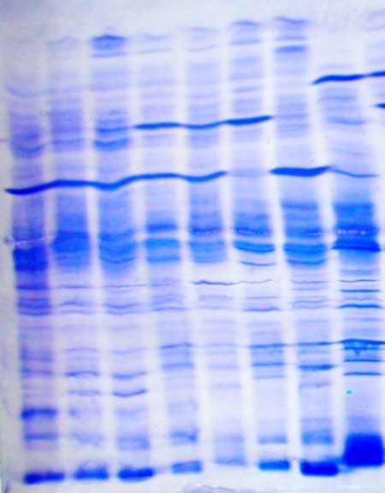
1 2 3 4 5 6 7 8
Fig № 7 IEF of muscle proteins: 1, 2 and 3 –
Russian sturgeon; 4 and 5 – Hybrid № 1; 6 –
Sterlet; 7 – Hybrid № 3 and 8 – Great sturgeon.

Conclusions
The simultaneous catch of more than one specimen at the same time and place (four or five specimens), as are the cases of hybrids № 2 and № 3, supports the view that the amount of obtained natural hybrids in populations of sturgeon species with drastically reduced numbers increases.
The increased number of these fertile hybrids is the other factor, together with the excess catches, leading to the genetic extinction of the sturgeon species in nature.

References

Dobrovolov ,I. S., 1973. Micro starch gel electrophoresis. Proceeding of the Institute of Oceanography and Fisheries, Varna, 12: 157-162

Dobrovolov, I.,P Ivanov, A.Tsekov, 2005. Genetic-biochemical identification of some sturgeons and their hybrids (Pisces, Acipenseridae). Verh. Internat. Verein. Limnol., 29, 917-921

Ene, A.C., R. Suciu 2001. Kariological investigation in natural hybrid of sturgeons of the Lower Danube River and Black Sea. Abstract, International Symposium Deltas & Wetlands 2001.
Smithies,O.,1955. Zoneelectrophoresis in starch gels:group variations in the serum proteins of normal human adults. Biochem.J.,61,629-641.

Tsekov,A., P.Ivanova, M.Angelov, S. Atanasova, J.Bloesh. 2008. Natural Sturgeon Hybrids along Bulgarian Black Sea Coast and in Danube River. Acta zool.bulg., 60(3), 311-316.

