GFTN Bolivia

Open Offer

2010

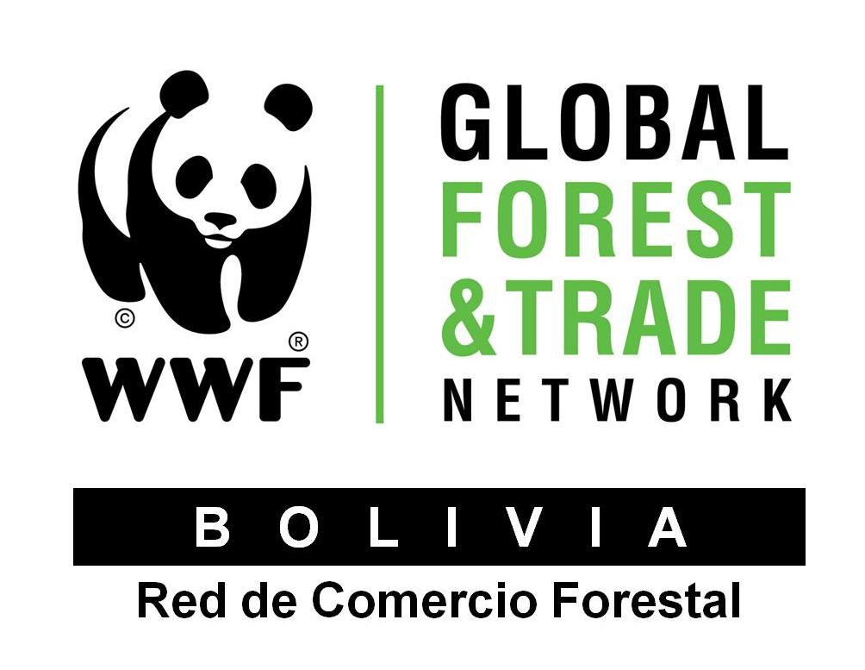

Contact details:

Maria del Carmen Carreras

mcarreras@wwfbolivia.org



Exporter Profile

World Wildlife Fund - WWF
Global Forest and Trade Network - GFTN
gftn.panda.org
Note: The information in this profile is reviewed periodically by GFTN and, to the best of our knowledge, is an accurate representation of the products offered as well as approximate availability. Because of changing conditions, however, the information presented here should be verified with the supplier.

Supplier name and contact | Company and main products | Last date profile updated
Green Label Floors SRL  Contact: Lydia Vrsalovic  Tel: (+591) 4-4287341  4-4319516  lydia@jolyka.com  www.jolyka.com | JOLYKA FLOORING produced by GREEN LABEL FLOORS. Currently exports to USA and European markets. | 01/10/2010
Products
Note: Unless otherwise noted, all products are hardwoods.
Hard Wood Flooring: Solid Prefinished, Engineered Prefinished

Species & Availability
FSC-certified Flooring (sqft) available:

Commercial Name | Scientific Name | Unfinished and Prefinished | Volumes sqft (year)
Cumaru | Dipteryx odorata | Solid Flooring | 480
Cumaru | Dipteryx odorata | Engineered 3 Ply single strip | 360
Palo Maria | Calophyllum brasillense | Solid Flooring | 480
Palo Maria | Calophyllum brasillense | Engineered 3 Ply single strip | 360
Garapa | Apuleia leiocarpa | Solid Flooring | 480
Garapa | Apuleia leiocarpa | Engineered 3 Ply single strip | 360
Masaranduba | Manilkara bidentata | Solid Flooring | 480
Masaranduba | Manilkara bidentata | Engineered 3 Ply single strip | 360

For more information, contact company directly or Forest and Trade Network – GFTN-Bolivia: mcarreras@wwfbolivia.org
 Exporter Profile

World Wildlife Fund - WWF
Global Forest and Trade Network - GFTN
gftn.panda.org
Note: The information in this profile is reviewed periodically by GFTN and, to the best of our knowledge, is an accurate representation of the products offered as well as approximate availability. Because of changing conditions, however, the information presented here should be verified with the supplier.

Supplier name and contact | Company and main products | Last date profile updated
MABET S.A.  Contact: Carlos E. Vivado  Tel: (+591) 2-2862374  cvivado@mabet.com.bo  www.mabet.com.bo  LA PAZ - BOLIVIA | MABET currently exports to European, USA and Chilean markets. 795 employees, $10, millions in gross sales | 01/10/2009
Products
Note: Unless otherwise noted, all products are hardwoods.

Lumber – AD & KD; standard dimensions & grades
Dimension stock – S2S & S4S; milled to customer specifications
Moldings - milled to customer specifications

Species & Availability

FSC-certified lumber (m³) available:

Commercial Name Scientific Name Current Products Volumes available (year)
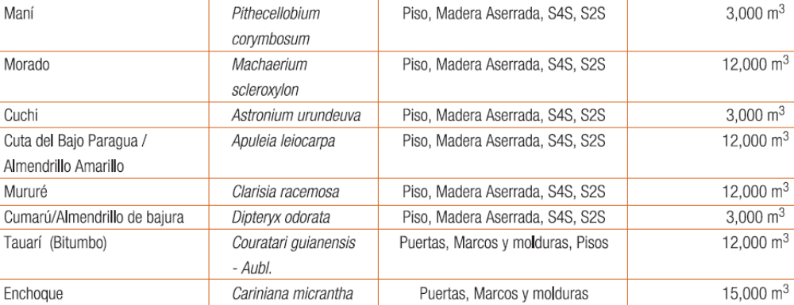

For more information, contact company directly or Forest and Trade Network – GFTN-Bolivia: mcarreras@wwfbolivia.org
 Exporter Profile

World Wildlife Fund - WWF
Global Forest and Trade Network - GFTN
gftn.panda.org
Note: The information in this profile is reviewed periodically by GFTN and, to the best of our knowledge, is an accurate representation of the products offered as well as approximate availability. Because of changing conditions, however, the information presented here should be verified with the supplier.
Supplier name and contact | Company and main products | Last date profile updated
MADERERA IPACARAÍ - Contact: Mario Antonio Becerra Roca  Tel: (+591) 3-8523393  maderera_ipacarai@terra.com  mbezerraroca@hotmail.com  RIBERALTA - BOLIVIA | IPACARAI currently exports to Belgium, Spain, Mexico, Argentina and China markets. 100 employees, $1, million in gross sales | 01/10/2009
Products
Note: Unless otherwise noted, all products are hardwoods.

Lumber – Sawn wood, AD & KD; standard dimensions & grades
Dimension stock – S2S & S4S; milled to customer specifications
Moldings - milled to customer specifications

Species & Availability

FSC-certified lumber (m³) available:

Commercial Name Scientific Name Current Products Volumes available (year) M3
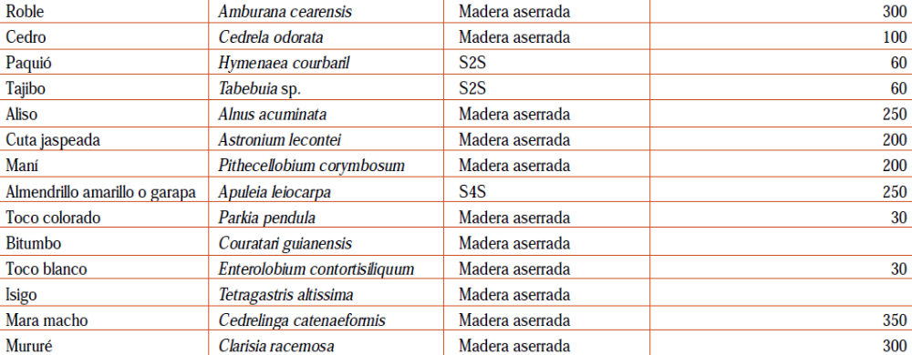

For more information, contact company directly or Forest and Trade Network – GFTN-Bolivia: mcarreras@wwfbolivia.org
 Exporter Profile

World Wildlife Fund - WWF
Global Forest and Trade Network - GFTN
gftn.panda.org
Note: The information in this profile is reviewed periodically by GFTN and, to the best of our knowledge, is an accurate representation of the products offered as well as approximate availability. Because of changing conditions, however, the information presented here should be verified with the supplier.

Supplier name and contact | Company and main products | Last date profile updated
PROMAD S.A  BOLIVIA  Contact: Luis Ramiro Salazar  Tel: 591-2-2850145  promadsa@yahoo.es  www.promadsa.com  LA PAZ - BOLIVIA | PROMAD currently exports to European, and North American markets. 40 employees, $0.5, million in gross sales | 26/01/2010
Products
Note: Unless otherwise noted, all products are hardwoods.

Dimension stock – S2S & S4S; milled to customer specifications
Flooring – solid, T&G, end-matched; standard dimensions & grades
Laminated profiles and edge glued panels – solid and finger jointed, custom made
Species & Availability

Non-FSC lumber (m²) available

Commercial Name Scientific Name Current Products Volumes available (year)

Tajibo | Tabebuia impetiginosa | Pisos-Flooring-decking | 48.000 m2
Almendrillo de bajura | Dipteryx odorata
Paquio | Hymenaea courbaril
Almendrillo o Garapa | Apuleia leiocarpa
Mara (mahogany) | Swetenia macrophylla | Lam. Profiles and edge glued panels | 500 m3
Cedro (Spanish cedar) | Cedrela odorata
Roble (Bolivian oak) | Amburana cearencis
Otras medio duras

For more information, contact company directly or Forest and Trade Network – GFTN-Bolivia: mcarreras@wwfbolivia.org
 Exporter Profile

World Wildlife Fund - WWF
Global Forest and Trade Network - GFTN
gftn.panda.org
Note: The information in this profile is reviewed periodically by GFTN and, to the best of our knowledge, is an accurate representation of the products offered as well as approximate availability. Because of changing conditions, however, the information presented here should be verified with the supplier.

Supplier name and contact | Company and main products | Last date profile updated
INDUSTRIA MADERERA SAN LUIS  Contact: Federico Sauto  Tel: (+591-3) 3476264  sanluis@cotas.com.bo  SANTA CRUZ - BOLIVIA | San Luis currently exports to European and Latino American markets. 150 employees, $1.3, millions in gross sales | 01/10/2009
Products
Note: Unless otherwise noted, all products are hardwoods.

Lumber – Sawn wood AD & KD; standard dimensions & grades

Species & Availability

FSC-certified lumber (m³) available:

Commercial Name Scientific Name Current Products Volumes available (year) Pt
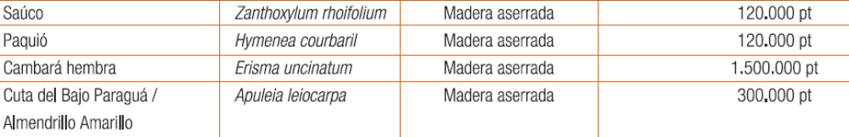

For more information, contact company directly or Forest and Trade Network – GFTN-Bolivia: mcarreras@wwfbolivia.org

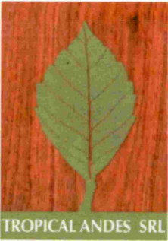 Exporter Profile

World Wildlife Fund - WWF
Global Forest and Trade Network - GFTN
gftn.panda.org
Note: The information in this profile is reviewed periodically by GFTN and, to the best of our knowledge, is an accurate representation of the products offered as well as approximate availability. Because of changing conditions, however, the information presented here should be verified with the supplier.

Supplier name and contact | Company and main products | Last date profile updated
TROPICAL ANDES S.R.L.  Contact: Guillermo Crooker Muñoz  Tel: (591-2) 2711751 /  2711743  gcrooker@tropicalandes.com  LA PAZ - BOLIVIA | Tropical Andes currently exports to EE.UU., Chile, Mexico, Oceania, Europe and Asia markets. 20 employees, $2, millions in gross sales | 01/10/2009
Products
Note: Unless otherwise noted, all products are hardwoods.

Lumber – AD, KD; standard dimensions & grades
Dimension stock – S2S & S4S; milled to customer specifications
Decking – S4S, E4E; standard dimensions & grades

Species & Availability

FSC-certified lumber (m³) available:

Commercial Name Scientific Name Current Products Volumes available (year) m³
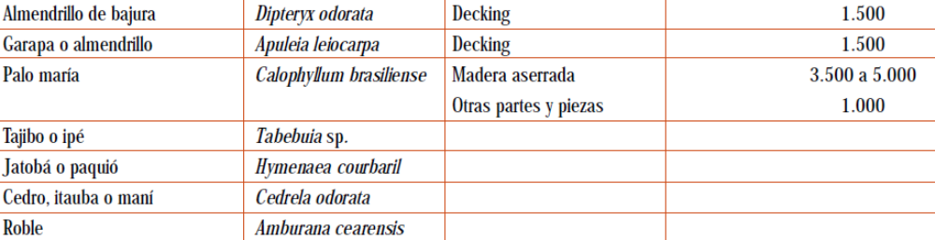
For more information, contact company directly or Forest and Trade Network – GFTN-Bolivia: mcarreras@wwfbolivia.org
 Exporter Profile

World Wildlife Fund - WWF
Global Forest and Trade Network - GFTN
gftn.panda.org
Note: The information in this profile is reviewed periodically by GFTN and, to the best of our knowledge, is an accurate representation of the products offered as well as approximate availability. Because of changing conditions, however, the information presented here should be verified with the supplier.

Supplier name and contact | Company and main products | Last date profile updated
SAN JUAN PANDO S.R.L.  Contact: Alfredo Oilo Rivera  Tel: (+591-3) 8524445  aoilo@sanjuanpando.com  PANDO - BOLIVIA | San Juan Pando currently exports to Holland, EE.UU., Spain, and Chilean markets. 60 employees, $1, million in gross sales | 01/10/2009
Products
Note: Unless otherwise noted, all products are hardwoods.

Lumber – AD, KD; standard dimensions & grades
Dimension stock – S2S & S4S; milled to customer specifications
Flooring – solid, T&G, end-matched; standard dimensions & grades
Decking – S4S, E4E; standard dimensions & grades
Moldings - milled to customer specifications

Species & Availability

FSC-certified lumber (m³) available:

Commercial Name Scientific Name Current Products Volumes available (year) m³
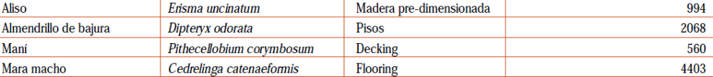

For more information, contact company directly or Forest and Trade Network – GFTN-Bolivia: mcarreras@wwfbolivia.org


Exporter Profile

World Wildlife Fund - WWF
Global Forest and Trade Network - GFTN
gftn.panda.org
Note: The information in this profile is reviewed periodically by GFTN and, to the best of our knowledge, is an accurate representation of the products offered as well as approximate availability. Because of changing conditions, however, the information presented here should be verified with the supplier.

Supplier name and contact | Company and main products | Last date profile updated
SINATURE  Contact: Ricardo Vargas  Tel: (+591-4) 4532348  r.vargas@sinature.net  rvargasalanes@gmail.com  COCHABAMBA BOLIVIA | SINATURE currently exports to Germany, England, Belgium and EE.UU. markets. 20 employees, $150,000 in gross sales | 01/10/2009
Products
Note: Unless otherwise noted, all products are hardwoods.

Flooring – solid, T&G, end-matched; standard dimensions & grades
Decking – S4S, E4E; standard dimensions & grades
Garden Furniture
Species & Availability

FSC-certified lumber (m³) available:

Wood Species | Scientific Name | Current Products | Volume m3 (monthly)
Paquió | Hymenaea courbaril | Strips, S2S y S4S. | 60 m3/month/3 CNT
Roble | Amburana cearensis | Strips, S2S y S4S. | 60 m3/month/3 CNT
Cumaru | Dipterix odorata | Strips, S2S y S4S. | 60 m3/month/3 CNT

For more information, contact company directly or Forest and Trade Network – GFTN-Bolivia: mcarreras@wwfbolivia.org

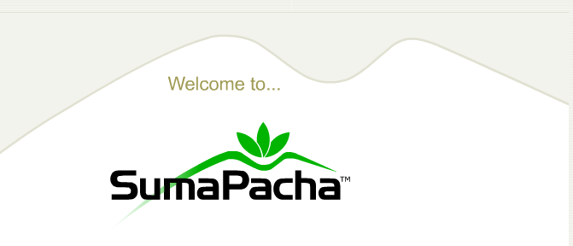

Exporter Profile

World Wildlife Fund - WWF
Global Forest and Trade Network - GFTN
gftn.panda.org
Note: The information in this profile is reviewed periodically by GFTN and, to the best of our knowledge, is an accurate representation of the products offered as well as approximate availability. Because of changing conditions, however, the information presented here should be verified with the supplier.

Supplier name and contact | Company and main products | Last date profile updated
Suma Pacha S.A:  Contact: Michelle Arteaga  Tel: (+591) 2-2154450/1  2-2154449  marteaga@unitedbolivia.com  www.sumapacha.bo | Suma Pacha produced indoor and outdoor furniture, flooring and decking, doors and windows Currently exports to USA and Spain markets. | 01/10/2010
Products
Note: Unless otherwise noted, all products are hardwoods.
Flooring – solid, T&G, end-matched; standard dimensions & grades
Decking – S4S, E4E; standard dimensions & grades
Indoor and outdoor furniture, Doors and windows.

Species & Availability
FSC-certified Flooring (sqft) available:

Commercial Name | Scientific Name | Products | Volumes M3 (year) | Additional volumes
Cumarú / Almendrillo de bajura | Dipteryx odorata | Outdoor furniture, decking and sawn wood | 5000 m3 | 7000 m3
Garapa/Cuta/Almendrillo | Apuleia Leiocarpa | Outdoor furniture | 5000 m3 | 7000 m3
Tajibo rosado/Ipe | Tabebuia impetiginosa | Sawn and Decking | 500 m3 | 500 m3
Paquió - Jatoba | Hymenaea courbaril | Outdoor furniture and decking | 1000 m3 | 1000 m3
Ochoó | Hura crepitans | Indoor furniture | 5000 m3 | 5000 m3
Yesquero blanco | Cariniana ianeirensis | Doors/windows/Indoor furniture | 3000 m3 | 3500 m3

For more information, contact company directly or Forest and Trade Network – GFTN-Bolivia: mcarreras@wwfbolivia.org


Exporter Profile

World Wildlife Fund - WWF
Global Forest and Trade Network - GFTN
gftn.panda.org
Note: The information in this profile is reviewed periodically by GFTN and, to the best of our knowledge, is an accurate representation of the products offered as well as approximate availability. Because of changing conditions, however, the information presented here should be verified with the supplier.

Supplier name and contact | Company and main products | Last date profile updated
DEKMA Bolivia S.A.  Contact: Fernando Calderón  Tel: (+591 -2) 285 0504  fcalderon@dekmabolivia.com | DEKMA produced Decking, screen, fence, tiles, outdoor furniture  Currently exports to European Market. | 01/10/2010
Products
Note: Unless otherwise noted, all products are hardwoods.
Fences, tiles, screen, and outdoor furniture
Decking – S4S, E4E; standard dimensions & grades

Species & Availability

FSC-certified Flooring (sqft) available:
Commercial Name | Scientific Name | Products | Volumes M3 (year)
Almendrillo amarillo | Apuleia leiocarpa | Decking, screen, fence, tiles, | 2484.21
Almendrillo de bajura o Cumarú | Dipteryx odorata | Garden furniture | 390.66
Cambará macho o alizo angelyn | Qualea sp. | Decking, screen, tiles, | 786.73
Tajibo o ipé | Tabebuia sp. | Garden furniture | 118.72
Maní | Sweetia fruticosa | Decking, screen, tiles, | 130.54
Morado | Machaerium scleroxylon | Garden furniture | 255.99
Mururé | Clarisia racemosa | Decking, tiles | 621.05

For more information, contact company directly or Forest and Trade Network – GFTN-Bolivia: mcarreras@wwfbolivia.org

Exporter Profile

World Wildlife Fund - WWF
Global Forest and Trade Network - GFTN
gftn.panda.org
Note: The information in this profile is reviewed periodically by GFTN and, to the best of our knowledge, is an accurate representation of the products offered as well as approximate availability. Because of changing conditions, however, the information presented here should be verified with the supplier.

Supplier name and contact | Company and main products | Last date profile updated
La Chonta WoodS  Contact: Pablo Antelo Gil  Tel: (+591 -3) 342-1213  Fax: (+591 -3) 342-1215  pantelo@lachonta.com | La Chonta produced exterior and interior doors, moldings, frames, outdoor furniture and sawn wood AD/KD  Currently exports to Europe, Asia, United States and Oceania. | 01/10/2010
Products
Note: Unless otherwise noted, all products are hardwoods.
Lumber – AD & KD; standard dimensions & grades
Moldings - milled to customer specifications
Garden furniture and Doors.

Species & Availability
FSC-certified Flooring (sqft) available:
Wood Species | Scientific Name | Current Products | Volume m3 (monthly)
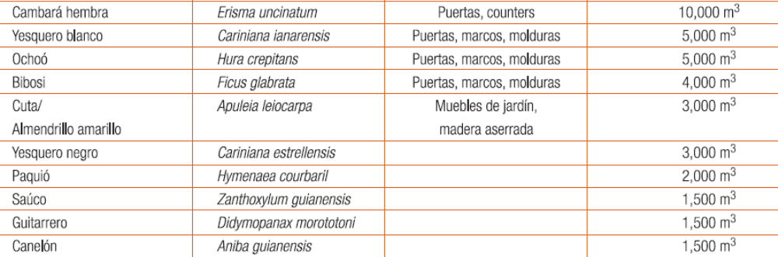
For more information, contact company directly or Forest and Trade Network – GFTN-Bolivia: mcarreras@wwfbolivia.org


Exporter Profile

World Wildlife Fund - WWF
Global Forest and Trade Network - GFTN
gftn.panda.org
Note: The information in this profile is reviewed periodically by GFTN and, to the best of our knowledge, is an accurate representation of the products offered as well as approximate availability. Because of changing conditions, however, the information presented here should be verified with the supplier.

Supplier name and contact | Company and main products | Last date profile updated
MADERSEC  Contact: Juan Carlos Ávila  Tel: (+591 -4) 4711518 / (+591 -4) 4712113  Cel. 591-77414014  madersec@gmail.com | Madersec offers kiln dry services Wood processing, flooring S4S, decking and moldings.  Currently exports to United States and China. | 01/10/2010
Products
Note: Unless otherwise noted, all products are hardwoods.
Moldings - milled to customer specifications
Flooring – S4S, E4E; standard dimensions & grades
Kiln dry and processing services.

Species & Availability
Non-certified Flooring (sqft) available:
Commercial Name | Scientific Name | Products | Volumes M3 (year)
Curupaú | Anadenanthera colubrina | Procesamiento de madera | 4.800
Almendrillo de bajura | Dipteryx odorata | Pisos, decking, molduras
Cedro | Cedrela odorata
Roble | Amburana cearensis
Tajibo o ipé | Tabebuia sp.

For more information, contact company directly or Forest and Trade Network – GFTN-Bolivia: mcarreras@wwfbolivia.org

