
WWF FOREST PROGRAMME

Illegal Logging in Northwestern Russia
And Export of Russian Forest Products
To Sweden

WWF's Approach to Forest Conservation

WWF's mission is to stop the degradation of the natural environment and build a future in which humans live in harmony with nature by:

- Conserving the world's biological diversity;
- Ensuring that the use of renewable natural resources is sustainable;
- Promoting the reduction of pollution and wasteful consumption.

The protection target is: The establishment and maintenance of viable, representative networks of protected areas in the world’s threatened and most biologically significant forest regions, by 2010.

The forest management target is: 100 million ha of certified forests by 2005, distributed in a balanced manner among regions, forest types and land tenure regimes.

The forest restoration target is: By 2005, undertake at least twenty forest landscape restoration initiatives in the world’s threatened, deforested or degraded forest regions to enhance ecological integrity and human well-being.

Particular attention will also be paid to issues that cut across the targets, including threats (forest fires, illegal logging, climate change and conversion), policy issues (subsidies, trade barriers, investment flows) and opportunities (community forest management).

This project was completed with the financial support of WWF Sweden

Written by
© Olga Lopina, Andrei Ptichnikov, Alexander Voropayev

Editor
Per Larsson

The authors acknowledge Ekaterina Zaytseva for the help in interviewing companies.

Photos on the cover
© WWF Russia / Sergey Kischenko
© WWF Russia

January 2003

Any full or partial reproduction of this publication must include the title and give credit to the above-mentioned publisher as the copyright holder. No photographs from this publication may be reproduced without prior authorization from WWF Russia.

Published in January 2003 by WWF Russian Programme Office
© Text 2003 WWF. All rights reserved.

INTRODUCTION

The northwest of European Russia is a region where most of the Russian forest products export to Europe is originated. The region consists of Arkhangelskaya Oblast (including Nenets Autonomous District), St.Petersburg and Leningradskaya Oblast, Murmanskaya Oblast, Novgorodskaya Oblast, Pskovskaya Oblast, Vologodskaya Oblast, and Republics of Karelia and Komi (Fig. 1).
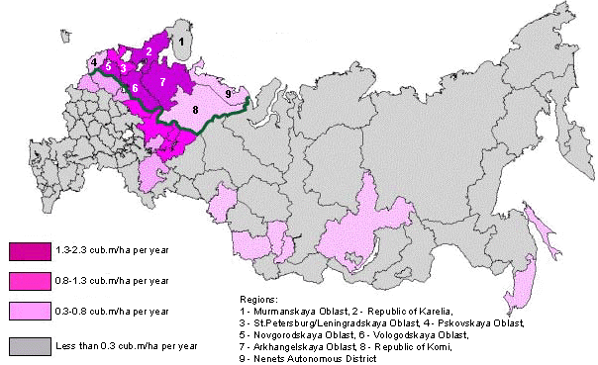

Figure 1. Regions of northwestern Russia. Intensity of wood harvesting in Russia (estimated by Kuusela)

Northwestern Russia is characterised by the most intensive wood harvesting in the country. At the same time, it is rich in forest, which covers about 70 % of the area. Coniferous species, including mostly Scots pine and Norway spruce, account for about 50% of the forest area, aspen and birch are widespread too. The majority of forests in northwestern Russia is still close to natural state because the intensity of forest management is much lower than in neighbouring Finland and Sweden. Moreover the last European large tracts of intact forests are located there, mostly in the Republics of Karelia and Komi and Arkhangelskaya Oblast. The forests of northwestern Russia have clear Global and European significance – they contain high biodiversity and rare species, these enormous areas are very important for carbon sequestration and mitigation of global warming.

According to the Forest Code of the Russian Federation (1997), all forests of the country are state-owned. The total forest area is 1129.4 million hectares (by the state inventory of the Forest Fund of Russia as of 1 January 1998). The most of forests is in federal ownership (99.89%) but governed by different agencies (Fig. 2). Forests of inhabited areas are in municipal ownership. Forests are directly managed by state forest management units (leskhozes), which are supervised by regional committees of natural resources accountable to the Ministry of Natural Resources of the Russian Federation in Moscow. The legislation allows granting federal forests to the regional ownership. Forests may be leased by logging companies or private persons for various kinds of use for a period ranging from 3 to 49 years. The leased area was 80.9 million ha as of 1 January 2001. On the other hand, the structure of the Russian forest industry is rather different, with prevailing private ownership (Fig. 3).

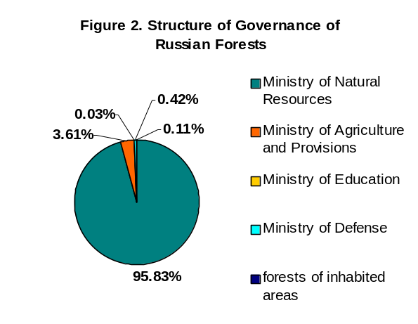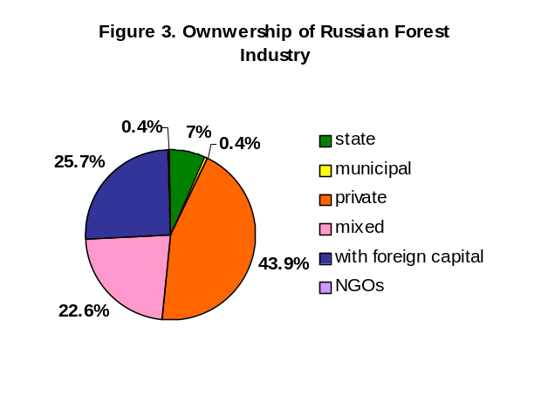
Illegal Logging and Forest Crime

WWF believes that illegal logging and other forms of forest crimes are part of a larger problem that includes issues of forest governance and corruption. They expend far beyond some individuals violating resource-management laws. WWF uses the term “illegal logging and forest crime” to include both large and small-scale timber theft and a variety of issues such as transfer pricing, breaching tax rules, any illegal aspects of timber sourcing and circumvention of concession agreements through bribery or deception. There is also a whole range of corrupt activities, which has the cumulative effect of reducing effectiveness of governance even if the precise letter of the law is not breached. Up to 65 per cent of WWF’s Global 200 forested ecoregions are threatened by illegal logging. WWF believes that illegal logging and forest crime are best stopped using a combination of existing tools and the development of new policies.
WWF Position Paper

Illegal logging is one of key threats to forests worldwide. The trade of illegally harvested wood is a multi-million dollar industry going on in over 70 countries, in all types of forests, from Brazil to Canada, from Cameroon to Indonesia, and from Peru to Russia. Since illegal logging and trade activities tend to be concentrated in forests rich in plant and animal diversity, environmental costs are also high. Illegal logging became a big problem in the region, particularly in the past decade. The share of illegal wood in the export ranges from 25 to 30% and even to 50% by various estimates. Illegal logging is caused by both low level of control of logging operations from the government and lack of responsible approach of logging and wood trading companies, which do no not control the origin of wood. This results in severe overlogging in densely populated areas and overall changes of forest quality. Illegal logging has also significant social impact because it reduces income from forest resources. The latest estimates show that Russia loses approximately 1 milliard USD a year due to illegal logging and trade.

Sweden is so far the second largest consumer of roundwood (by volume) from northwestern Russia, following Finland. The export to Sweden predominantly consists of industrial roundwood (pulpwood and sawlogs) – 2 314 thou m³, i.e. 6% of the total Russian roundwood export or 15% of the export to Europe in 2001 (all Russian export is by the State Customs Committee of the Russian Federation if other not mentioned). The Russian export to Sweden (by value) comprises industrial roundwood (89.5%), plywood (8.5%), paper and a little bit of fuelwood (both about 2%). Most forest products are exported to Sweden from northwestern Russia via seaports (Fig. 4).

Figure 4. Russian Forest Products Export to Sweden (by value)
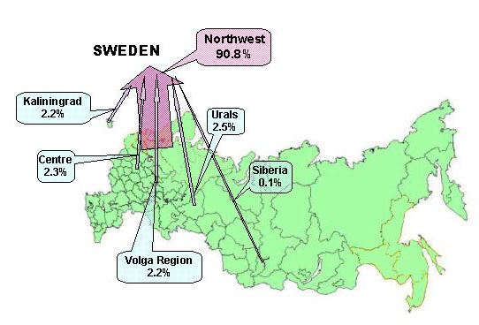
The share of Russia in the Swedish roundwood import (by volume) is higher (22%) – second place after Latvia (all Swedish import is by the National Board of Forestry if other not mentioned). The key areas of the export to Sweden are St. Petersburg/ Leningradskaya Oblast (78%) and Vologodskaya Oblast (16%). Sweden accounts for 17% of the total roundwood export of northwestern Russia. In some regions, its share is even higher – 24% in Vologodskaya Oblast, 26% in St. Petersburg/Leningradskaya Oblast, and 68% in Kaliningradskaya Oblast. By the assessment of WWF experts, customs data, and the Count Chamber, the roundwood export is particularly non-transparent and seems to include the most percentage of wood of doubtful origin. Hence the Swedish government and Swedish wood importers may contribute much to tackling the problem, at least to the extent their Finnish neighbours do now.

In 2000, the Taiga Rescue Network and WWF Sweden published report Towards Responsible Swedish Timber Trade. It was the first attempt to study the origin of Russian wood imported to Sweden. The study was mostly based on interviews and questionnaires to Swedish importing companies. It showed that the main sources of exported wood were forests of northwestern Russia (predominately Leningradskaya Oblast and Vologodskaya Oblast). However it was not possible to verify the information received from Swedish companies about their responsibility in wood trade.

This report is an attempt to analyse the problem of illegal logging in northwestern Russia in relations with forest products export and is based on official data and information from independent sources.

THREATS TO THE FOREST BIODIVERSITY OF NORTHWESTERN RUSSIA

The boreal forest, or "taiga," is the world's largest forest biome stretching around the Northern Hemisphere; in Europe it covers Norway, Sweden, Finland, and northern European Russia, up to the Ural Mountains. The natural boreal forest is a mosaic of upland forests and wetlands with lakes and rivers interspersed. The dominant species are coniferous species – Norway spruce (Picea abies), Scots pine (Pinus sylvestris), and deciduous species European aspen (Populus tremula) and birch (Betula spp.). Boreal forests naturally have a different age structure, gap-phase dynamics generated by windfall and forest fires, wetlands and lakes. Some boreal species (birds, lichens, fungi, etc.) require specific habitats and can survive only in natural forests. Human disturbances, such as felling, human-induced fires, or pollution, extinguish such species and decrease the diversity of boreal forests.
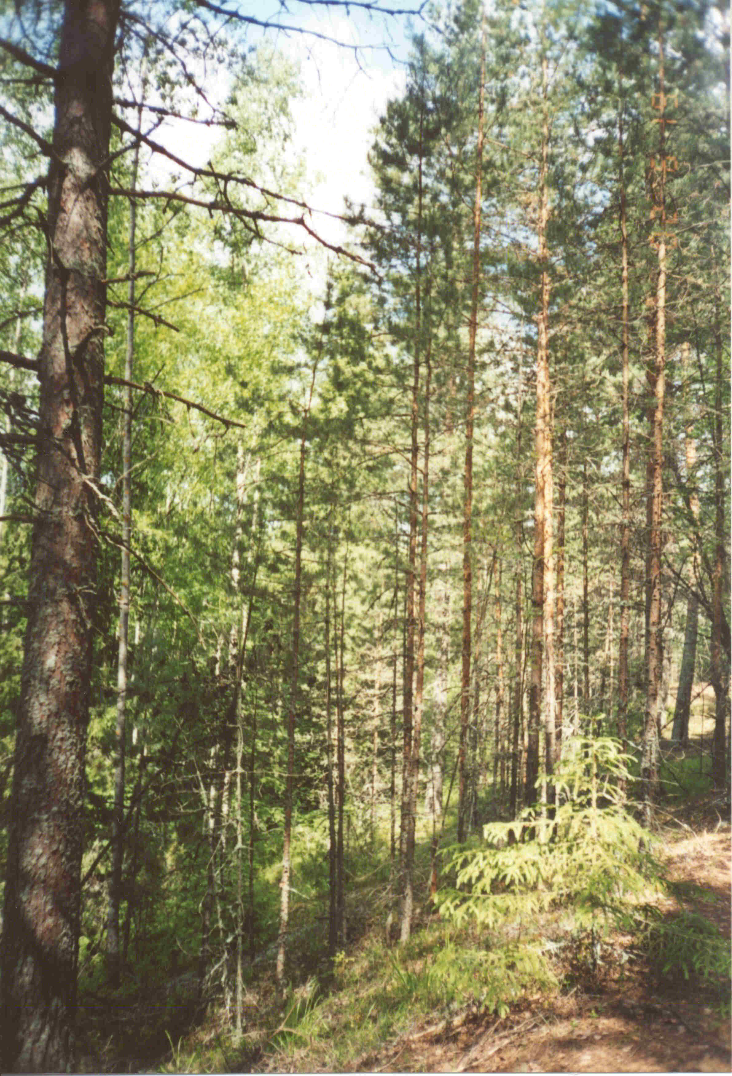
© G.Shilkrot
Felling is the major factor damaging biodiversity. The development of forestry in northwestern Russia and its environment impact is analysed in The Last of the Last: The Old-Growth Forests of Boreal Europe (D.Aksenov, M.Karpachevskiy, S.Lloyd, A.Yaroshenko, 1999). Selective cutting first began in the region in the 18th century to build the fleet of Peter the Great, produce tar, charcoal, and potash. The impact on forests was insignificant. The second stage of forest exploitation, called industrial forestry, began at the end of the 19th century. Large-scale clear cutting was launched in northwestern Russia in the 1930s to supply pulp and paper mills, which used trees of various sizes. At the same time, there increased export of forest products to Europe owing to the high demand for hard currency. Large-scale clearcuts of 1000 ha and logging in excess of official allowable cut levels became widespread. The motto of the period was "cut & run," without any attention to forest regeneration. Hence the share of mature and overmature forests of high environmental and commercial value considerably reduced, area of low-valuable species (e.g. aspen) grew, and many intact forests were converted into secondary ones. The area of pine forests in southern Karelia and Vologodskaya Oblast decreased twice (!) for the past 40 years. In the 1970s–1980s, artificial reforestation and thinning were introduced in some areas of northwestern Russia. However they are not common due to economic and management reasons.

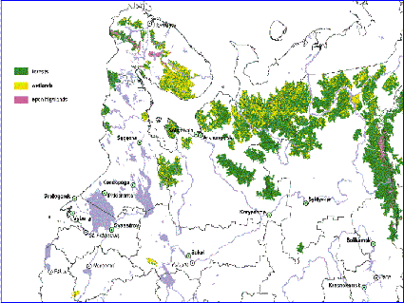
Compared with Sweden or Finland, the intensity of logging and forestry operations in Russia is much lower. Russian secondary forests are richer and more viable than Fennoscandian mono-cultural forests but poorer than natural coniferous old-growth forests. At the same time, the recent Global Forest Watch survey revealed last intact forests in some remote and sparsely populated areas. Nowadays they do not exceed 12 to 15% of the region forests (Fig. 5). Notwithstanding Russia holds more intact forests than all other Europe as a whole. The remaining intact forests of northwestern Russia are unique natural heritage, being a pool of biodiversity providing viable population of species. The forests are still inhabited by many species of plants and animals, which are extinct or endangered in other Europe. It is the only place in the continent where large tracts of intact forests (over 50 thousand hectares) remain. These last forests also provide reference ecosystems to research ecological dynamics and structure needed for the development of sound management practice.
Figure 5. Intact forests
of northwestern Russia

There are also other types of high conservation value forests. Some of them have a status of protected areas with different limitations of human activities (IUCN Categories I–IV). They are zapovedik (strict nature reserve), national park, nature park, zakaznik (nature reserve and wildlife sanctuary), nature monument, etc. Such protected areas are established by federal, regional, or local acts and are managed by environment departments. There are also so called special protective areas with logging prohibited, which are established by state forest inventory according to special by-laws. They are intended to protect forests of catchment areas, habitats of rare species, such as capercaillies’ mating-places, etc. A kind of protection status is also established for so called Forests of Group I, which are managed by the state forest service. They do not fully correspond to protected areas because various kinds of thinning are allowed there. Some high conservation value forests, including most of intact forests, are not legally protected. It means they are open for all kinds of logging, including clearcutting. Still some efforts are made by NGOs to protect them. In 1996, they initiated a moratorium supported by a number of foreign companies on purchasing wood from intact forests of Karelia and Murmanskaya Oblast. However only a legal protection status can stop all harvesting in these forests.

Forest fires are not of great significance in the region as in the Russian Far East or Siberia. They are necessary for boreal forest ecosystems. However their occurrence is much above the natural level. More than 90% of all forest fires are induced by human. Every year hundred thousands of hectares of forests in northwestern Russia suffer from forest fires.

The contemporary forest management is mainly oriented to the export of roundwood due to the shortage of processing facilities. Various estimations show that roundwood trade neither provides enough revenue for good reforestation and silviculture nor benefits local communities involved in wood harvesting. Roundwood trade does not attract foreign investments and is not able to provide long-term economic growth of the region (Table 1).

Table 1. Foreign Investments in the Forest Industry of the Russian Federation and Northwestern Russia, 2001
Sectors | Russian Federation | Northwestern Russia
Forest Industry (total) | 241 045 | 121 976
Pulp and paper industry | 137 021 | 85 613
Sawmilling | 50 616 | 14 115
Wood harvesting | 25 166 | 12 556
Other (plywood, fibreboard, etc.) | 28 242 | 9 692
Note: data of the State Statistics Committee of the Russian Federation in thousand USD

The foreign investments in wood harvesting account only for about 10% in the country as a whole and just slightly less in northwestern Russia, although the roundwood export provides near 40% of the export revenue. The investments in sawmilling and other wood processing are much less because the region is specialised in roundwood export.

As a result, roundwood trade spurs illegal harvesting and, along with this, does damage to forests, reducing their ecological and economic values.

ILLEGAL LOGGING IN NORTHWESTERN RUSSIA

Illegal logging occurs when timber is harvested, transported, processed, bought or sold in violation or circumvention of national or sub-national laws (WWF Position Paper – Illegal Logging and Forest Crime).

The regional Departments of the Ministry of Natural Resources of the Russian Federation informed of 20.8 and 20.9 thousand m³ of illegally harvested wood for 9 months of 2001 in Vologodskaya and Pskovskaya Oblasts. It means it accounted for about 0.5% and 3.5% of legally harvested wood in the regions, respectively. However, these values reflect only rough and registered breaches, i.e. cutting without permission or in excess of allowed volumes. The estimates of the Ministry changed after the recent inspection of forest management (April–May 2002) made by the new governing body of the Ministry of Natural Resources of the Russian Federation by the order of the President Administration. They became closer to other organisations’ estimates. The Commission established by the Administration of Vologodskaya Oblast in May 2001 to combat with illegal logging reports 1.5-fold growth of events of illegal logging for the year. It also concluded that only small events of illegal logging (less than 500 m³) were uncovered and registered. Sometimes employees of the State Forest Service are involved in such violations. Greenpeace Russia together with the Northwest Department of Natural Resources inspected the Slantsevskiy Selskiy Leskhoz (Leningradskaya Oblast) and revealed that about 200 m³ of wood were illegally logged in established felling areas every night. By the Control and Inspection Department of the President of the Russian Federation, the damage done only by recorded violations in the forest sector in 2001 was 2.8 milliard roubles (about 100 million USD) with the annual growth as much as 5.8 times! The “leaders” of such growth were Primorskiy Kray, Kostromskaya Oblasy (8 times), and Vologodskaya Oblast (6.2 times).

However the main problem of illegal logging in Russia is not poachers. It is legal logging companies which log in excess of limits allowed by felling licenses, outside established felling areas, including in protected areas, and local cut protected species, e.g. larch.

The Fiscal Police and regional Administrations of northwestern Russia inform that a significant amount of extracted timber (up to 50%) is avoid of tax, mostly due to payment in cash. The Federal Service of Fiscal Police of the Russian Federation announced in October 2001 that about 1 milliard of USD was lost in the forest industry every year because of law violations (RIA Novosti, 5th October 2001). It is more than a half of the Russian roundwood export (1.7 milliard of USD in 2001).

PRODUCTION AND CONSUMPTION OF FOREST PRODUCTS IN NORTHWESTERN RUSSIA

To estimate illegal logging in northwestern Russia we compared wood harvested in the region with the total wood consumed and exported from the region. If all wood is legally harvested, the volume of harvested wood is equal to the volume of consumed wood in the region and exported wood plus wood delivered from other regions of the country.

Roundwood in northwestern Russia, as in the whole country, is used for production of pulp, sawnwood, plywood, and other products as well as for construction, repairing, packaging production, and other local needs.

By the data of the State Statistics Committee of the Russian Federation, the region produced 3.2 million tons of pulp (for market pulp, paper and paperboard production) from about 14 million m³ of pulpwood (data of producers) in 2001 (Fig. 6). The amount of woodchips consumed for this purpose was very low – less than 0.5%.

The region also produced 6.7 million m³ of sawnwood and about 0.5 million m³ of plywood and veneer sheets. For this production it consumed at least 13.9 million m³ (data of the State Statistics Committee) and 1.6 million m³ of roundwood, respectively. The estimate of the consumption for the production of plywood was based on the mean consumption of roundwood for the production of one cubic metre of plywood in the region. The region also used 0.7 million m³ of roundwood for construction purposes. Hence the total amount of roundwood consumed in the region for such purposes was 30.2 million m³.

According to the Russian customs, the region exported about 13 million m³ of roundwood in 2001. It means that the total roundwood consumed in the region and exported from it in 2001 was about 43.2 million m³.

By the data of the State Statistics Committee of the Russian Federation, the region produced 31.0 million m³ of industrial roundwood in 2001. Hence the difference between legal production and consumption (including export) of industrial roundwood in the region in 2001 was 12.2 million m³.

Some roundwood might be delivered to the region from neighbouring areas. However this volume could not be high. Six nearby regions (Tverskaya, Yaroslavskaya, Kostromskaya, Kirovskaya, Permskaya, and Tyumenskaya Oblasts) legally produce about 12 million m³. Moreover these regions have developed wood-processing industries, so they need raw material as well. We estimate that these regions consume nearly all legally harvested roundwood inside; the roundwood export is low (10%). Transportation costs are rather high, so only big pulp and paper mills could be real buyers of such roundwood. But only two of them (Arkhangelsk PPM and Syktyvkar Forest Complex) declare the purchase of some pulpwood from nearby regions. We estimate that the delivery of industrial roundwood from nearby regions to northwestern Russia does not exceed 1 million m³. It means that at least 11.2 million m³ of industrial roundwood (about 36%) might be produced from illegally harvested wood.

We should also note that domestic consumption also includes roundwood used for local needs, repairing, mining, packaging production, and other purposes. By the estimate of the Research and Design Institute of Economy, Production Management, and Information on Forest, Pulp and Paper, and Woodworking Industries, these items averaged 20% of the total consumption (without export) of industrial roundwood in 2001 – for northwestern Russia it was about 7.5 million m³. It means that the actual volume of illegal wood is higher than our estimation. We also compared the volume of industrial roundwood produced in the region forests (data of the State Statistics Committee of the Russian Federation by producing companies) and the volume of legally harvested wood (data of the Ministry of Natural Resources of the Russian Federation by forest management units of all kinds of ownership).

Total consumption and export of industrial roundwood
43.2 million m³

Production of industrial roundwood
31.0 million m³
Roundwood used for pulp production
14 million m³
Roundwood export
13 million m³

Roundwood used for sawnwood production
13.9 million m³
Difference between legal industrial roundwood and its consumption
11.2 million m³
1 million m³
Delivery from other regions of Russia
Roundwood used for plywood & veneer sheets production
1.6 million m³
Roundwood used for construction purposes
0.7 million m³

Figure 6. Production and consumption of roundwood in northwestern Russia

The former reported 31.0 million m³ of industrial roundwood and the latter did about 63 million m³ of legally harvested wood in 2001, i.e. the output of industrial roundwood was about 49.2%. By expert assessment, it averages 60.3% in the country (data of the Count Chamber of the Russian Federation). Hence the declared delivery of roundwood from forests of the region might be lower that it must be based on the harvest.

One more contradiction is between the volume of harvested wood reported by the Ministry of Natural Resources of the Russian Federation based on the data of forest management units (about 63 million m³) and the volume of harvested wood reported by the State Statistics Committee of the Russian Federation based on the data of harvesters (logging companies and forest management units) that is 30.6 million m³. Such difference may be caused by the fact that logging companies report less wood than they harvested (it is not illegally harvested wood but undeclared) or inaccurate statistics. Notwithstanding the analysis of the existing “inaccurate” official statistics clearly shows that the level of illegal logging in northwestern Russia is very high.

ENVIRONMENTAL PROBLEMS OF ILLEGAL LOGGING

Environmental problems of illegal logging are related to two main factors:
- No royalties, taxes, and other charges are paid by logging companies for illegally harvested wood. Therefore state forest management units do not obtain enough funds to implement forest management measures. The Count Chamber noted in Report “Efficiency of Forest Resources Use of the Russian Federation” that the lack of funding of such works was 1.5 milliard roubles (about 50 million USD) in 2000 and the control of forest incomings was very ineffective. As of January 1, 2001, forest users did not pay forest charges to the amount of 1.3 milliard roubles. In Russia, near 20 million hectares of 80 million hectares of exploitable forests are not properly reforested. As a result, the species structure of forests degrades, a considerable part of high-quality timber stands decreases, the share of low-quality stands increases, a considerable amount of commercially valuable trees comes down, etc.
- Illegal logging first results in the degradation of ecologically most valuable stands. In northwestern Russia, they are intact forests, which are essential for the maintenance of ecosystem functions, conservation of rare species, protection of biodiversity, etc.

Illegal logging is related, in many respects, to the weakness of the state control in forestry. However a considerable part of responsibility lies on logging companies and trading agents, which actually practice illegal logging and involve illegally harvested wood in commercial circulation. In private discussions top managers of Russian wood exporting companies often say about high percentage of wood sold by spot contracts in cash, particularly in seaports. Special middlepersons control this business, reselling such wood to official exporters. So far WWF considers that each forest company must do its best to ensure the legality of wood used and production at the present-day situation in Russia.

In order to convince governmental bodies of Russia and Europe, responsible wood buyers, and international environmental organisations of the legality of wood origin, harvesters must meet national legislations; wood processing and exporting companies should introduce procedures to trace the origin of wood and make their business more transparent. There are already cases of responsible attitude to wood trade in Russia.
Illegally harvested wood is legalised through subsequent transportation and trade which imply illegal practices, as follows:
- Misclassification of wood to avoid profit taxes (e.g. stating pulpwood instead of sawlogs, etc.);
- Signing double invoices or contracts, providing no payments back to Russia or dollar payment in cash that is illegally brought to the country, undervaluing export prices in “official” contract to hide profit which is paid in cash or remitted to a secret bank account;
- Documenting export through overnight companies or export by faked documents; underdeclaration of wood volume by bribing customs officials in places where state control is weaker.

Wood Labelling in Vologodskaya Oblast – a case study

In several regions of Russia, local authorities established labelling or issuing transport certificates for each lot of wood. In northwestern Russia, such practice exists in Vologodskaya Oblast. Each lot of wood is accompanied by three copies of a certificate with the hologram. A certificate has information about a felling license, tax number of business, leskhoz or other logging enterprise which harvested wood. One copy of the certificate is stored in a logging enterprise, the second one is given to a control post of road police, and the third one is given to an organisation which receives this lot of wood. Road police confiscates all wood lots without such certificates. However, as such labelling practice is a regional initiative, all transit wood, wood transported to regional customs, and wood transported within the region (technological transportation) may move without a certificate. Another shortcoming of the system is that a certificate is issued by a logging enterprise although on blanks of the regional Department of Natural Resources. Hence it is intended to stop poaching but not illegal harvesting of logging enterprises themselves. Nevertheless the introduction of this system in May 2001 revealed a significant amount of illegally harvested wood that may be also caused by the loss of high skilled professionals after the replacement of the regional Forest Service by the Department of Natural Resources.

CAUSES OF ILLEGAL LOGGING

Illegal logging in Russia is mainly caused by the following factors:
1) Inadequate state control, which, in turn, is a result of insufficient funding of forestry
2) Policy of large timber traders
3) Imperfect legislation
4) Low standard of life and high unemployment in rural areas

In this report we discuss only two first causes. In accordance with the Forest Code of the Russian Federation, forestry is funded by budget through royalties and other forest charges. However these payments do not come routinely.

Another cause of poor forestry funding is very low stumpage prices. The mean stumpage price in 2001 was 38.5 roubles per cubic metre (about 1.3 USD) and the minimum stumpage price was 17.9 roubles (data of the Ministry of Natural Resources of the Russian Federation). The federal budget of 2002 fixed a correction factor of 1.12 that was less than the actual inflation. For comparison, stumpage prices range 18.6 to 54.8 USD in Finland, average 12.3 USD in Canada and 28.5 USD in Sweden (in 1999–2000).

The share of the country stumpage price in the mean roundwood price is less than 7% while in other developed countries it ranges from 30% to 70%. It is important to note that the growth of such low stumpage prices is even less than the growth of forest products prices. Thus the mean stumpage price increased 2.1 times since 1998 while the mean forest products price did 2.3 times. An attempt to increase the minimum stumpage price last year was halted by very powerful “forest industry lobby.”

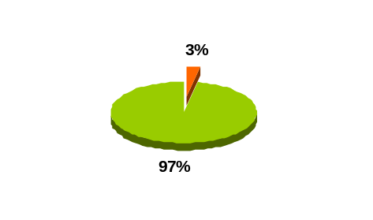
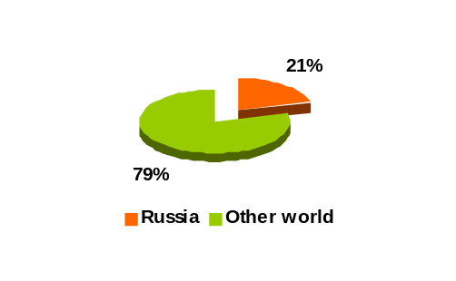
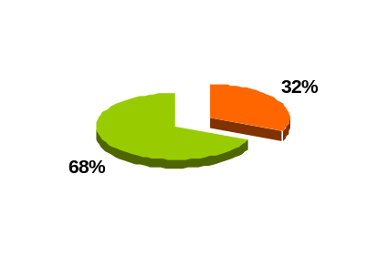
The State has also low revenues from the forest industry because of low level of wood processing, which is characteristic of present-day Russia. The country exports mainly roundwood, leading by export value and far more by quantity (Fig. 7).
Figure 7. Russia’s share of the world’s forest products export by value (left), roundwood export by value (centre), and roundwood export by quantity (right) in 2001 (FAO Bilateral Database – http://www.fao.org)

It means that Russian roundwood is much cheaper than anywhere else. According to the Ministry of Natural Resources of the Russian Federation, only 50% of wood is processed in the country, while the other “forest” countries process from 80% to 100%.

It is well known that export of processed wood is more profitable for national economies. The growth of domestic wood processing will create job vacancies and raise revenues that, in turn, will increase the standard of life in Russia and decrease illegal logging. Illegal logging has not only direct effect, resulting in deforestation and degradation of forest structure, but also indirect effect, decreasing revenues, which are used for forest regeneration and protection.
Pskov Model Forest – a case study

The Pskov Model Forest of 46 000 hectares, located in Strugi Krasnye between St. Petersburg and Pskov, is established to introduce environmentally appropriate, socially beneficial, and economically viable forest management for Russia’s huge forests, which are still state-owned. As the current legislation provides clear cutting and traditions of economically viable thinning are poor, the forest productivity in Russia is one-third to one-forth and income per 1 ha of forest is one-tenth to one-fifteenth as many as in Sweden. This makes it the most urgent problem of the Russian forestry, considering the low output generates poverty of local people engaged in forest activities.

Overall goal
The overall goal of the project is to develop and demonstrate methods of sustainable forest management, using the model area in Pskovskaya Oblast as a pattern. The model of sustainable management of boreal secondary forests with highly intensive use in an area close to the European forest market has been generated and discussed with stakeholders and decision makers. Now the demonstration and education process in the Model Forest is launched.

Project objectives
The main objectives of the Model Forest Project are:
1. To provide economic sustainability of forestry and local communities
2. To involve local communities in forest relations
3. To maintain ecological functions of forest, including biodiversity
4. To make tools of sustainable forest management in the Model Forest

The project initiated by WWF Germany and WWF Russian Programme Office is now more than halfway implemented and the first results are seen. There is a number of demonstration areas established in the forest to show advantages of forest landscape planning. Cutting and reforestation instructions are developed within the project, which are revolutionary new for the country. Wood quality is raised by cutting all aspen and thinning the forest on a regular basis. While clear cutting, a sufficient number of trees are left standing that, along with twigs and brushwood left on ground, favours natural regeneration and wildlife conservation. Hence local biodiversity is maintained without costly planting of seedlings from other ecosystems.

The contemporary stage of the project is the initiation of voluntary forest certification the newly developed Russian FSC standard. Certification implies that production meets high standards of environment conservation and social responsibility. The demand for certified forest products is increasing on environmentally sensitive western markets.

The project aims at involving local population in forest relations through public hearings, scholars excursions, mass media, and workshops in order to raise the public awareness of sustainable forest management and promote modernisation of the federal forest legislation.

The project findings are highly competitive, can be applied in forest planning and management and used by big forest companies. All major stakeholders demonstrate considerable interest in the project findings. The activities attract new stakeholders such as Russian Institute of Advanced Training of Senior Foresters, Swedish National Board of Forestry, corporate sector, including leading wood exporter to Sweden Lemo Concern, IKEA, etc.

Other strengths of the project are as follows:
- GIS-based system of forest conservation planning
- Long-term forest planning system for an intensive forestry model based on statistical approaches, GIS technologies, and optimisation methods
- Ecological and landscape planning system
- Analysis of conditions and factors for changing forest use standards to promote intensive forestry
- GIS-based management system as a final product to a forest user
- Forest dynamics model
- Environmental education and involvement of communities in forest management decision making
- Informational support of the project, including demonstration sites
- Education and dissemination prospects of making educational films on sustainable forest management
- Preparation for FSC certification
http://www.wwf.ru/pskov

RUSSIAN-SWEDISH TRADE OF FOREST PRODUCTS

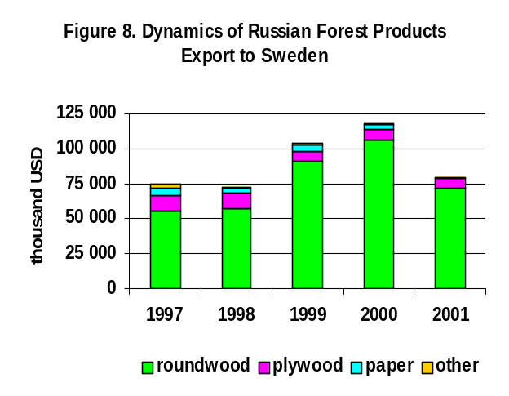
Russian export of forest products to Sweden actively developed in 1997 to 2000, but it decreased due to market fluctuations in 2001, almost to the level of 1997 (Fig. 8). Roundwood has prevailed in the export for all these years (second item – plywood), with the share increased.
75%
80%
88%
90%
90%
We also compared the data on Russian roundwood export to Sweden and Swedish import from Russia for 1998–2001 (Swedish import in 1998 are by the FAO Bilateral Database). It shows that the Russian data of roundwood export to Sweden and Swedish data of roundwood import from Russia are different, with the gap decreasing from 15% to 7% (Fig. 9). The difference is not very high but it is stable. This may point out undeclared Russian roundwood export or poor customs account (possible double contracts).
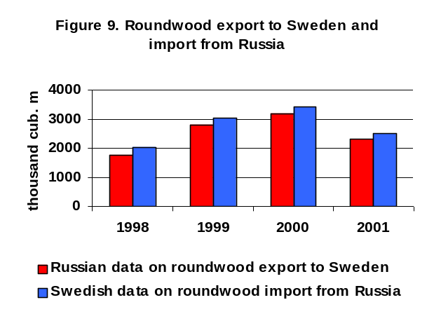
There are maybe also other reasons, for example, different measurement. Thus Finnish experts say that their system of measurement increases the volume of imported roundwood. However the analysis made by the Count Chamber of the Russian Federation in 2001 revealed that foreign customers decreased the volume of roundwood by 13% to 17% due to measurement (5% by admissible error and 8% to 12% by using measurement systems which are not in compliance with Federal Act On Standardisation). The inspection made by the Control and Inspection Department of the President of the Russian Federation in the beginning of 2002 showed similar results – the use of unauthorised measurement methods which did not meet the state standards resulted in decreasing the volume of exported roundwood by 20%. It means the problem is not so easy and cannot be explained only by the difference of measurement systems. One of possible explanations is double contracts shown in the Russian and Swedish customs, while the customs authorities, on the Russian side in particular, do not accurately control volumes of exported wood.

We also compared the structure of the Russian roundwood export (by Russian data) and Swedish roundwood import (by Swedish data) for these four years. As the results are similar, we present here only the data of 2001 (Fig. 10). Hence the Russian “export” was lower than the Swedish “import” by all the positions but spruce. The highest difference concerned pine – 43% and larch (in category other coniferous) – 91%. As Russian export taxes are the same for all conifers, it seems that it indicates illegal logging – companies harvest pine and larch while felling licenses are issued to harvest spruce.
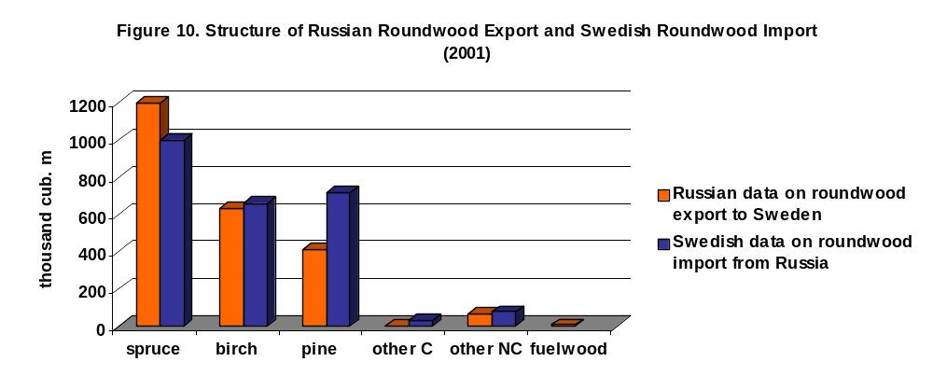
Another interesting point is fuelwood export, which has been declared in Russian customs documents for all these years but in Swedish documents only in 1999 (it made up one twenty-fifth of the Russian fuelwood export declared). The declaration of fuelwood by Russian exporters may be explained by lower export taxes than those of industrial roundwood. On the other hand, Sweden declared chips and particles imported from Russia in 1998–2000, which were not mentioned in the Russian export.

This shows that Sweden may import also illegal wood, this first concerns pine and larch. Even if undeclared and understated wood is legally harvested (that is doubtful), its export is illegal because Russian companies do not pay taxes at all or pay lower taxes for wood exported.

LEADING SWEDISH IMORTERS AND RUSSIAN EXPORTERS

In 2001, top 10 Swedish companies with an import of more than 40 thousand m³ each (Russian data) bought in Russia about 84% of all forest products (Fig. 11).
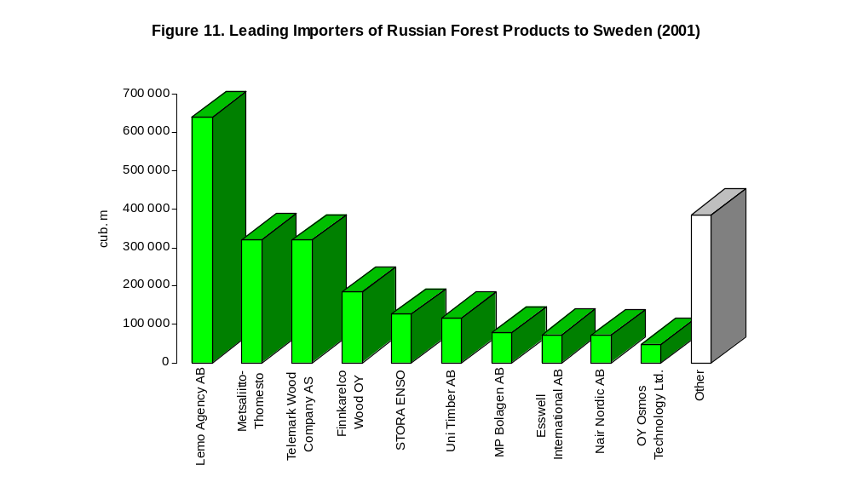 However only five of ten leading roundwood importers of 2001 (Lemo Agency AB, Thomesto, Telemark Wood Company AS, StoraEnso/Stora Skog AB, and MP Bolagen AB) were among leaders for three previous years and eight months of 2002 (Table 2). We show the data of eight month of 2002 in the Table but does not analyse them.
roundwood
16%
28%
14%
13%
8%
5%
3%
2%

Table 2. List of Swedish Leading Roundwood Importers in 1998–2000 and 8 months of 2002
8 months of 2002 | 2000 | 1999 | 1998
Lemo Agency AB | Lemo Agency AB | Lemo Agency AB | Lemo Agency AB
SÖDRA Skogsagarna EK | Thomesto | Modo Skog AB | Telemark Wood Company AS
Metsaliito/Thomesto | Telemark Wood Company AS | Telemark Wood Company AS | Modo Skog AB
StoraEnso | StoraEnso | Thomesto | Thomesto
Esswell International AB | Finn Trading | StoraEnso | Stora Skog AB
Arcadia Marketing Ltd. | Nivida AB | Fagerlid Industrier AB | Fagerlid Industrier AB
Telemark Wood Company AS | Esswell International AB | Russ Wood | Viking Wood Company AS
Nivida AB | Viking Wood Company AS | MP Bolagen AB | Moelven Nor East AS
MP Bolagen AB | OY Osmos Technology Ltd | Moelven Nor East AS | Russ Wood
Finnkarelco Wood OY | MP Bolagen AB | Skarus AB | MP Bolagen AB
Note: Bold – companies which imported roundwood in 2001

Table 2 shows that players in the Russian–Swedish roundwood trade are changeable. Companies come to the Russian market and leave it, as happened with Uni Timber AB, which appeared on the market in 2000, became the sixth importer in 2001 and left the market in 2002 (together with its Russian affiliated company Uniles).

The following 10 Swedish importers of forest products from Russia accounted for about 8%. We just list them in Table 3. All of them imported roundwood. The biggest importer of other forest products in 2001 was Yasmina International Ltd., which purchased plywood (7 713 m³), but it was the tenth leading importing company in the year by value of forest products import.

Table 3. Following Swedish Ten Biggest Importers of Russian Forest Products and Volumes of their Import (in m³)
Wema Holzhandel GmbH | 34 820
Bestland | 33 852
SCA Skog AB | 22 005
Sterigma OY | 21 186
Aranna OY | 18 299
Glicedale Inv. Ltd. | 16 330
Holmen Skog AB | 14 085
Enbuske AB | 12 688
Interwood | 12 267
Orion Traders Ltd. | 10 424

The report does not analyse the environment performance and responsibility of small wood importing companies. However the brief analysis shows that some of them, such as SCA Skog AB and Holmen Skog AB, establish direct links with more transparent and responsible Russian wood producers, e.g. the National Forest Industry Company. Some other importers do not have direct links with such companies and often buy wood without interesting in wood origin. In this case, it is not possible to ensure that exported wood is legal and does not come from high conservation value forests.

One more important point is that Sweden-based importers of Russian roundwood to Sweden account only about one third of the total number of importing companies. The others are registered in Finland, USA, Latvia, Norway and so on, including the Bahamas, Gibraltar, Cyprus.

In 2001, top 10 Russian companies, with an export of more than 52 thousand m³ each, sell to Sweden about 71% of all forest products (Fig. 12). 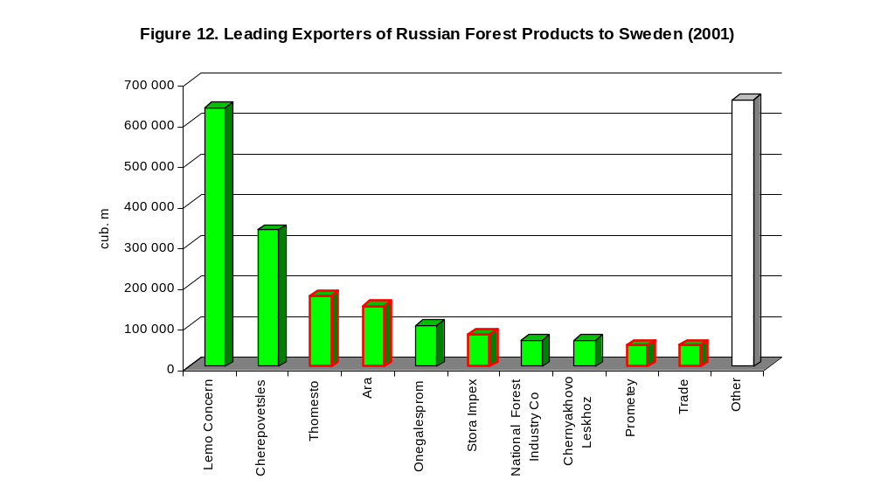
roundwood
14%
7%
6%
3%
2%
27%
29%
– trading agents
4%

Half of them are trading agents. Only five companies deal with harvesting themselves (Lemo Concern, Cherepovetsles, Onegalesprom, National Forest Industry Co., and Chernyakhovo Leskhoz) while selling roundwood of other producers as well.
Both leading Swedish importers and Russian exporters interact with each other.

WOOD SUPPLY CHAINS OF SWEDISH IMPORTING COMPANIES

One of the causes of illegal logging in Russia is the policy of large wood traders. By the assessment of WWF experts, it is a usual practice in Russia when a trading company buys wood from any seller in cash, without asking about the origin of wood. Sometimes this takes place in ports and then such wood is exported. Sometimes small traders buy wood from a private seller, and then resell it to an exporting company.

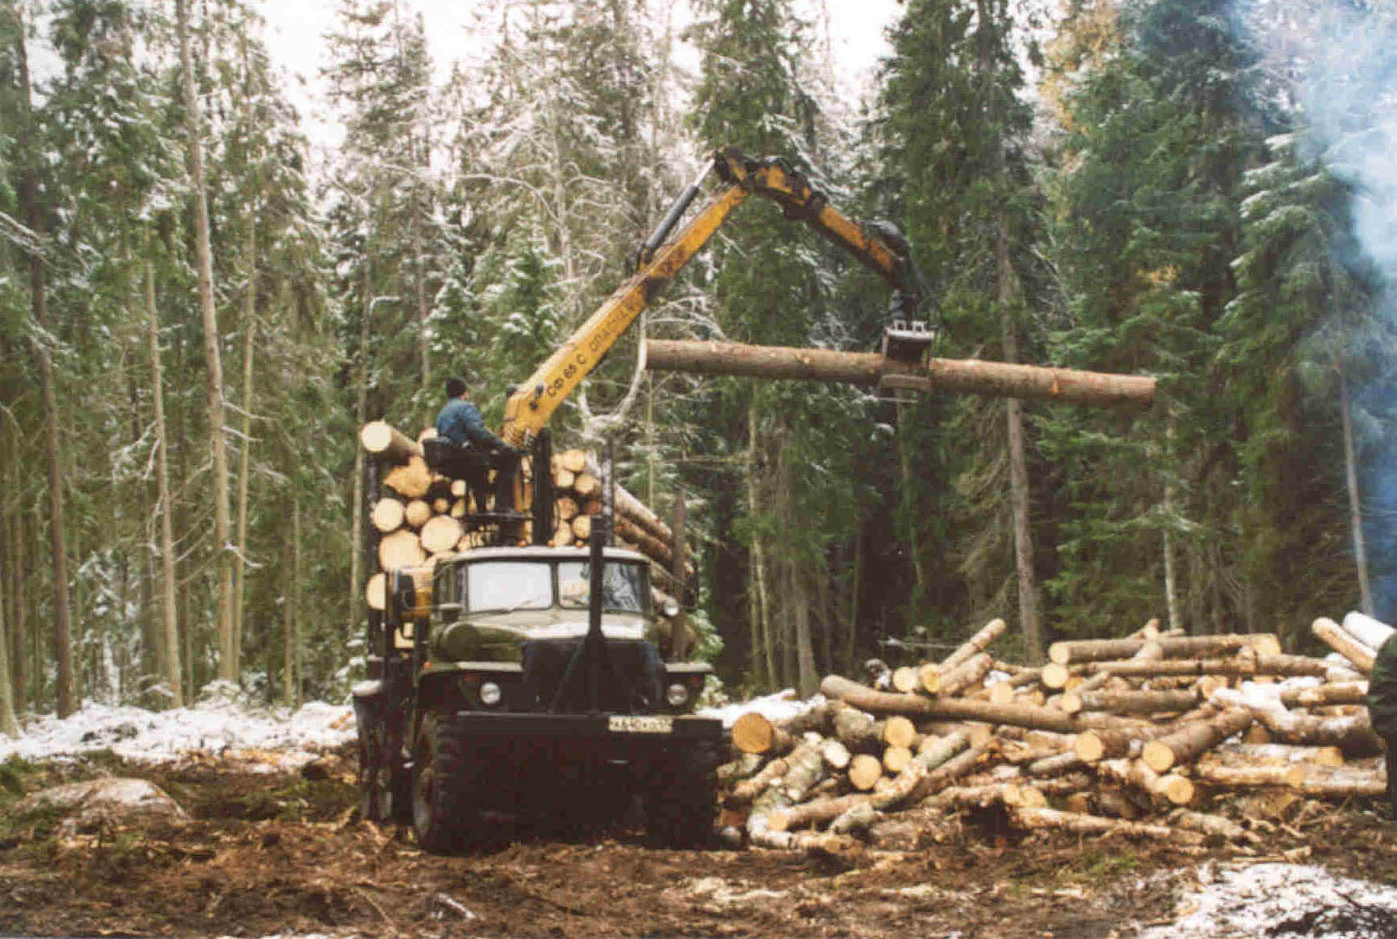
We analysed supply chains of eight Swedish leading importers of forest products operating in northwestern Russia. The analysis was made by the Russian customs data and investigation of WWF experts, including interviewing managers of Russian exporting and Swedish importing companies. Different colours in the figures indicate different companies. The same colour means that companies are affiliated. Percentage shows the share of a company in all products imported by a Swedish party. On the Swedish side, only major buyers of imported products are shown.
© WWF Russia / A. Ptichnikov

MP Bolagen AB was not analysed because it bought wood in Kaliningradskaya Oblast, outside the case study area. The company interacted only with leskhozes, which practised thinning, and it was one of two Swedish companies which imported fuelwood (according to the Russian customs data), not mentioned in the Swedish customs data.

The analysis of wood supply chains of leading importers shows that they have different purchase policies. Better practice is likely shown by Telemark Wood AS, which has only one supplier, a system of tracing wood origin, and interacts with NGOs and other stakeholders in Russia. The company wood supply chain is shown in Fig. 13. It operates only through big holding company Cherepovetsles, which exports products of its affiliated companies and some more logging companies of Vologodskaya Oblast.

Sweden
Telemark Wood AS
Cherepovetsles 100%
Severnyy
Put
Belozerskiy
Lespromkhoz
Belozerskles
Belyy
Ruchey
Vashkinskiy
Lespromkhoz
Belousovoles
Babayevskiy
Lespromkhoz
Vashkinskiy
Leskhoz
SÖDRA

Russia

Figure 13. Wood supply chain of Telemark Wood AS

StoraEnso imports wood of four companies: Ust-Luzskiy Wood-Processing Mill, Stora Impex, which buys wood from StoraEnso’s joint ventures, Progress, and Petrovles, which exports wood harvested by its affiliated companies (Fig. 14).

StoraEnso
Ust-Luzskiy Wood-Processing Mill – 9%
Stora Impex 63%
Progress – 2%
Petrovles – 26%
Petrovles-Podporozhye
Petrovles-Pasha
Petrovles-Lyuban
Petrovles-Volosovo
STF-Strug
STF-Gdov
STF-Kingisepp
Sweden

Russia
Fig 14. Wood supply chain of StoraEnso
The company also buys Russian wood directly in Swedish ports and just all products imported by Finnkarekco Wood Oy. The company has a system of tracing wood origin, interacts with NGOs and other stakeholders. There is no doubt about the origin of wood of its suppliers.

Lemo Agency AB imports wood of its affiliated company Lemo Concern (including Lemo International and Vyborg Wood Terminal) and buys a little bit from Guilead (Fig. 15).

Sweden
Lemo Agency AB
Lemo International 84%
Vyborg Wood Terminal
16%
Guilead – 0.1%
Lemo Les
Forest
Lemo-Forest
?
?
Gatchina Wood Group
Megatex
Dost
Korsnäs
Rörvik Timber AB / Jabo Timber AB

Russia
Figure 15. Wood supply chain of Lemo Agency AB

Lemo International exports wood of Lemo Concern’s logging companies operated in Leningradskaya Oblast. Wood of the Vyborg Wood Terminal, which purchases wood from subcontractors, are not examined enough. The same concerns Guilead but its share is insignificant.

Lemo Agency AB holds workshops for its Russian companies on tracing wood origin and certification. Lemo Concern has declared an ecological policy and made forest pre-assessment. It joined the Association of Environmentally Responsible Timber Producers of Russia.

However, concerning the affiliated company Vyborg Wood Terminal, Director General of the Group A. Benin said that it purchased a large number of roundwood from third companies and could not ensure the origin of such wood.

Metsaliitto Osuuskunta Company and Thomesto Sverige AB together hold the second place in the Russian forest products export to Sweden (Fig. 16).

The share of Thomesto Sverige AB is dominant – 79%. The company purchases wood from two Thomesto’s companies in Russia (Thomesto Terminal and Thomesto Vologda) and four more companies. Thomesto Vologda exports wood of two known enterprises and a small company established in 2001 (Energuiya) of which we are unaware. However Thomesto Terminal buys wood from trading agents and by spot contracts, which are difficult to check. Some of this wood may be of doubtful origin. Three more suppliers (National Timber Industrial Company, Kipelovo Forestry Enterprise, Petrovles) are well known and deal with logging themselves. One more supplier – Lenles – is a trading agent but exports wood of a big logging company (Belyy Ruchey).
Sweden
Thomesto
Terminal – 74%
Petrovles – 6%
Petrovles-Pasha
Petrovles-Volosovo
Petrovles-Luban
Spot contracts
Thomesto
Vologda – 2%
Andomskiy Lespromkhoz
Petrovles-Podporozhye
Kirillovskiy Leskhoz
Energuiya
Kipelovo Forestry Enterprise – 3%
Lenles – 6%
National Timber Industry Co – 9%
Belyy Ruchey
Kirillovskiy Lespromkhoz
Kovzhinskiy Lespromkhoz

Metsaliitto
Thomesto
Sverige AB
Onegalesprom 100%
?

Russia

Figure 16. Wood supply chains of Metsaliitto Osuuskunta Company and Thomesto Sverige AB

In 2001, Thomesto was bought by Metsaliitto. This positively changed the ecological policy of Thomesto Terminal – main supplier of Thomesto Sverige AB. A new ecological officer of the company began to introduce a system of tracing wood origin.

Nair Nordic AB has the same number of supplier as Thomesto Sverige AB (Fig. 17).
Nair Nordic AB
Peterburgles 28%
Petrovles – 4%
?
Arvid – 2%
Cherepovetsles 22%
Onegalesprom 18%
Progress – 26%
Andomskiy Lespromkhoz
Belozerskiy Lespromkhoz
Belousovoles
Snip
Petrovles-Pasha
Petrovles-Podporozhye
Belyy Ruchey

Sweden

Russia
Figure 17. Wood supply chain of Nair Nordic AB

Most of them are logging companies which are also suppliers of other big Swedish importers. However it buys wood from two trading agents with unknown subcontractors.

Finnkarelco Wood OY has only two suppliers (Stalkon and Ara – fourth Russian exporter to Sweden) but they both are also trading agents (Fig. 18).
Finnkarelco Wood OY
Stalkon – 18%
Ara – 82%
?
?
StoraEnso

Sweden

Russia

Figure 18. Wood supply chain of Finnkarelco Wood OY

Finnkarelco Wood OY is a non-transparent company. There is no information about it in mass media, telephone directories, and in the Internet. All wood imported by Finnkarelco Wood OY to Sweden is bought by StoraEnso. The latter informed WWF RPO that the StoraEnso International Wood Procurement made an audit of the supply chain and wood origin of Finnkarelco Wood OY. However neither Russian nor Swedish public and NGOs are aware of this audit. It seems that the company cannot ensure the origin of wood. In 2002, the share of Finnkarelco Wood OY in the roundwood import to Sweden considerably decreased (to 2.5%) and the company left the top ten.

Uni Timber AB has the most number of suppliers with the most complex wood supply chain (with sub-subcontractors) among all the leading importing companies (Fig. 19).
Uni Timber AB
Private exporter 2 7%
Onegalesprom – 8%
?
?
Ecoles – 3%
Private exporter 1 16%
Zeta – 25%
Trade – 37%
Severlesprom
Kipelovo Forestry Enterprise
Udmurtgeology
Svir
Andomskiy Lespromkhoz
Food Enterprise No. 15
Vytegorskiy Lespromkhoz
Spot contracts
Petroexportles 2%
Guilead – 2%
?
?

Sweden

Russia
Figure 19. Wood supply chain of Uni Timber AB

However the problem is not in the number of suppliers but in the complexity of the chain and prevalence of non-transparent trading agents with “strange” subcontractors (geology and food enterprises!?) and unknown producers. Such a supply chain needs an effective tracing system to ensure the legality of wood origin. Otherwise one is always doubtful about sources of wood, considering a lack of information about suppliers, their subcontractors, and wood producers.

In 2002, the company stopped import of roundwood from Russia, directly and through its Russian affiliated company Uniles (operated in 2001).

Esswell International AB and OY Osmos Technology Ltd. have the similar supply chains (Fig. 20). The former is a trading company, which sells most of its wood imported from Russia to OY Osmos Technology Ltd. and also to one Ireland-based company.

Sweden
Esswell International AB
Brig – 5%
8%
62%
?
?
SEV – 38%
Alf+ – 5%
Velo Trade – 13%
Prometey – 69%
OY Osmos Technology Ltd.
?
?
?
Gatefort Alliance
?
Severles

Russia

Figure 20. Wood supply chains of Esswell International AB and OY Osmos Technology Ltd.

The supply chains of these companies are much simpler than that of Uni Timber AB but with only trading agents of mainly of one or two years old. The only “long-term” company is Brig registered in Kalmykiya (southern steppe Russia) with no forest at all. There is no information about these traders and their subcontractors. To operate with such supply chain and ensure the legality of wood origin need an effective tracing system, but it is difficult to establish it because of suppliers short life. Even relations with “long-term” Brig were established in 2000. Certainly, the companies quickly increase their business in Russia that demands more sources of wood, but they changed all their suppliers for two years and new suppliers seems not to be more reliable.

By the analysis of supply chains we classified Swedish importers into four groups:
- A company has one or a limited number of suppliers and a system of tracing wood origin – Telemark Wood Company AS, StoraEnso (with some reservations)
- A company has a number of suppliers and a system of tracing wood origin, but some trading agents among suppliers are non-transparent, so an effective control of their operations is required – Lemo Agency AB and Metsaliitto/Thomesto
- A company has several suppliers, both logging and trading companies, but has no system of tracing wood origin, some suppliers are non-transparent with unknown subcontractors – Nair Nordic AB
- A company has a non-transparent supply chain with only or prevailing trading agents with unknown subcontractors and no system of tracing wood origin – Finnkarelco Wood OY, Uni Timber AB, Esswell International AB, and OY Osmos Technology Ltd.

ASSESSMENT OF RESPONSIBILITY OF ROUNDWOOD IMPORTERS

WWF experts assessed the responsibility of Swedish importers of roundwood based on direct interviews of the companies listed below, data of the State Customs Committee of the Russian Federation, information in the Internet, and expert judgement (Table 4).

Table 4. Responsibility Rating of Leading Swedish Roundwood Importing Companies
* Company’s agent in Russia Lemo International was interviewed
Rating  characteristics  Companies | Company does not purchase wood in doubtful sources | Company purchases wood by clear contracts | Company collaborates with environmental NGOs, has a website, and makes an audit | Company has a documented policy of suppliers selection | Company does not use wood from HCVF | Company has trained environment personnel and makes open reports | Logging and/or customs violations of suppliers | Responsibility rating
Lemo Agency AB* | 2 | 1 | 1¹ | 1 | 1² | 1 | 1 | 8
Metsaliitto/Thomesto | 1³ | 1³ | 1³ | 1³ | 1³ | 1⁴ | 0 | 6
Telemark Wood Company AS | 3 | 1⁵ | 1 | 2⁶ | 1⁷ | 1⁸ | 0 | 9
Finnkarelco Wood OY | 1⁹ | 0¹⁰ | 0 | 0 | 1 | 0 | 1 | 3
Uni Timber AB | The company stopped operating in Russia in 2002
StoraEnso | 2¹¹ | 2 | 1 | 1¹² | 1¹² | 2 | 0 | 9
Esswell International AB | 0¹³ | 0¹⁴ | 1¹⁵ | 0 | 1¹⁶ | 0 | 1 | 3
Nair Nordic AB | 1¹⁷ | 0¹⁸ | 1 | 1 | 0 | 0 | 0 | 3
OY Osmos Technology Ltd.** | 0 | 0 | 0 | 0 | 0 | 0 | 1 | 1
** Only by WWF experts

Decision making base for the responsibility rating
Company does not purchase wood from doubtful sources (source: WWF survey)
3 – Company purchases all wood only from reliable logging or trading companies
2 – Company purchases the most of wood from reliable logging or trading companies but some wood is bought from doubtful sources
1 – Company purchases the most of wood from doubtful sources
0 – Company purchases all wood from doubtful sources

Company purchases wood by contracts with clear requirements for legality and ecology (source: WWF survey)
2 – Company purchases all wood only by contracts with clear requirements for legality and ecology

1 – Company purchases the most of wood by contracts with clear requirements for legality and ecology but some wood is bought by contracts without such requirements

0 – Company purchases all or the most of wood by contracts without requirements for legality and ecology
Company collaborates with environmental NGOs, has a website indicating the procurement areas, and makes an external audit of the procurement areas (source: WWF survey, Internet)
2 – Company fulfils all these requirements
1 – Company fulfils only some of these requirements
0 – Company does not fulfil these requirements
Company has a documented policy of suppliers selection and successfully implements it (source: WWF survey)
2 – Company completely fulfils this requirement
1 – Company partially fulfils this requirement
0 – Company has no such policy
Company does not use wood from high conservation value forests (source: WWF survey, Internet, local media screening)
2 – Company has a system to confirm that wood is not harvested in high conservation value forests
1 – Company has elements of a system to confirm that wood is not harvested in high conservation value forests
0 – Company has no system to confirm that wood is not harvested in high conservation value forests
Company has trained environment personnel and makes open annual environment reports (source: WWF survey, Internet)
2 – Company fulfils these requirements
1 – Company partially fulfils these requirements
0 – Company does not fulfil these requirements
Logging and/or customs violations of suppliers (source: customs information, expert assessment)
1 – Logging and/or customs violations are unknown
0 – Logging and/or customs violations are found

In case the scores made by the companies themselves and WWF experts are different, we use the experts’ scores and explain their decisions (see below).

¹ The score is lower because the company has no external audit of the procurement areas.
² The score is lower because the company purchases also wood logged by third companies but has no system of tracing wood origin, so cannot completely exclude wood from high conservation value forests.
³ The score is lower because the company began to work with the suppliers only from May 2002 but it is impossible to change the situation completely for such a short period although the progress is obvious.
⁴ The score is lower because the company does not begin to prepare an open annual environment report although it has a new skilled environment officer.
⁵ The score is lower because the company has no clear requirements for wood legality and ecology in contracts.
⁶ The score is higher because the company presented to WWF materials confirming it had a documented policy of supplier selection and successfully implements it.
⁷ The score is lower because the company has only elements of a system to confirm that wood is not harvested in high conservation value forests.
⁸ The score is higher because the company does not make open annual environment reports but it has skilled environment personnel.
⁹ The score is lower because WWF considers that the company’s suppliers cannot ensure the legal origin of all wood they buy from subcontractors.
¹⁰ The score is lower because WWF has no evidence that the requirement is met.
¹¹ The score is lower because the company buys wood from Finnkarelco Wood OY, which is not an absolutely reliable supplier.
¹² The score is lower because the requirement is not fully met (see 11).
¹³ The score is lower because the company has no mechanism to ensure that wood is not from doubtful sources and all its suppliers are “doubtful” trading agents.
¹⁴ The score is lower because the company has no contracts with clear requirement for wood legality and ecology.
¹⁵ The score is higher because the company has begun to collaborate with environmental NGOs.
¹⁶ The score is lower because the company no mechanism to ensure that wood is not from high conservation value forests.
¹⁷ The score is lower because the company has no mechanism to ensure that wood is not from doubtful sources.
¹⁸ The score is lower because WWF has no evidence that the requirement is met.

The expert assessment shows that the level of responsibility in the Russian-Swedish roundwood trade differs much (Figure 21). The leaders – Telemark Wood Company AS and StoraEnso have a higher level of responsibility. However, as mentioned above, StoraEnso buys all roundwood imported to Sweden by Finnkarelco Wood OY, which cannot be considered a fully responsible company. We recommend StoraEnso to pay more attention to this supplier. The final score of Lemo Agency AB is 7, less than in Table 8. The reason is that the company buys roundwood mostly from two Russian exporters – Lemo International and Vyborg Wood Terminal. If the former demonstrates rather responsible practice, the latter is likely a non-transparent trader which buys wood from various companies and private exporters without interesting in wood origin. As its share is 16%, we decreased the final score of Lemo Agency AB by this figure. We recommend the company to pay more attention to this exporter and introduce a system of tracing wood origin for the exporter’s subcontractors.
Threshold of responsible business

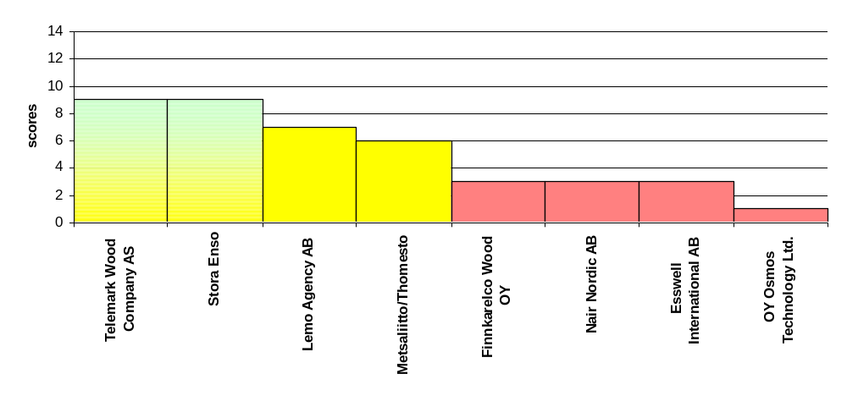Figure 21. Company’s Level of Responsibility

Five companies – Finnkarelco Wood OY, Nair Nordic AB, Esswell International AB, OY Osmos Technology Ltd., and Uni Timber AB – show basically non-transparent approach to roundwood trade, with low transparency, a number of doubtful subcontractors, and likely purchase of illegally harvested wood and maybe wood from high conservation value forests. These companies must change their usual practice and begin responsible wood procurement. Immediate measures are required to improve environmental parameters of their trade. Thomesto shows obvious progress in responsible attitude to environment, after being bought by Metsaliitto, but still much should be done to improve the previous practice. The company may be considered in transition.

WWF Russia proposes to apply traffic light system to help responsible buyers to select reliable partners for wood supply. Such a system is not new. It is widely used by some
well-known companies, such as Tetra Pack AB, for selecting reliable suppliers. Hence green light means that a wood supplier fulfils basic requirements for responsible timber trade. WWF recommends to have business with such a company if it continues to implement responsible practice. Yellow light means that a wood supplier is transparent enough, implements some requirements for responsible wood trade. WWF recommends for responsible buyers to continue business (but not establish the new one) with such a company if it improves its wood procurement system and is audited by a third party. Red light means that a company is not transparent and does not have adequate wood procurement policy. WWF recommends for responsible buyers to have no business with such a company until it develops and implements an ecological policy and establishes an effective system of tracing wood origin.

For all wood importers we recommend to use the web-site: www.ruswoodorigin.ru to obtain information about transparency and environment responsibility of Russian wood suppliers.

CONCLUSION

Based on the report WWF claims for:

Public procurement:
The countries should adopt public procurement policies requiring wood and forest products sourced from legal and well managed forests. Independent third party chain of custody certification and forest management certification, such as the Forest Stewardship Council (FSC), should serve as the central means of verification

Trade agreement:
Russia and Sweden should pursue an agreement specifying that these governments ensure wood and forest products they export derive from legal and sustainable sources (e.g. the agreement between the United Kingdom and Indonesia)

Technical support and aid:
Russia and Sweden should provide technical support and aid to assist in improving forest management. Support should include capacity building and ensuring investment flows are not environmentally damaging

Corporate sector:
Private sector, principally forest managers, retailers, the forest products industry and financial institutions should commit to the following actions:
- Join the Global Forest and Trade Network and sign up to their charter – a corporate charter for responsible forestry,
- Investment screens – financial institutions agree to the adoption of transparent forest policy as part of the investment screening process to ensure investments support responsible forestry (legal and sustainable)

The GFTN currently consists of 19 local Forest and Trade Networks active in nearly 30 countries, mainly in Europe and North America. There are also networks in Japan and East Asia open to members in Hong Kong, China and South Korea. More than 800 companies are members of the GFTN, including forest owners, timber processors, construction companies, retailers, investment agencies and local authorities. Members are committed to gradually producing, trading and/or sourcing independently certified forest products.

The Association of Environmentally Responsible Timber Producers of Russia is the newest member of the WWF Global Forest and Trade Network (GFTN). It was established in 2000 to assist Russian timber producers improve forest management standards and achieve independent certification. Members of the Association must sign up to the Association's ecological policy principles (see below). Non-certified members of the Association are required to demonstrate legal origin for their timber prior to joining. In addition, members are regularly monitored by independent auditors to ensure they make clear, sustained progress towards certification within a defined time period. In return the Association provides a range of benefits, including information and training on certification, and links to foreign markets. The Secretary of the Association can provide foreign buyers with credible information on members, enabling them to purchase from producers who can demonstrate legality of timber origin and clear progress towards certification.

Public – private partnership: opportunity for agreements between both sectors
- Implementation of chain-of-custody methodologies, such as wood tracing
- Producers groups support to satisfy procurement policies

Adherence to sustainable development of business is an essential requirement for the management of a present-day company. Sustainable development at the contemporary conditions means that the balance between economic, environmental, and social aspects of business in the broad sense of these terms is achieved and sustained. Hence ecological management is a fundamental part of the development of any company.

Ecological policy is a basic requirement for any certification system, such as ISO14001, FSC or similar. The stepwise implementation of ecological policy will finally lead to the certification of the whole area of forest management and wood procurement. The transparency and progress in ecological policy verified by a third party provide companies with the necessary recognition of consumers, governmental and non-governmental organisations. The credibility of ecological policy is based on the development and assessment made by a company in cooperation with the world's leading environmental organisations, such as WWF, Greenpeace, Friends of the Earth.

The Principles of Ecological policy are developed by WWF Russian Programme Office based on “Principles of Responsible Trade of Russian Timber" recently endorsed by key environment NGO's, such as Greenpeace, WWF, IUCN and others. The Principles are in compliance with the world's experience. They are tested in Russia by several wood importing companies in their day-to-day operations, FSC certifications and in the WWF Model Forests located in the Republic of Komi and Pskovskaya Oblast. The implementation of ecological policy means that a company recognises problems of the Russian Forest sector, has an adequate policy to tackle them, meets the requirements of responsible wood trade, and verifies it by an independent audit.

Principles of Ecological Policy

Principle 1. All wood used by the company is legally harvested or the legality of origin is monitored and beyond a doubt

1.1 The company has a transparent wood supply policy
Wood supply policy includes:
- Ceasing the purchase of wood in cash, without relevant documents, and from doubtful suppliers
- Purchasing wood by contracts with clear requirements for origin legality and ecology
- Transparent wood tracing procedure and the company’s readiness to verify it

1.2 The network of suppliers is optimised in accordance with the supply requirements of responsible forest management
Optimisation of the supply network includes:
- Careful selection of wood suppliers in order to influence the quality of their forest management
- The number of suppliers is balanced with the company’s capacity to check them qualitatively
- Purchasing wood at trading agents which have, in turn, a transparent system of tracing wood origin

1.3 Mechanisms of monitoring suppliers are implemented
Wood origin monitoring mechanisms consist of:
- There is an internal system of monitoring wood supply, including a cutting area inspection procedure
- Verifying the internal monitoring system by a third party

Principle 2. The company does not use wood from protected areas and supports the protection of high conservation value forests

2.1 The company is aware of restrictions of the forest use regime and roundwood procurement and accurately meets them
- The company does not use wood from protected areas, except such felling (main cutting) is legally allowed
- The company does not use wood from the following categories of protection forests of Group I where commercial (main) cutting is prohibited: spawning-ground protection zones of valuable fish species, valuable forest sites, reserved forest sites, subtundra forests
- The company does not use and project to utilise wood from areas which are included in the prospected list of new protected areas and special protection sites endorsed by the Government of the Russian Federation or regional Administrations
- The company does not use wood from large intact forests until interested parties arrive at a mutually acceptable social, economic, and environmental solution to conserve or use of them

2.2 The company supports the identification and protection of high conservation values forests in leased areas
- If a region of the Russian Federation has no justified maps of high conservation value forests, the company initiates their identification or actively supports it
- The level of protection and use of leased forests is in compliance with their conservation value
- Basic biotopes and ecologically significant sites are identified in each cutting area when granting, marked in management plans and flow charts

Principle 3. The company operates in compliance with the principles of inexhaustible forest management (applicable only for leaseholders)

3.1 The harvesting practice of the company does not exhaust forest resources in leased areas in the long term

- The company has and implements a programme of inexhaustible forest management

Principle 4. Company’s trained personnel ensures the transparency of ecological policy

4.1 The company ensures that the implementation of ecological policy is transparent
- The company ensures that its economic activities regarding the implementation of ecological policy are transparent
- The company promotes its ecological policy
- The company makes publicly available annual reports, preferably made by a third party

4.2 The personnel is trained to implement ecological policy
- The company has an environment director (top manager) responsible for the ecological policy of forest use and procurement
- The company has an item of expenses in the budget to implement the ecological policy
- The personnel is trained for implementing ecological policy

© 1986, WWF–World Wide Fund For Nature (Formerly World Wildlife Fund) ® WWF Registered Trademark owner
WWF Russia
109240, Moscow
Nikoloyamskaya ul. 19, bld.3
Tel.: +7 095 727 0939
Fax: +7 095 727 0938
With several million supporters and a network of offices in more than 90 countries on five continents, WWF is one of the world’s largest independent conservation organizations.

WWF’s mission is to stop degradation of the planet’s natural environment and to build a future in which humans live in a harmony with nature, by:
- Conserving the world’s biological diversity
- Ensuring that the use of renewable natural resources is sustainable
- Promoting the reduction of pollution and wasteful consumption

Let’s leave our children a leaving planet!

WWF works with large companies exporting timber from Russia as well as with other big companies that consume large amount of timber to make their activity more transparent with the aim to stop illegal logging.

