
MESOAMERICAN REEF
STRATEGIC PLAN
2005-2009

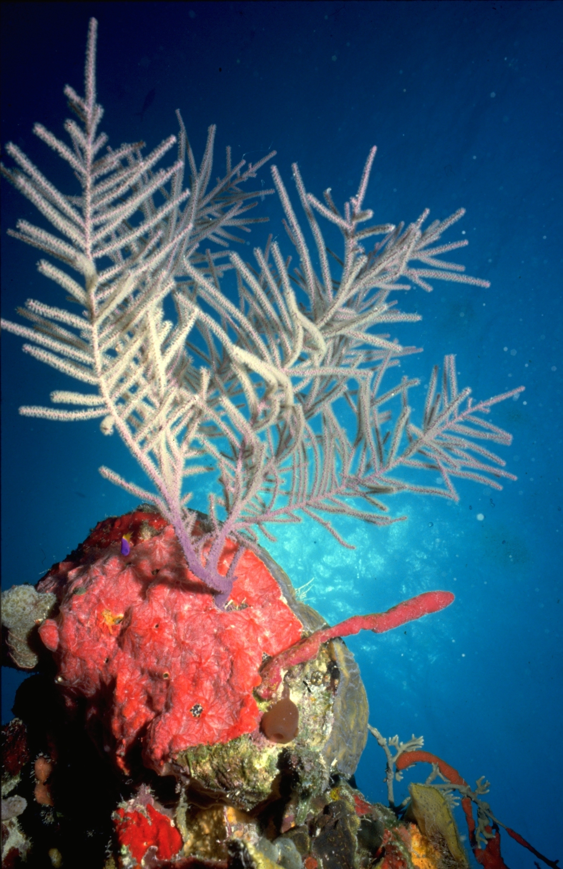
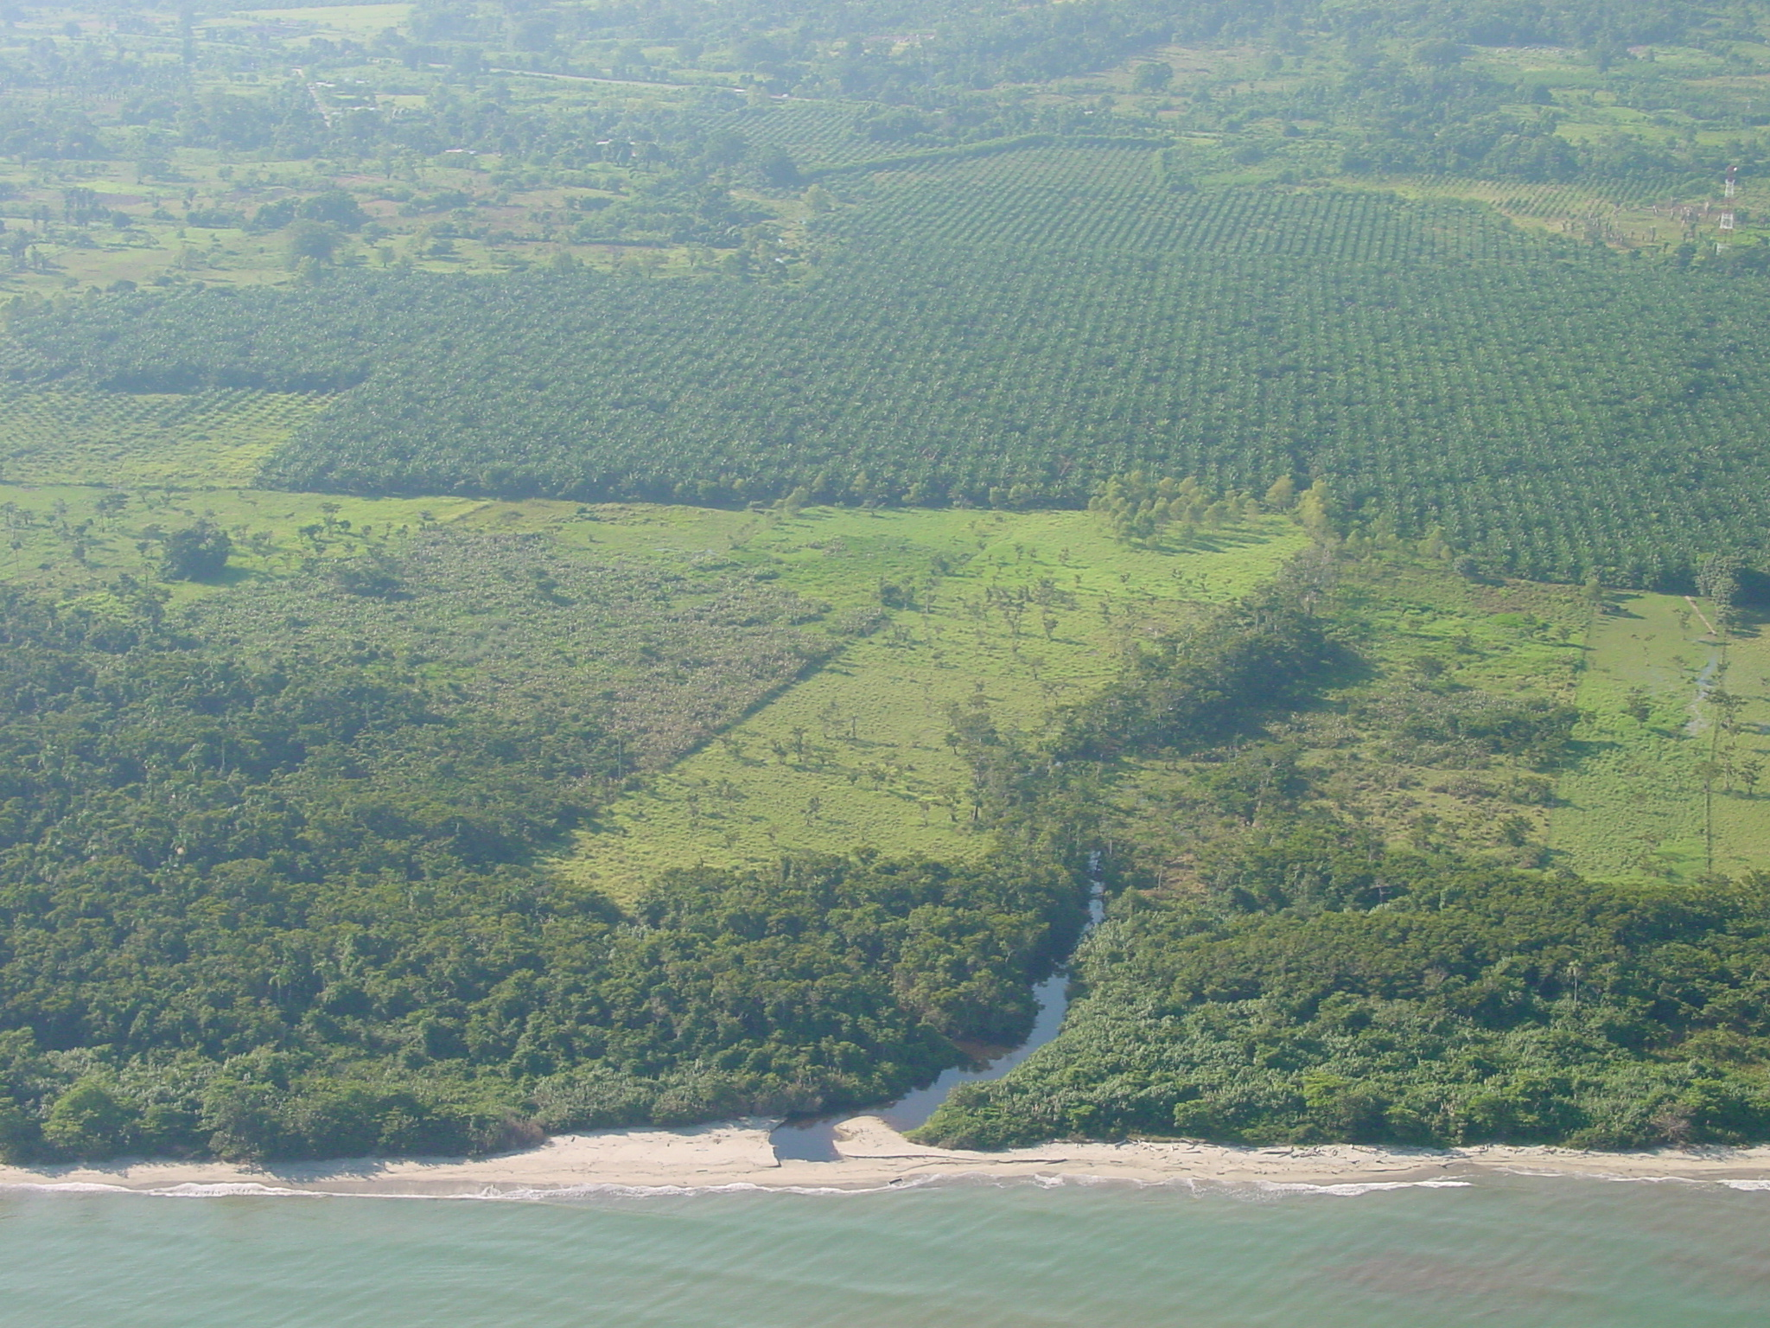
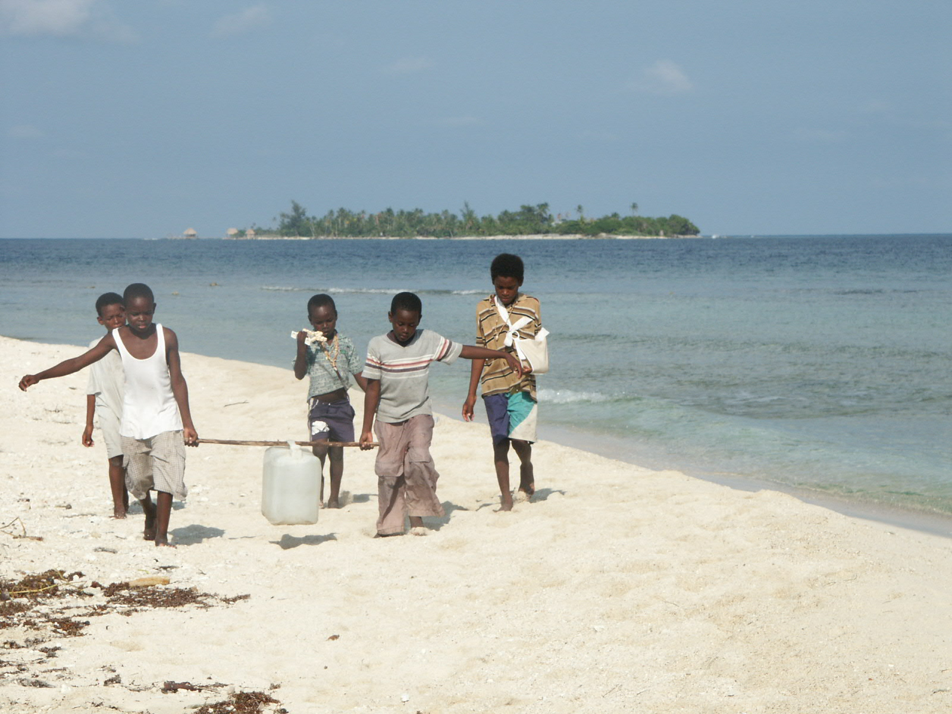

November 2004

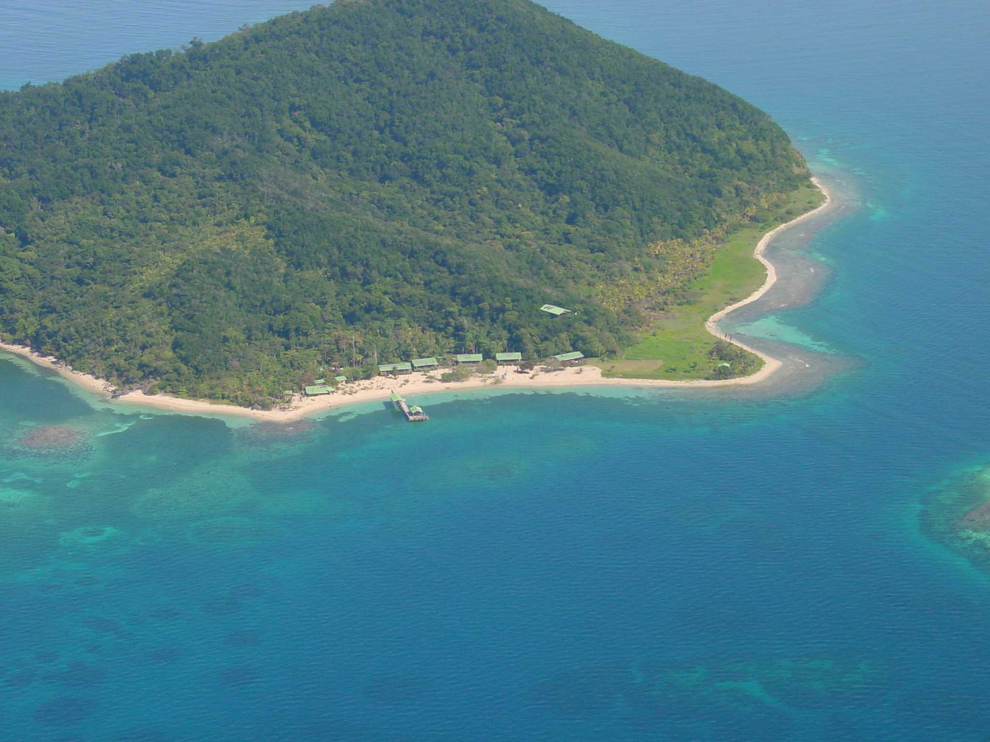
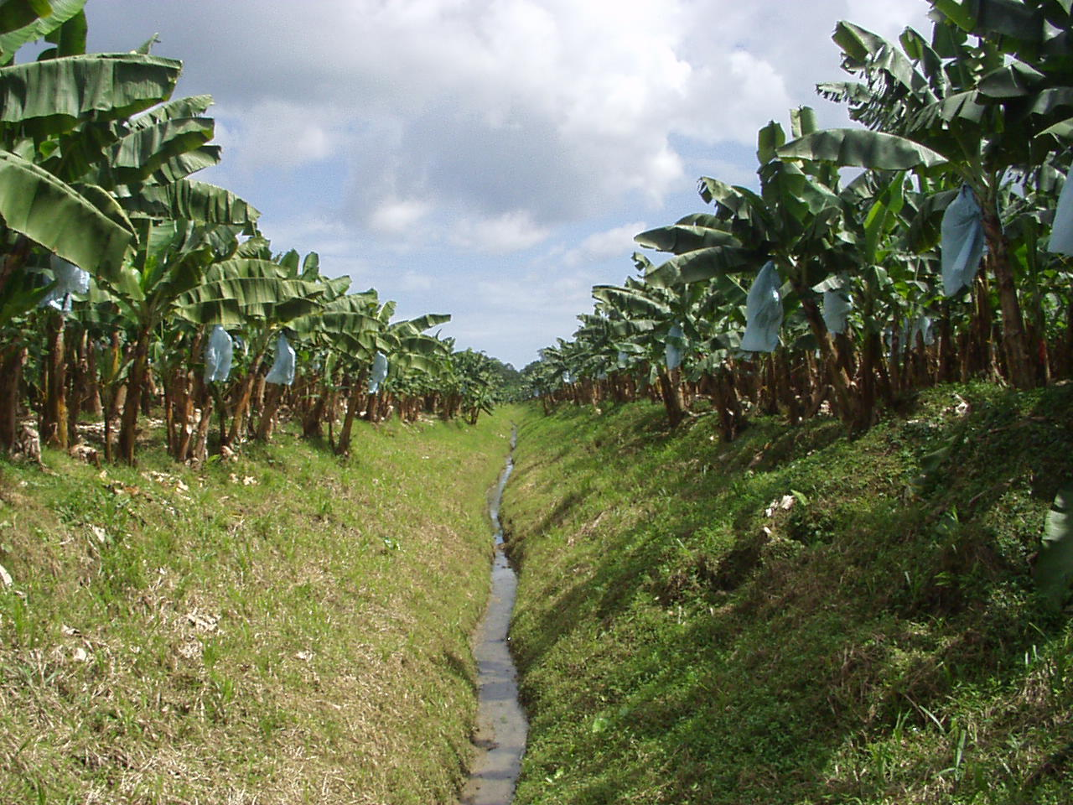
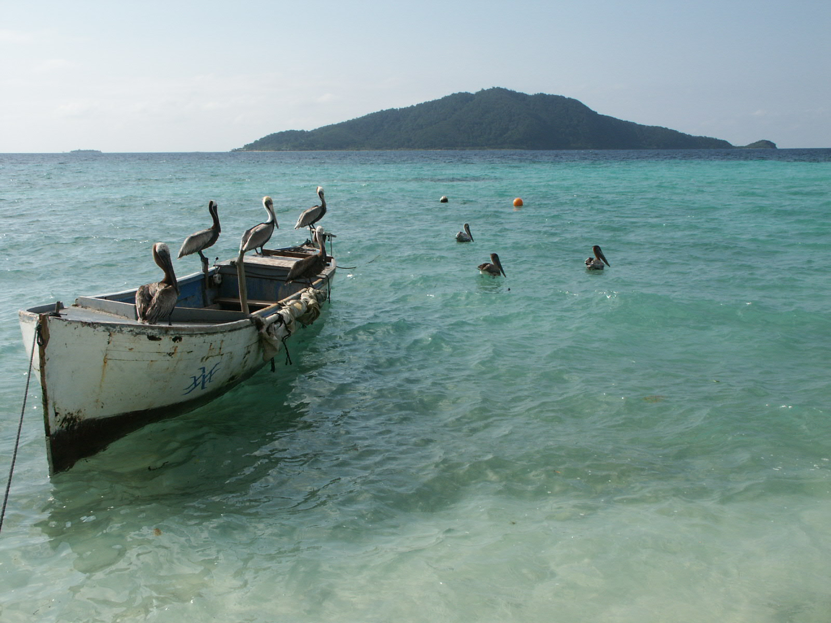

The MAR Strategic Plan has been developed by the WWF MAR team with technical assistance of Foundations of Success (FOS).

WWF team:
- Sylvia Marín, Central America Regional Representative
- Melanie McField, Senior Scientist, Belize
- José Vásquez, Agriculture Senior Program Officer, Honduras
- Alvaro Hernández, Fisheries Senior Program Officer, Mexico
- Sandra Andraka, Species Program Officer, Costa Rica
- Ana Isabel Estrada, Executive Assistant, Costa Rica

- Kate Newman, Director Marine Ecoregions, Endangered Spaces, USA
- Miguel Jorge, Marine Coordinator, LAC Secretariat, USA
- Lauren Spurrier, Deputy Marine Coordinator, LAC Secretariat, USA

FOS team:
- Marcia Brown, Washington, D.C.
- Richard Margoluis, Washington, D.C.

Reviewers:
- Miguel Jorge, Marine Coordinator, LAC Secretariat, USA
- Guillermo Castilleja, VP LAC Secretariat, USA
- Carlos Saavedra, Executive Director, Summit Foundation, USA

Table of Contents

 | Summary | 1
I. | Context | 7
II. | Achieving Conservation in the MAR | 11
III. | Our Strategies  - Reduce the Impacts of Pollution from Commercial Agriculture and Other Sources.  - Reduce the Impacts of Unsustainable Commercial Fishing  - Enhance the System of Protected Areas | 15
IV. | Measuring our Success in the MAR | 36
V. | Appendices  - Workplan and monitoring plans for Pollution from Commercial Agriculture.  - Workplan and monitoring plans for Commercial Fishing.  - Workplan and monitoring plans for the System of Coastal and Marine Protected Areas. | 41

Accronyms

BMPs | Better Management Practices
CCAD | Central American Commission for Environment and Development
CI | Conservation International
GEF | Global Environment Facility
ICRAN | International Coral Reef Action Network
MAR | Meso-American Reef
M&E | Monitoring and Evaluation
MBRS | Mesoamerican Barrier Reef System
MCPAs | Marine and Coastal Protected Areas
MPA | Marine Protected Area
TNC | The Nature Conservancy
USAID | United States Agency for International Development
WCS | Wildlife Conservation Society
WWF | World Wildlife Fund

Summary

WWF is reassessing its strategic focus for the MesoAmerican Reef (MAR). Other key partners are undertaking similar exercises and new collaborators are also now working in the MAR. This affords both the opportunity to a) refocus our actions on threats that we have a comparative advantage to address, and b) join forces and divide labor with other groups in an effort to generate the greatest collective impact for conservation of the MAR. The development of this updated strategic plan is a critical first step in that process. It is based on WWF’s most up-to-date analysis of the MAR’s conservation status and threats, and represents ambitious, realistic and measurable results which we believe WWF is poised to achieve. It is also the starting-point for agreeing with other institutions on a broader shared strategy to conserve the MAR.

Analysis of present situation
The identification of priority actions in the MAR started with a detailed analysis of cause and effect relationships between natural resources in the ecoregion, threats from human and “natural” sources, and the root causes of these threats. This analysis allowed us to identify key factors affecting the health of the MAR ecosystems and key leverage points to change the current situation.

This analysis clearly shows that the major threats affecting species, habitats and ecological processes in the MAR include i) habitat destruction, ii) pollution, and iii) overfishing. The drivers of these threats include: iv) coastal development, v) commercial agriculture, and vi) deforestation. The root causes include among others: a) growing local and international demand for natural resources, b) unplanned and rapid tourism development, c) immigration and population growth, and d) inadequate policies and weak enforcement of existing regulations.

The MAR team then ranked major threats according to urgency, extent of area affected, WWF niche, and opportunity to act. The result is a prioritization of threats – found in the following table – that has guided the strategic plan. Note that according to the “Total Score”, there seemed to be a natural division in significance between the top three and the bottom three ranked threats.

Prioritization of Threats to the MAR
 | Urgency | Area | WWF Niche | Opportunity to Act | Total  score | Ranking
Commercial Agriculture | 5 | 4 | 6 | 6 | 21 | 1
Commercial Fishing | 4 | 6 | 5 | 5 | 20 | 2
Coastal Development | 6 | 3 | 4 | 4 | 17 | 3
Sewage & Nutrients | 3 | 5 | 1 | 2 | 11 | 4
Tourism | 2 | 2 | 3 | 3 | 10 | 5
Maritime Transport | 1 | 1 | 2 | 1 | 5 | 6

MAR Goal, strategies and objectives
The purpose of the MAR Strategic Plan is to help WWF articulate a clear vision and path towards achieving the long-term conservation of the MAR ecoregion. All the threats facing the MAR go beyond the capacity of any one conservation organization to address directly.

MAR Goal: To enhance the health of the Mesoamerican Reef's diverse ecosystems, providing sustainable livelihoods for local people, while preserving one of the world’s great natural treasures.

Achieving long-term conservation of the ecoregion requires the concerted and coordinated effort of governments and the private sector as well as conservation organizations and donors. This fact is addressed in our strategic plan, which focuses foremost on those threats that WWF has the capability to address immediately and those for which we see the greatest probability of successful results. Programmatic strategies are designed to achieve measurable objectives, and articulate selected interventions linked to key factors –or causes– that generate threats and thus affect the long-term conservation of the MAR ecoregion. This plan therefore focuses on the following three priority strategies:

- Reduce the Impacts of Pollution from Commercial Agriculture and Other Sources;
- Reduce the Impacts of Unsustainable Commercial Fishing; and
- Enhance the System of Marine and Coastal Protected Areas.

These three priority strategies are clearly interrelated, since sustainable fishing practices are critical for maintaining viable marine protected areas, and effectively managed coastal and marine protected areas are key to protect important fish populations. Moreover, protected areas are fundamental for the conservation of representative habitats that would otherwise be damaged and fragmented by unplanned coastal development. Finally, the conservation and sustainable resource use strategies in the coastal and marine environment are insufficient if we do not address the threat of coastal water pollution due to land-based activities. We may build a strong protected areas network, but if this network is embedded in polluted water, we will not be able to achieve our ultimate conservation goal in the MAR.

The following table summarizes WWF’s three key strategies and expected outcomes in the MAR.

Expected Results/Outcomes (All by 2009)
Strategy 1: Reduce the Impacts of Water Pollution from Commercial Agriculture and Other Sources – This strategy is designed to reduce the presence of priority fungicides, pesticides, and herbicides in the MAR marine environment and control soil erosion from major commercial agricultural sectors.
- 20% reduction in the fungicides with highest presence in MAR organisms and highest use in Honduras, Guatemala and southern Belize.
- 25% reduction in the total volume of four priority insecticides in pineapple and banana plantations in Honduras, Guatemala, and Belize.
- Reduction in the herbicides with highest presence in MAR organisms and highest use in Honduras, Guatemala, and southern Belize in sugar cane, banana and pineapple plantations.
  - 35% reduction in propanil
  - 10% in glyphosate and 2-4D
  - 5% in Paraquat
- Reduction of soil erosion in all Dole pineapple plantations in Honduras to a maximum of 7 tons/hectare/year.
- Reduction soil erosion in all Dole, Chiquita, and Fyffes banana plantations in Honduras, Guatemala and Southern Belize to a maximum of 5 tons/hectare/year.
Strategy 2: Reduce the Impacts of Unsustainable Commercial Fishing – This strategy is designed to reduce fishing effort, enhance fishing practices, limit and regulate fishing access, and protect key species.
- WWF-trained fishermen reduce on average 50% of their time spent fishing, due to involvement in alternative economic activities.
- Better Management Practices for lobster, conch, and finfish are adopted and used by 60% of all fishers in the WWF focal areas, and used to develop new regulations.
- Three new areas under formalized agreements (e.g., concessions, leases) limiting fishing access.
- No fishing of any species in 10 of the most important snapper/grouper spawning sites in MPAs.
- No reports of fishing of rainbow parrot fish in Mexico and Belize.
Strategy 3: Enhance the System of Marine and Coastal Protected Areas – This strategy is designed to ensure that major habitats types in MAR are legally protected, well managed, and adequately financed.
- At least 20% of all major habitat types, critical habitat for focal species (crocodiles, turtles and manatees) and key ecological processes are within legally established MPAs.
- At least three of the seven MPAs trained in evaluating the effectiveness of their management (using NOAA / WCPA / WWF Management Effectiveness guidelines) demonstrate improved management.
- All priority (Tier 1 and Tier 2) MPAs have 100% of core costs covered as defined by the MAR MPA Network Financial Analysis.
- As a demonstration model of sustainable financing, at least three water-using companies (beverage, hydroelectric or agro-industrial) contribute to upper watershed conservation in the Sierra de las Minas Biosphere Reserve.

As described above, our strategies address three priority threats. Other threats, particularly from coastal development and tourism, are still under consideration within our strategic planning context. Issues of coastal zoning and regulatory compliance are more readily addressed by governmental authorities, although WWF is developing a strategy on how best to influence or guide these critical activities. Other issues affecting the MAR may or may not evolve into complete programmatic strategies for WWF, depending on the commitments of other organizations within a broader MAR Conservation Action Plan, to be developed jointly with other organizations over the next year. These potential but not fully developed strategies include: tourism, freshwater, and aquaculture.

Addressing pollution from agricultural sources
Mounting evidence from bioaccumulation research in coral reef species in the MAR confirms conventional wisdom that pollution resulting from agriculture contributes significantly to coral reef degradation. Our strategy, therefore, involves linking monitoring of bioaccumulation in marine organisms with the agrochemicals used by key industries in the agribusiness sector. Consequently, WWF’s main objective is that by the end of 2009, we will have achieved a biologically significant reduction in the amount of pesticides with highest presence in indicator species in the MAR and highest use in Honduras, Belize, Guatemala and Mexico especially in banana, pineapple, and

sugarcane plantations. By reducing soil erosion in all Dole, Chiquita, and Fyffes banana and pineapple plantations in Honduras, Guatemala, Belize and Mexico, we will also reduce agrochemical runoff.

Rather than confront agribusiness through newspaper headlines, WWF will engage key industry leaders openly and transparently to identify better management practices that reduce or substitute the use of these harmful agrochemicals. Through collaboration, we will better understand their actions as well as the incentives and strategies that might work best to reduce their impacts. Pollution sources go beyond the industrial plantations. Therefore WWF and the large agro-export industries will engage local communities and growers to promote better management practices that help reduce coastal water pollution. In doing so, we will affect real change through measurable results on the ground and in the water.

Reducing pollution from commercial agriculture will increase the viability of species and habitats providing a healthier environment for both biodiversity conservation and fisheries productivity. Not addressing the mounting threat from agrochemical pollution could result in decreased reproductive success and health of reef-building corals and commercially important species, thereby reducing the potential success of other strategies. Clearly, the human health costs of not addressing this threat are significant as well, given that most of the MAR’s human populations rely heavily on the marine resources most affected by toxic bioaccumulation.

Addressing overfishing
Unsustainable fishing, particularly overfishing, is pervasive throughout the MAR and remains one of the major impediments to a healthy reef system. Because hundreds of widely dispersed, poorly organized communities and cooperatives contribute to overfishing, addressing this threat requires a complex set of strategies. The WWF MAR team identified and prioritized seven objectives that must be achieved to address the threat of unsustainable fishing in the MAR. In summary, WWF wishes to reduce fishing effort, which leads to overfishing and degrades marine ecosystems, eliminate destructive fishing practices (e.g. bottom trawling and SCUBA diving), which destroy habitats, and enhance ecological processes (such as fish reproduction and herbivory) that keep fisheries and reefs healthy. With a diffuse set of actors and four different sets of laws and regulations to contend with, WWF is focused on generating localized models of sustainable fishing in target sites that can be adapted and spread throughout the ecoregion. To reduce effort WWF will work with fishermen that wish to stop fishing and switch to alternative sources of income. At the same time, we will strengthen local cooperatives in an effort to help them seek government support for limiting access to the resources they traditionally use and establish procedures that promote self-enforcement.

WWF is also working to identify better management practices currently being carried out by fishermen in the MAR and the wider Caribbean; promoting the adaptation of these better practices in key fishing areas. We will seek the effective protection of at least 10 spawning aggregation sites, which are essential to maintain the future of finfish fisheries in the ecoregion.

One attribute of a healthy reef is the balance between corals and macroalgae. To maintain and restore this balance, it is essential to maintain healthy populations of herbivores in the reef the largest of which is the Rainbow Parrotfish. WWF will seek to establish legal and effective protection of this fish throughout the ecoregion through an education campaign targeting fishermen and decision-makers. We will work with these same decision-makers to assure that new regulations do not generate perverse incentives that lead to an increase in fishing effort. Finally we will explore ways to influence both local and international markets for seafood since the serious depletion of some species like conch is driven primarily by local demand while the vast majority of lobsters caught in the MAR are destined for the export market. Here again we will be partnering with wholesalers and retailers to encourage fishermen to adopt better practices.

Establishing a Network of Marine and Coastal Protected Areas
Our third major conservation strategy strives to achieve the development and effective management of an ecologically representative and functional network of marine and coastal protected areas (MCPAs). MCPAs are an effective and efficient conservation strategy because they address multiple threats and promote natural resiliency particularly in response to acute disturbances like hurricanes. The primary threats addressed through the MCPA strategy include overfishing, tourism, coastal development and pollution. No individual protected area can assure all of these vital functions, particularly in the highly interdependent marine environment.

This work requires a scientifically robust ecoregional MCPA Network design including a representation analysis and identification of gaps that builds on the WWF ecoregional vision. Once the network design is completed, efforts will shift towards building political support for the establishment of new MPAs where gaps remain. Thus, the most critical coastal habitats (e.g. turtle nesting beaches and sensitive cayes) will –where feasible– be included within this Network and thus protected from coastal development that would further degrade and fragment these areas, thereby threatening their long-term viability. On the other hand, we recognize that even a comprehensive network can not protect all important areas, including, for example, coastal mangroves and littoral forests. Therefore our strategy to address coastal development will aim to meet these extended needs for zoning and control of development.

Sustainable financing of the Network is a key priority and a major challenge. WWF is well equipped to provide leadership and support for the development of a financial sustainability plan for this priority strategy. The main activity of financial planning for the MCPA Network will result in two immediate outputs including a budget for the network and identification of the current and potential sources of financial support. In addition WWF is developing an innovative PA financing tool within the region, through the payment for environmental services, which represents a third output. The outcome of financial sustainability is evident – local managers will be in full control of their finances and management decisions, with less reliance and time spent on perpetual proposal writing and reporting, allowing more time for effective PA management.

Finally monitoring and evaluation of the ability of the MPAs within the network to achieve their individual objectives is an essential part of achieving conservation in the MAR. To promote the integration of M&E into MPA management, WWF will improve the management effectiveness of priority areas in the MCPA Network. This strategy entails activities that support PA management through financial, technical and other forms of assistance. In particular, WWF plans to promote the adoption of management effectiveness evaluation guidelines, enabling managers to be better equipped to evaluate their own success and improve management. This work normally includes the careful monitoring of visitor impacts to MPAs, which is of growing concern within the region. MPAs offer a unique opportunity for local managers to implement tighter controls on visitor activity, resulting in less direct avoidable damage from tourists. Direct support of PA management will occur only in the highest priority areas with good M&E systems and management capacity. All of these activities will lead to improved PA management, supporting the conservation of biodiversity, fisheries, and the tourism value of marine ecosystems thereby contributing to all aspects of WWF’s ecoregional goal including support for sustainable livelihoods. A well designed, well-managed and financially sound MCPA Network will support the conservation of key species, critical habitats (including spawning and nursery grounds) and ecosystem functions needed to support healthy reefs.

Measuring our success
WWF has developed detailed monitoring plans for each of the strategies, which are included in the Appendix to this document. The monitoring plans provide impact indicators for Outcomes and process indicators for Outputs. In addition to specific outcome and output indicators, we identified how, when, where we will measure and who will be responsible for doing it.

Our Goal represents what we ultimately want to achieve in the MAR. As such, measuring and monitoring it is crucial. It is against the measurement of our Goal that we will assess our attainment of our specific objectives to determine if our actions are as successful as we hope. In order to measure and monitor our Goal, we have developed a monitoring plan just as we have done for each one of our objectives (see Appendix for monitoring plans related to objectives).

Conclusion
The MAR strategic planning document is a “living document” that will be periodically reviewed and updated. It provides ample detail on the planning process, descriptions of each priority strategy and expected results, as well as the monitoring plans. A question currently not addressed through this strategic plan is the overall budget required to implement it. WWF recognizes that developing the detailed and overall cost figures for the successful implementation of this plan is an important next step to guide our institutional fundraising efforts. With focused program priorities, WWF is now in a stronger position to develop the budget for this five year plan, articulate a fundraising strategy and work with the WWF network and outside donors to attract the necessary resources (technical, human, and financial) for its successful implementation in the field.

The combination of our pollution, fisheries and protected area network strategies represent an ambitious and results-oriented package of actions that will go a long way to assure long-term vitality of the MAR’s coral reef ecosystems. However, to guarantee that the MAR is healthy and productive in 50 years, WWF recognizes the need to build alliances and influence other major players. The Tulum+8 process represents the best opportunity to accomplish this. As active participants in Tulum+8, WWF will engage other NGOs and the private sector to identify the best ways to address other threats such as tourism. We will work to bring these groups as well as, donors and governments towards a renewed affirmation of the need to save the MAR through the adoption of a comprehensive set of strategies and outcomes reflected in high-level political commitments that can attract additional financial support and transform development in the MAR.

I. Context

History of WWF involvement in MAR
For over 20 years WWF has worked in the MesoAmerican Reef, initially as part of our comprehensive conservation programs in Mexico and Central America, which allowed WWF significant latitude to set conservation priorities in each country in consultation with local counterparts. During the early 90s, and given their high biodiversity and marine conservation value, WWF-Mexico decided to support the declaration of Sian Ka’an as a protected area, while WWF-Central America engaged in similar efforts in Hol Chan in Belize. In both cases WWF was successful in working with the national governments to declare these as part of the first marine protected areas in the MAR, including continued funding for the management of these areas and capacity building support for marine conservation at state and national level.

In the mid 1990s, and recognizing the importance of shifting the goals of conservation from a primary focus on preserving site-level species diversity to including larger landscape-level attributes such as spatial and temporal scale patterns of biodiversity, habitat diversity, unique phenomena and ecological processes, WWF decided to embark on ecoregion conservation. In that context, the MAR was selected as one of WWF’s Global 200 priority ecoregions, which are areas of outstanding biodiversity whose protection is vital for the conservation of biodiversity at a global scale. With the financial support of Summit Foundation, in 1998 WWF was able to initiate large-scale conservation work in the MAR based on the guidance of an ecoregional planning process and establishing strong coordination among WWF-Central America, WWF-Mexico, WWF-US and other collaborators for joint conservation action.

Value of the MAR and why WWF is working in the ecoregion
The Mesoamerican Reef is part of a larger interconnected system of currents and benthic habitats that stretch throughout the Caribbean basin and beyond. Containing the largest coral reef system in the Atlantic, the MAR extends nearly 450 miles from the northern tip of the Yucatan peninsula in Mexico to the Bay Islands off the coast of Honduras. The MAR is considered a distinct ecoregion because within its boundaries it includes “a characteristic set of communities that share a large majority of their species, dynamics and environmental conditions, and interact ecologically in ways that are critical for their long-term persistence” (Dinnerstein et al., 1995)

The 1997 Tulum Declaration, signed by the Heads of State of the four countries and the intergovernmental Action Plan, established high-level political support for the conservation and management of the Mesoamerican Reef as a single ecosystem.

Associated with the MAR ecoregion are extensive areas of coastal wetlands, lagoons, sea-grass beds and mangrove forests that provide critical habitat for threatened and endangered species. Unusual geophysical features include the complex array of patch reefs and faros in a relatively deep shelf lagoon; the great diversity of reef types in a small geographical area; and the large offshore mangrove keys of marine origin. The ecoregion features marine turtles, crocodiles, dolphins, more than 500 species of fish, the elusive whale shark and the largest population of manatees in the Western Caribbean.

Commercially exploited fisheries include spiny lobster, queen conch, shrimp, grouper, and snapper. Other important industries along the coastline of Mexico, Belize, Guatemala and Honduras are tourism, extensive agricultural activities such as banana, pineapple, citrus, sugar and oil palm plantations, and commerce (through major ports in Guatemala and Honduras). All these important economic activities have an impact on the reef system since they often produce the destruction and fragmentation of coastal habitat, water pollution and over-exploitation of marine resources. Ironically, both tourism and fisheries, the major income generators for the local and national economies of these countries, depend directly on the health of the reef and associated coastal and marine ecosystems.

Key recommendations from the MAR Ecoregional planning process
Since the program’s inception in 1998, WWF focused attention on the ecoregional conservation planning process, which included a “biological assessment” or a thorough collection, analysis, and organization of key existing biological and oceanographic information needed for conservation planning and priority-setting at the ecoregional scale. This effort was completed in 1999 with the technical support of WWF’s Conservation Science Department and the University of Miami.

During the year 2000, once these preliminary assessments were completed, WWF convened an Ecoregional Planning Workshop that brought together an eminent group of local and international experts to generate a detailed “conservation seascape”, a biodiversity vision, and the long-term conservation priorities for the Mesoamerican Reef. During this meeting, the experts also evaluated socio-economic conditions and the major threats throughout the ecoregion. This analysis has been guiding WWF’s conservation actions in the ecoregion and is an important scientific basis to mobilize coordinated and complementary activities at the local and ecoregional level among the numerous stakeholders.

WWF’s ecoregional conservation vision has been instrumental in guiding the development and implementation of site-specific conservation efforts. The ecoregional planning process confirmed the importance of protecting several coastal and marine areas of the highest ecological value, such as N.E. Yucatan, Banco Chinchorro, Sian Ka’an, S. Yucatan, Turneffe Islands, Lighthouse Reef, Glovers Reef Atoll, Gladden Spit, and the Cayos Cochinos / Bay Islands complex. Here WWF has been working with local and international partners to consolidate the protection of these areas by reducing threats from unsustainable practices and strengthening local capacities for effective management.
In terms of key threats to the long-term conservation of the MAR, the ecoregional planning process identified the following threats and response strategies that –so far– have guided WWF’s program implementation:

- Coastal habitat degradation and fragmentation: Stop degradation of key habitats (e.g. mangroves), implement integrated coastal management plans, and establish / consolidate a representative network of coastal and marine protected areas.
- Declining water quality: Implement integrated system for monitoring all water-borne pollutants in the MAR, and reduce inflow of most toxic pollutants.
- Declining or depleted fisheries: Protect and enforce the implementation of critical no-take zones, designate additional artisanal fishery zones for sustained management by local communities, and implement fisheries regulations.
- Increased stress due to oceanographic and climato-meteorological phenomena: Establish a comprehensive monitoring program with uniform parameters, data collection and analytical methods networked throughout the MAR and with other major reef ecoregions worldwide, recuperate critical coastal environments for enhanced defense from storm events, and work on lowering emissions of greenhouse gases from major industrialized countries.

Of the above mentioned response strategies, over the last five years WWF has focused conservation actions on: habitat protection, fisheries management, and coastal water quality. In addition to these WWF has also invested significant efforts in creating an enabling environment for lasting conservation through training, capacity building, research and ecoregional coordination. Now, after several years of successful implementation of the MAR program, WWF is ready now to re-assess its strategic focus on key ecoregional priorities, considering the fact that several new partners and collaborators are working in the ecoregion, new opportunities are emerging to forge alliances with other organizations, and the risk of over-extending WWF capacities and available funding.

Purpose of strategic planning
The purpose of the MAR Strategic Plan is to help WWF articulate a clear vision and a strategic path to achieve the long-term conservation of the MAR ecoregion. The objectives are to articulate the key programmatic strategies identified by WWF, describe selected interventions and link them back to key factors or levers affecting the long-term conservation of the MAR ecoregion.

In order to do this adequately, WWF engaged the assistance of the NGO Foundations of Success (FOS) to help WWF carry out and complete the strategic planning exercise together with the WWF MAR team. From the start of this planning exercise, and based on analysis of the conceptual model of the ecoregion, FOS was asked to help focus the planning process on the following three priority strategies:

- Reduce the Impacts of Pollution from Commercial Agriculture and Other Sources;
- Reduce the Impacts of Unsustainable Commercial Fishing; and
- Enhance the System of Protected Areas.

WWF’s planning process within the context of a broader inter-institutional planning process
Since 1997 WWF recognized the importance of working with an ecoregional perspective in the MAR, and actually assisted the four governments in developing an early MBRS Action Plan, which lead to the development of the GEF-funded MBRS program implemented by the four governments of the ecoregion through CCAD. Since that date, other organizations have also identified the MAR as a key conservation priority, including The Nature Conservancy –TNC–, Wildlife Conservation Society –WCS–, Conservation International –CI–, and donors such as Summit Foundation, Oak Foundation and USAID. Each organization has developed their own priority-setting process to define key activities and areas of intervention. However, all of the organizations have expressed their desire for increased collaboration and information sharing among all actors to foster synergies, promote joint strategic actions, and avoid duplication of efforts in the ecoregion.

Given the plans for a Tulum+8 collaborative program to reaffirm the regional governments’ commitment to the Tulum Declaration and to revise the joint Action Plan, this is a crucial time to develop a joint inter-institutional MAR Conservation Action Plan. This plan is intended to build on the Biodiversity Vision developed by WWF together with multiple partners in the ecoregion in the year 2000, and to generate a five-year operational plan detailing activities and investment priorities for each organization working in the ecoregion. Key actors to involve in this process include primarily: WWF, TNC, WCS, CI, MBRS, ICRAN members, governments, and local NGOs. In addition we propose to include donors such as: Summit, WB/GEF, Oak, USAID, and Avina-Mar Viva together with other local stakeholders from each country (e.g. other regional projects, or academia).

The Strategic Plan developed in this document reflects WWF’s own internal vision about the strategic priorities for the organization in the MAR. This Strategic Plan articulates WWF’s programmatic focus based on conservation priorities, needs, opportunities, and institutional capacity. It reflects our analytical process to prioritize WWF actions in the MAR and will be the foundation to engage with partners and collaborators in broader discussions during the construction of the inter-institutional Conservation Action Plan, considering other factors such as organizational “niche”, available funding, institutional priorities, and coordinated action with other partners and collaborators. It is WWF’s expectation that this Strategic Plan will be a key input in the development of the MAR Conservation Action Plan starting in early 2005.

Structure of MAR Strategic Plan
The five-year MAR strategic planning process started in 2003 with an initial exercise facilitated by FOS. During 2004, this process was completed in two additional meetings involving the MAR team from Central America, Mexico, WWF-US and the WWF LAC Secretariat. The strategic planning document has been prepared following an easy-to-read structure including graphs and tables to summarize and highlight key concepts.

The document starts with a five-page Summary or an abbreviated version of the full document, followed by a detailed Context section, which allows the reader to understand WWF’s history and earlier involvement in the ecoregion and our ecoregional conservation priority-setting process since 1998. The following section explains the Conceptual Model for the MAR and WWF’s assessment of the current situation in terms of key threats to long-term conservation. The document further includes a description of the overall Conservation Goal and, for each Conservation Strategy, the justification for this strategy, a results chain, objectives and a monitoring plan. Besides describing the three main strategies of WWF’s program, the document also presents a brief summary on tier 2 strategies which may or may not evolve into full-blown programmatic strategies, depending on the results of the Ecoregional Conservation Action Plan developed jointly with other organizations next year. Tier 2 strategies include: tourism, freshwater, and aquaculture.

The document concludes with a chapter on Measuring our Success in the MAR, which presents a monitoring plan that includes specific indicators that we will use to measure our progress in reaching our Goal over the next few years.
II. Achieving Conservation in the MAR

Analysis of the Present Situation

MAR Conceptual Model
The strategic analysis of priority actions in the MAR started with the development of a conceptual model for the ecoregion. The conceptual model (labeled Conceptual Model of MAR Threats) below is a diagram of a set of relationships between certain factors that are believed to impact or lead to a target condition. The MAR conceptual model developed by the team with the assistance of FOS, depicts the linkages between natural resources present in the ecoregion, threats from human and “natural” sources, and root causes of these threats. This analysis allowed us to identify key factors affecting the health of the MAR and key lever points to change the current situation.

The conceptual model clearly shows that the major threats affecting species, habitats and ecological processes in the MAR include i) habitat destruction and degradation, ii) effluents and pollution, and iii) overfishing and extraction of focal taxa. Linked to these direct threats are the drivers of threats in the MAR, including: iv) coastal development, v) commercial agriculture, and vi) deforestation. As can be extracted from the diagram, the root causes of the direct and indirect threats include among others: a) growing local and international demand for natural resources, b) unplanned and rapid tourism development, c) immigration and population growth, and d) inadequate policies and weak enforcement of existing regulations.

Threats ranking table
Based on the analysis of the conceptual model, the MAR team engaged in a threat ranking exercise, which allowed us to evaluate and rank individual threats according to four criteria, which we consider important in deciding about focal programmatic strategies. The criteria included:

- Urgency: the relative importance of this threat with regard to overall impact on the degradation of the MAR
- Area: the relative importance of this threat in terms of total area affected in the MAR; more area affected implies greater importance.
- WWF Niche: the relative importance of this threat in terms of WWF’s institutional capacity to engage in the issue; e.g. experience, knowledge, and staff.
- Opportunity to Act: the relative importance of this threat in terms of external conditions which could facilitate engagement in this issue, e.g. political will, presence of other organizations interested in partnering with WWF, funding opportunities, etc.

The following table presents the results of the ranking exercise, determining priority “factors” to address in the MAR project model. As a result of this ranking, Commercial Agriculture clearly emerged as the top priority, followed by Commercial Fishing and Coastal Development (including Tourism as one of the strongest forces driving coastal development throughout the ecoregion).

The following section describes how the priority threats analysis is built into the construction of project strategies, which in most cases address more than one threat identified in our MAR conceptual model.

Prioritization of Threats to the MAR
 | Urgency | Area | WWF Niche | Opportunity to Act | Total  score | Ranking
Commercial Agriculture | 5 | 4 | 6 | 6 | 21 | 1
Commercial Fishing | 4 | 6 | 5 | 5 | 20 | 2
Coastal Development | 6 | 3 | 4 | 4 | 17 | 3
Sewage & Nutrients | 3 | 5 | 1 | 2 | 11 | 4
Tourism | 2 | 2 | 3 | 3 | 10 | 5
Maritime Transport | 1 | 1 | 2 | 1 | 5 | 6

Our Vision for the MAR
The MAR team developed a new MAR Goal or Vision Statement building on earlier versions developed since 2000.

MAR Goal: To enhance the health of the Mesoamerican Reef's diverse ecosystems, providing sustainable livelihoods for local people, while preserving one of the world’s great natural treasures.

This long-term goal seeks to be ambitious and inspiring, maintaining a balance between conservation and human needs in this unique ecoregion. A detailed monitoring plan for the MAR Goal is presented in section IV “Measuring our Success in the MAR”.

Project conceptual model
The Project Conceptual Model of MAR Strategies diagram shows the summary of WWF’s combined strategic analysis using the MAR Conceptual Model and the Threats Ranking Table discussed above. The diagram shows in bold the key strategies selected by WWF to address the priority threats to the health of the Mesoamerican Reef.

The top priority strategies selected by WWF’s MAR team are the following:
- Reduce Water Pollution: This strategy addresses both commercial agriculture and aquaculture, which are the two main activities leading to chemical pollution of coastal waters in the MAR.
- Reduce Unsustainable Fishing: This strategy focuses on promoting adequate fishing practices in the MAR, which is critical to maintaining ecosystem balance throughout the ecoregion.
- Enhance the System of Marine and Coastal Protected Areas: This strategy is vital to address the growing threat of tourism and coastal development, which are leading to habitat destruction, degradation and fragmentation. This strategy is also extremely important to maintain and restore critical fish populations of ecological and economic value.

WWF has selected these strategies because they address the most important threats and underlying root causes driving the loss and degradation of key species, habitats and important ecological processes in the MAR. The selection of these strategies addresses not only key threats, but builds also on WWF’s experience and institutional capacity on these topics. For these same reasons, we have chosen not to focus on other important issues, such as population, in-migration, or broader ecoregional policy dialogue, although we will seek coordination of our efforts with other organizations and partners working on these strategies, particularly as we develop the Ecoregional Action Plan jointly with other organizations and partners in the ecoregion and prepare for the Tulum+8 meeting.
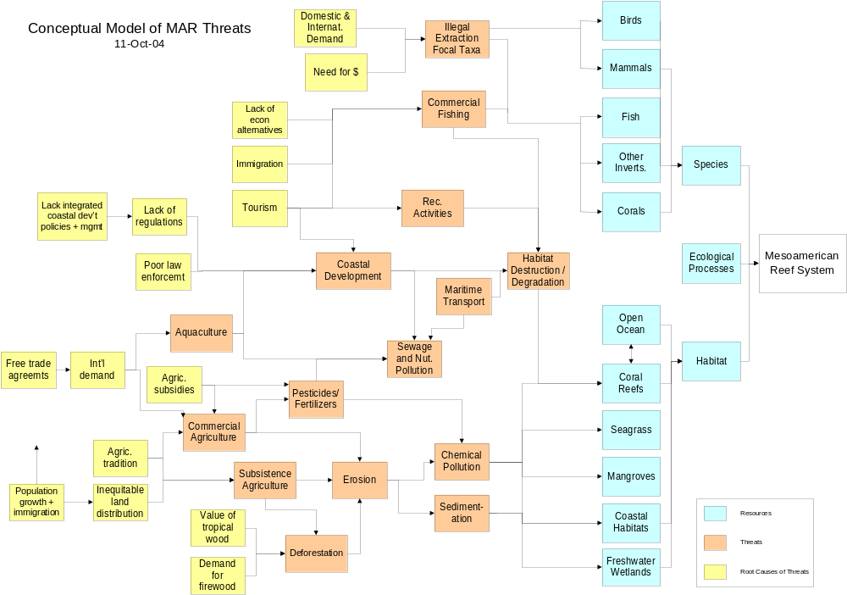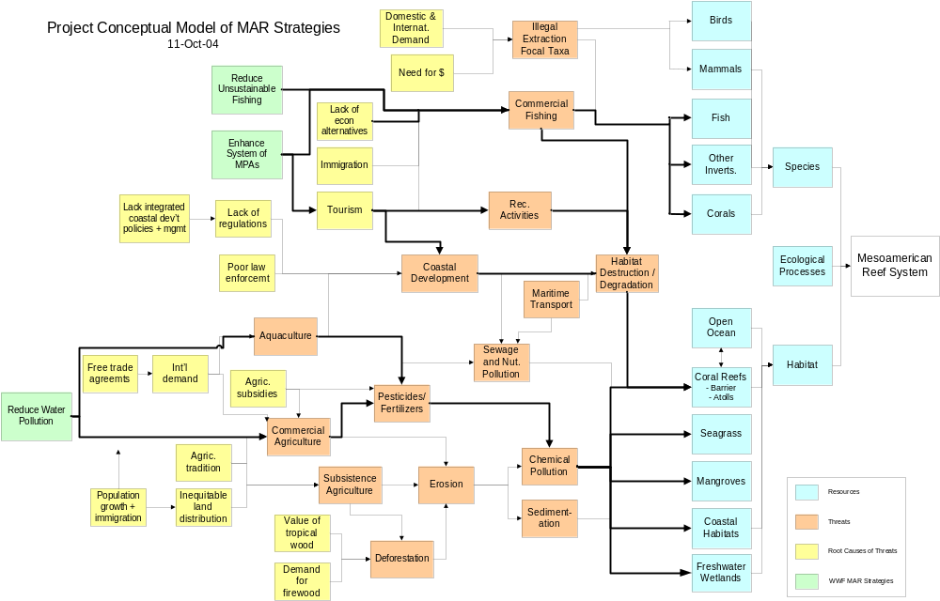

Our Strategies

For each of the priority strategies found in the following sections, you will see a description in the form of a results chain followed by a text explanation. The results chain representations provide a summary overview of the cause-and-effect relationship between what we will do (our actions) and what we will achieve (our goal and objectives). Furthermore, these chains clearly lay out our assumptions regarding the linkage between action and outcomes and thus provide a framework for our monitoring plans. Finally, by showing expected intermediate results, the results chains provide an opportunity to determine the sequence of results that are required to reach our goal and indicate the amount of time required to fully achieve each objective.

Expected Results/Outcomes (All by 2009)
Strategy 1: Reduce the Impacts of Water Pollution from Commercial Agriculture and Other Sources – This strategy is designed to reduce the presence of priority fungicides, pesticides, and herbicides in the MAR marine system and control soil erosion in major commercial agricultural sectors.
- 20% reduction in the fungicides with highest presence in MAR organisms and highest use in Honduras, Guatemala and southern Belize.
- 25% reduction in the total volume of four priority insecticides in pineapple and banana plantations in Honduras, Guatemala, and Belize.
- Reduction in the herbicides with highest presence in MAR organisms and highest use in Honduras, Guatemala, and southern Belize in sugar cane, banana and pineapple plantations.
  - 35% reduction in propanil
  - 10% in glyphosate and 2-4D
  - 5% in Paraquat
- Reduction of soil erosion in all Dole pineapple plantations in Honduras to a maximum of 7 tons/hectare/year.
- Reduction of soil erosion in all Dole, Chiquita, and Fyffes banana plantations in Honduras, Guatemala and Southern Belize to a maximum of 5 tons/hectare/year.
Strategy 2: Reduce the Impacts of Unsustainable Commercial Fishing – This strategy is designed to reduce fishing effort, enhance fishing practices, limit and regulate fishing access, and protect key species.
- WWF-trained fishermen reduce on average 50% of their time spent fishing, due to involvement in alternative economic activities.
- Better Management Practices for lobster, conch, and finfish are adopted and used by 60% of all fishers in the WWF focal areas, and used to develop new regulations.
- Three new areas under formalized agreements (e.g., concessions, leases) limiting fishing access.
- No fishing of any species in 10 of the most important snapper/grouper spawning sites in MPAs.
- No reports of fishing of rainbow parrot fish in Mexico and Belize.
Strategy 3: Enhance the System of Marine and Coastal Protected Areas – This strategy is designed to ensure that major habitats types in MAR are legally protected, well managed, and adequately financed.
- At least 20% of all major habitat types, critical habitat for focal species (croc, turtles manatees) and key ecological processes are within legally established MPAs.
- At least three of the seven MPAs trained in evaluating the effectiveness of their management (using NOAA / WCPA / WWF Management Effectiveness guidelines) demonstrate improved management.
- All Tier 1 and Tier 2 MPAs have 100% of core costs covered as defined by the MAR MPA Network Financial Analysis.
- As a demonstration model of sustainable financing, at least three water-using companies (beverage, hydroelectric or agro-industrial) contribute to upper watershed conservation in the Sierra de las Minas Biosphere Reserve.

Strategy 1: Reduce the Impacts of Water Pollution from Commercial Agriculture and Other Sources

Results Chain for Reducing Pollution from Commercial Agriculture
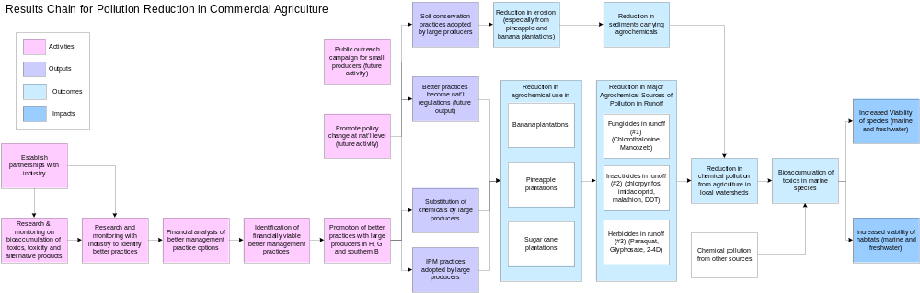

Objectives for Reducing Pollution from Commercial Agriculture

The WWF MAR Team has established the following objectives for reducing pollution from commercial agriculture:

- Ag1. By the end of 2009, achieve a 20% reduction in the fungicides with highest presence in MAR organisms and highest use in Honduras, Guatemala and southern Belize (chlorothalonil, mancozeb), especially in banana plantations.

- Ag2. By the end of 2009, achieve a 25% reduction in the total volume of 4 priority insecticides (deltamethrin, malathion, fipronil, and imidachloprid), especially in pineapple and banana plantations in Honduras, Guatemala, and Belize.

- Ag3. By the end of 2009, achieve a reduction in the herbicides with highest presence in MAR organisms and highest use in Honduras, Guatemala, southern Belize and Chetumal Bay, Mexico (35% reduction in propanil, 10% in glyphosate and 2-4D and 5% in Paraquat), especially in sugar cane, banana and pineapple plantations.

- Ag4. By the end of 2009, reduce soil erosion in all Dole pineapple plantations in Honduras to a maximum of 7 tons per hectare per year.

- Ag5. By the end of 2009, reduce soil erosion in all Dole, Chiquita, and Fyffes banana plantations in Honduras, Guatemala and Southern Belize to a maximum of 5 tons per hectare per year.

MAR Strategy for Reducing Pollution from Commercial Agriculture and Other Sources

In 2003, World Wildlife Fund (WWF) proposed to measure the impact and the bio-accumulation of agricultural effluents on targeted species within the Meso-American Reef. A representative sample of organisms potentially affected by agricultural effluents was evaluated, including one or more types of fish, mollusks, cnidarians, sponges, sea grass, algae, etc. Simultaneously, WWF has begun to work with the main agricultural industries in the area (e.g. bananas, pineapples, and sugarcane) and relevant government agencies to identify the types and quantities of agro-chemicals in use, as well as the poorer production practices that might be contributing to the overall agricultural effluent load that is affecting the reef. Complementing these activities, WWF proposed to collaborate with a progressive subset of area producers to identify better agricultural practices currently in use that reduce the overall effluent load from agriculture as well as its impact on the Mesoamerican Reef.

While excess nutrients, Nitrogen, Phosphorous, and Carbon, are widely recognized as a major contributor to global coral reef decline, the role of persistent organic pollutants (derived largely from agricultural activities) in reef ecosystem decline has rarely been studied or recognized as a significant threat. On-the-ground freshwater and marine water monitoring programs have been unable to measure significant agricultural pollution on or near the reef. It appears that only one independent study of agrochemical contamination in Belize (in the Stann Creek district) has been completed, which found no measurable pollutants.

To confirm that agrochemicals are indeed a threat to the Mesoamerican Reef, WWF decided to undertake bioaccumulation studies of a range of organisms found in the reef complex. Thus we selected the Sapodilla Cayes in the Gulf of Honduras gyre as the focus for the first round of tests. The primary aims of the first round of testing were finding appropriate test organisms and getting a first look at which chemicals are accumulating.

Our bioaccumulation results demonstrate significant pesticide contamination in every marine organism sampled - a real ‘dirty dozen’ list. Presence of fungicides, such as, Chlorothalonil and Mancozeb was detected. Chlorothalonil, used primarily in bananas, was the fungicide with the highest observed concentration. Both fungicides are included in the results chain for the MAR strategy.

Imidacloprid and DDT were the insecticides with the highest presence, followed by Lindane and Aldrin. Our program strategy includes Imidacloprid only, because at present it is used in bananas. DDT, Lindane, and Aldrin will need a different approach, since they were banned more than fifteen years ago. Any use of those insecticides is unlawful worldwide. At present, DDT is used by the health department in Belize to control mosquito larvae.

Propanil was the only herbicide found accumulated in fish, aquatic invertebrates, and marine organisms. Nonetheless, our program strategy includes Paraquat, 2,4-D, and Glyphosate, since they are used in bananas, pineapples and sugarcane production in heavy quantities. For example, three million litters per year is used in Honduras alone.

More conventional approaches to raising awareness about environmental threats often involves conservation groups ‘taking on’ industries. WWF’s approach to reducing private sector impacts on the environment is different. Our goal is to engage openly and transparently with strategic industries in order to better understand their actions in context, as well as the incentives and strategies that might work best to reduce their impacts. To change key industries we have to have the capacity to understand their businesses as well as their constraints. Our goal is to affect real change through measurable results on the ground or in the water rather than headlines in newspapers or scientific journals.

Our program strategy of engaging the private sector in the use of better management practices (BMPs) to reduce agrochemical pollution is well positioned to achieve results; conversely, it has lacked strong scientific evidence demonstrating the persistence of agrochemicals in the MAR environment or their impacts.

Results Chain 1: Establishing Partnerships with Industries
To promote BMPs to reduce water pollution and downstream impacts on the Mesoamerican Reef, WWF will engage the large agro-export industries to work along with local communities and growers to promote better practices that help reduce coastal water pollution. WWF has selected key areas and agro-industries in Honduras, Guatemala, Belize and Chetumal Bay in Mexico where efforts are being made to identify the primary agro-industrial threats to the Mesoamerican Reef and reduce them. Permanent crops and their cultivated areas as well as their watersheds have been identified. The larger agro-export industries in these three countries were identified – Dole Foods, Chiquita Brands, and Fyffes being the leaders. Additionally, the sugarcane industry in Honduras, Belize and Mexico uses high amount of herbicides to control weeds; consequently, WWF will seek to work jointly with this industry to reduce agrochemical contamination threats in the MAR.
These companies are aware of our findings regarding bioaccumulation of pesticides in Mesoamerican Reef organisms. They understand that our goal is not to go public with this data, but rather to use it to identify which chemicals are the most persistent in the environment and pose the greatest threats to the ecoregion. In fact, our findings allow us to trace key chemicals back to the different agro-industries, and this is why these companies have expressed willingness to work with us to reduce these threats.
Dole has agreed to work with WWF as long as both institutions sign an MOU. From Dole’s point of view communications about the work is the main issue to be addressed in the MOU. Dole wants to keep its production technology in house but also wants to publish results and impacts from the implementation of BMPs.
Chiquita Brands has worked closely with Rainforest Alliance in the ”Better Banana Project” since 1992. Based on this agreement, Chiquita cannot participate directly in a program with WWF. However, Chiquita will work with WWF on BMPs and provide information and analysis on its own practices, as well as on developing and implementing BMPs more generally
Fyffes learned of WWF’s concerns about the impacts of agriculture on the Meso-American Reef and interest in working with key industries to reduce those impacts from Chiquita. Once they understood that WWF’s interest is to work with the industry to reduce the source of agrochemicals that are bioaccumulating in reef organisms, they were more open to working together. They stated their plans to continue discussions with WWF in September 2004 after their team has had a chance to talk about the issue and their overall strategy.
Identification of Financially and Agronomically Sound Better Management Practices (BMPs) with Industry
An inventory of pesticides coming into Honduras, from which agriculture uses about 70%, was carried out. The results show a total of 760 different pesticides were imported by the agrochemical industry. This figure does not include different household chemicals, which were also brought into the country. Herbicides, fungicides, insecticides, and fumigants are the main categories of pesticides on the list.

At present, WWF knows that key players, such as Dole and Chiquita, are using pesticides which are being accumulated in marine organisms. In a joint effort, WWF and key industry leaders will work on the identification of better management practices to reduce or substitute the use of these harmful agrochemicals. Financial analyses will be conducted on agronomically sound BMPs to identify their financial viability.

Soil Conservation Practices
WWF will engage in soil conservation practices at specific sites and specific crops, such as bananas and pineapples. The focus here is on reducing soil erosion as part of a strategy for reducing sediments carrying agrochemicals. We are not trying to reduce the principal causes of erosion in general, which are probably primarily small farmers deforesting and planting subsistence crops on steep slopes. To address this issue, a different approach would need to be developed.
In addition, WWF will promote better land and water management practices within key watersheds in Guatemala and Honduras. By 2009, three activities regarding sustainable water management will be established in Polochic and Motagua watersheds in Guatemala and Aguán watershed in Honduras. These practices seek to promote conservation and restoration of ecological processes in priority freshwater ecosystems and to mitigate contamination threats to the Mesoamerican Reef.

Strategy for Reducing Pollution from Water-Using Industries
Phosphorous compounds and organic matter from water-using industries are currently leading to eutrophication, affecting freshwater organisms, and posing a serious threat to human health. According to WWF´s MAR Ecoregional Conservation Planning process (2002) the transboundary drainage systems that impose most upon the MAR reefs in terms of relative discharge levels extend from southern Belize through Guatemala and northern Honduras. Moreover, two of the six watersheds that pose the greatest magnitude of threat to the reefs include the Polochic and Motagua Rivers, which drain out into the Gulf of Honduras.

Several threats analyses have emphasized that suspended solids and chemical compounds are major threats to the Mesoamerican Reef. However, on-the-ground freshwater and marine water monitoring programs have been unable to measure significant agricultural and industrial pollution on or near the reef. Companies in the beverage business insist that their freshwater monitoring programs do not even find, much less show, significant levels of toxic chemical compounds. While our program strategy of engaging the private sector in the use of better management practices (BMPs) to reduce chemical pollution is well positioned to achieve results, it has lacked strong scientific evidence demonstrating the persistence of chemicals in the MAR environment or their impacts. The promotion of better management practices not only reduces company production costs, but also reduces harmful waste waters and inefficient water use. This initiative seeks to build alliances with large industrial water users, who have traditionally been seen as “the bad guys” by more traditional environmentalists. By involving the private sector and strengthening corporate responsibility we are making important links between freshwater conservation and sustainable long-term production that generates employment and socio-economic wealth.

Although until 2002, most of WWF-Central America’s resources within the MAR were allocated towards the establishment and effective management of a marine protected areas network, the program has increasingly stepped up its efforts to streamline resources into mitigating land-based threats linked to adjacent terrestrial areas by rivers and groundwater that carry nutrients, sediments and pollutants from the region’s Caribbean drainages. In 2003, WWF proposed to measure the impact and the bio-accumulation of agricultural effluents on targeted species within the Meso-American Reef. As with agricultural efluents, to confirm that chemical phosphorous and organic compounds from industrial activities are indeed a threat to the Mesoamerican Reef, WWF ought to establish a monitoring program to measure industrial pollutants at discharge point at companies within the Polochic and Motagua watersheds. Based on the outcomes of this pollutant monitoring program, the MAR ecoregional team will define if, and how, to work on addressing the reduction of pollutants from industrial activities.

Strategy for Reducing Pollution from Aquaculture
Aquaculture and specifically shrimp production is one of the fastest growing industries in Belize and Honduras mainly due to governmental protection through tax and duty exemptions. The industry in Belize has grown from 16 production hectares in 1983 to 2,700 hectares in 2004. While the industry provides a significant source of revenue, poor management practices have caused serious environmental and social impacts.

Shrimp production, through construction of ponds, is responsible for the loss of coastal savannas and mangrove areas, which leads to the loss of Yellowhead Parrot and other wildlife. Pond construction promotes soil erosion and reduces freshwater transport to wetlands, thereby altering hydrology, increasing sedimentation and salinization of coastal / estuary waters, and reducing freshwater availability to manatee, larvae, and other freshwater-marine organisms.

Lack of separation of solid wastes reduces soil integrity and promotes the proliferation of nuisance species such as rats. The use of fertilizers in the ponds results in accumulation of nutrients on sediments and groundwater, increase of plankton turbidity, and reduction of oxygen within the pond. Effluent discharge from the drainage of hatcheries, production pond or plant water during harvest and processing, results in slug-dosing with excess nutrients and concentrated organic waste, which produces nutrient loading of coastal waters, degrades water quality to a point below that which is optimal for reef growth. Direct extermination of wading birds by farmers who find them preying on shrimp can lead to local or regional extinction of rare bird species. Formulation of commercial shrimp feed requires capture of wild stocks for fish meal and fish oil. Fish meal use in shrimp feeds, on average, is two to three times that in weight of the shrimp it produces, which contributes to a net loss to global fisheries. Furthermore, excess of feed, as with excess fertilizer applications, can degrade water quality.

In 2003, WWF started working with the shrimp industry in Belize to identify impacts of production and better management practices to reduce them. WWF and the industry are working to identify environmentally friendly certification programs for which the shrimp industry might be candidates and to develop standards for a certification program if an acceptable pre-existing program is not identified; however, a full strategy must be developed to accelerate the reduction of this threat to the Mesoamerican Reef.

Strategy 2: Reduce the Impacts of Unsustainable Commercial Fishing

Results Chains for Reducing Unsustainable Commercial Fishing

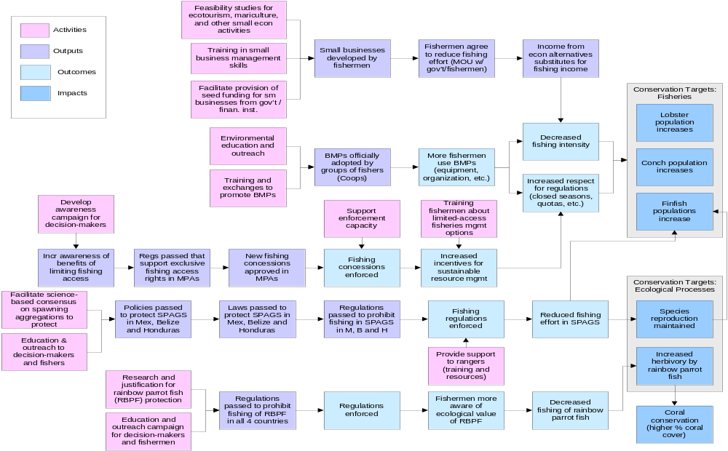

Objectives for Reducing Unsustainable Commercial Fishing

- Fs1. By the end of 2009, WWF-trained fishermen reduce on average 50% of their time spent fishing, due to involvement in alternative economic activities.

- Fs2. By the end of 2009, Best Management Practices for lobster, conch, and finfish are adopted and used by 60% of all fishers in the WWF focal areas, and used to develop new regulations.

- Fs3. By the end of 2009, there are three new areas under formalized agreements (e.g., concessions, leases) limiting fishing access.

- Fs4. By the end of 2009, there is no fishing of any species in 10 of the most important snapper/grouper spawning sites in MPAs.

- Fs5. By the end of 2009, there are no reports of fishing of rainbow parrot fish in Mexico and Belize.

MAR Strategy for Reducing Unsustainable Commercial Fishing
In spite of the numerous well-organized cooperatives with legal fishing rights existing in the Mesoamerican Reef ecoregion, many fishing practices are still unsustainable. The results of such fishing practices are over-exploitation, depletion, and ecological processes disrupted, threatening severely the unique marine ecosystems in the ecoregion. Frequently, such practices are motivated by the great demand for seafood, easy access to shore resources, difficulty of enforcement, and low capability of governments to manage their resources.

Lobster and queen conch are well-known commercial species in the ecoregion, and because of their high value fishermen prefer to focus on them. Nevertheless, some studies mention that fishermen target more than 100 species out of the more than 500 marine species reported in the ecoregion. Most of those species are finfish, which are not protected by as many regulations as lobster and conch. As most of the fisheries in the ecoregion are artisanal, official figures underestimate the real number of fishermen, which may be higher than 4,000. The high marine biodiversity along with the artisanal type fishing practices and the socioeconomic context represent a challenge in developing strategies that can make fishing access and conservation compatible.

After a broad analysis of the fisheries in the MAR ecoregion, WWF scientific staff concluded that fisheries can be divided into four large categories: 1) shrimp fishery, 2) lobster fishery, 3) queen conch fishery, and 4) finfish fishery. Because each fishery has a distinct ecological and economic value, we analyzed their relative importance, based on ecological, economic, social, and fishing intensity criteria. The results of our analysis are summarized in Table 1. This analysis concluded that finfish and lobster are the most important fisheries in the ecoregion; then queen conch and finally shrimp. We decided not to address shrimp fishing in this strategic plan, because it was ranked fourth and because it is not a major fishery in the ecoregion. There are only two small industrial fleets that practice shrimp trawling on the northeast of the Yucatan Peninsula (Arrowsmith Bank) and in the Gulf of Honduras. For this reason, our strategic plan will take into account only the lobster, finfish and queen conch fisheries.

Table 1. WWF MAR Team Ranking of Target Fisheries
 | Level of threat (to target species) | Area | Importance of target species to system | Impact of fishery on system | WWF experience | Total | Rank
Finfish | 2 | 4 | 4 | 3 | 3 | 16 | 1
Lobster | 3 | 3 | 3 | 1 | 4 | 14 | 2
Conch | 4 | 2 | 2 | 2 | 1 | 11 | 3
Shrimp | 1 | 1 | 1 | 4 | 2 | 9 | 4

WWF set the conservation of marine species and also marine ecosystems as conservation targets in its strategic plan. In order to enhance those conservations targets, WWF’s conservation strategy focuses its efforts on meeting five main objectives defined on the expertise of the marine and fisheries team, and research conducted by WWF and partner organizations. They are the following: 1) reducing excessive fishing effort by facilitating fishermen’s engagement in alternative economic activities, 2) developing Better Management Practices (BMP) for lobster, conch, and finfish, 3) limiting fishing access by strengthening cooperatives in co-management, 4) protecting fish spawning sites from fishing, and 5) enhancing herbivory within the coral ecosystems by protecting key herbivorous species from fishing pressure.

In addition to the five objectives mentioned, WWF recognizes that there are two more potential actions that could reduce fishing pressure: 1) changing seafood consumption patterns through tourism education and enforcing regulations related to buying and selling seafood, and 2) creating new policies to limit the expansion of fishing effort. Because of the WWF’s institutional capacity and considering the impact and feasibility of these objectives, WWF is not including them in this strategic plan; however, these topics may be regarded as part of other initiatives.

Results Chain 1: Reducing excessive fishing effort by facilitating fishermen’s engagement in alternative economic activities
The number of fishermen, the types of gear they use, and how frequently those gears are used determine the intensity of fishing effort. In addition to working on options to reduce fishing effort by cutting off certain gears from the ocean through better management practices, WWF is committed to facilitating fishermen’s departure from the fishery, by helping them shift to other economic alternatives. Even when it is desired to promote or create alternative jobs, investors must be realistic in order to determine business feasibility. For instance, tourism is a good option since the MAR ecoregion is one of the major tourist destinations of the world. The level at which fishermen can be involved in tourism is mostly working as guides for diving, kayaking, biking, etc.

This strategy includes activities such as studying the feasibility of economic alternatives in demonstration sites, providing technical training and financial support for alternative activities, and ensuring that those fishermen who become involved in alternative activities reduce their fishing effort.

Results Chain 2: Developing Best Management Practices for lobster, conch, and finfish
Studies on fisheries performed by WWF and other partners in the MAR ecoregion have shown that developing and using best management practices (BMPs) are good options to override overexploitation and other ecological threats. Fishing practices include the type of techniques, equipment and gears, their impact on target and non-target species and impacts on the ecosystem. Fishing practices also consider how well fishermen abide by existing regulations. Therefore a good fishing practice or BMP is the one that: 1) has effective management actions, 2) follows regulations, and 3) uses gears, equipment and techniques that have a demonstrated lower impact on the target population, non-target species, or ecosystem.

BMPs have two main components: fishing techniques and human behavior. After identifying the most environmentally friendly techniques and regulations, the next step is to promote their use among fishermen. The two main obstacles to introducing BMPs are that fishermen find it difficult to shift their environmental practices and they are concerned about the higher cost of new techniques. Promoting the use of fisheries BMPs involves working hard with fishermen in order to convince them about the advantages of the new practices. Hence, a great effort in environmental education for fishermen is also required in order to internalize the use of the resources.

Results Chain 3: limiting fishing access by strengthening cooperatives in co-management
Issuing permits to fishermen is not a guarantee to limiting access, even under the assumption that no illegal fishermen will enter into the fishery. This is because without many restrictions, legal fishermen may use their gears as much as they decide, often resulting in excessive fishing effort. Limiting access to a group of organized fishermen helps avoid illegal practices and stimulates the development of specific commitments and signed agreements with other actors or sectors they interact with to promote sustainable management.

For years, enforcement of fisheries regulations has been demonstrated to not be effective since their implementation costs are frequently higher than the value of the yield. For this reason, once a fisherman perceives that others may take advantage of open access, he will have an incentive to overexploit the resource. Co-management is a tool intended to address this problem. Co-management recognizes the legal fishing rights of fishermen groups with accepted leadership, and ensures that no other fishermen will use the resource. Co-management also provides rights and responsibilities of good management to fishermen. As the authority reduces its participation in enforcement, organizations work together with rangers, and both determine the appropriate regulations for managing the resources.

WWF’s conservation strategy will strength fishermen organizations by raising awareness in fishermen, cooperatives and policy makers from three MPAs on the benefits of implementing limited fishing access and promoting concessions instead of permits. In order to achieve this objective, WWF will perform a sociological study to determine the feasibility of some initial fishermen groups adopting limiting access. WWF is also planning to provide support to rangers to reduce illegal fishing in three focal areas.

Results Chain 4: Protecting fish spawning sites from fishing
Spawning aggregation sites are fundamental biological events occurring during some periods of the year that help maintain the coral reef community structure. For years, fishermen have obtained empirical knowledge on this biological process, which allowed them to increase their yield during aggregation periods. In Mexico there are about 38 sites where some 15 species aggregate for reproduction and spawning. Severe exploitation regimes on such spawning sites have led to a reduction in their number. Some authors mention that one third of the original spawning sites have been affected by fishermen. Twenty four of those sites are located in MPAs, which will facilitate their conservation and management. On the other hand, the increasing development of some coastal areas in the MAR underscores the urgency of protecting spawning aggregation sites.

WWF will promote consensus among universities, fishermen, authorities and other partners to declare the 10 most important spawning sites as no-take zones. Such action requires designing and implementing a public campaign focused on educating fishermen and the general public on the importance of protecting spawning sites. WWF will also produce scientific publications providing evidence of fisheries impacts on the community structure.

Results Chain 5: Enhancing herbivory by protecting herbivorous species from fishing
The constant extraction of finfish biomass disrupts the ecological processes in the MAR; for instance, catching herbivorous species will reduce herbivory on reefs, leading to accelerated growth of algae. Macroalgae in particular can overgrow or out-compete corals for living-space on the reef. Parrotfish are key grazers on reefs, in both juvenile and adult life phases. Adults of the larger parrotfish, such as the rainbow parrotfish, can reach up to four feet in length and are now being targeted by fishers in the MAR due to the depletion of other finfish species. The rainbow parrotfish is large, highly visible, easily identifiable, and thus serves as a good umbrella species for other herbivores. The strategy to gain their protection would combine research focused on this species (distribution and ecological role in the MAR) with a public awareness campaign for fishers and government authorities about their key ecological role and potential value for ecotourism (the humphead wrasse of the Caribbean). These efforts will lead to a greater appreciation of the ecological value of this species and its eventual protection under the fisheries regulations of each country. WWF will support the enforcement of these regulations within specific MPAs, which will contribute to adequate enforcement. This will lead to a reduction in fishing of rainbow parrotfish which will increase herbivory and enhance reef health in the ecoregion

Strategy 3: Enhance the System of Marine Protected Areas

Results Chain for the System of Marine Protected Areas

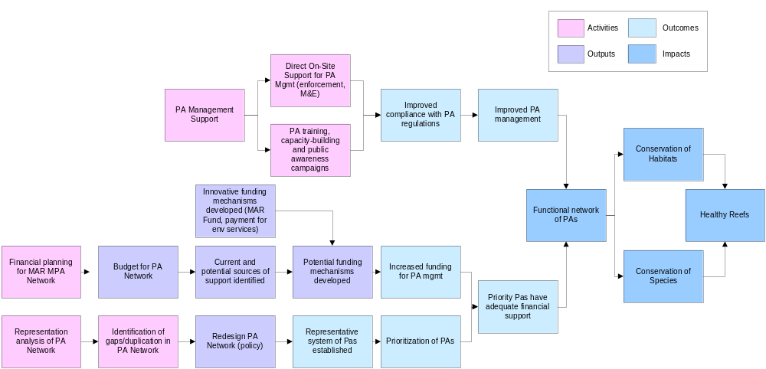

Objectives for Enhancing the System of Marine Protected Areas (MPAs)

- By the end of 2009, at least 20% of all major habitat types, critical habitat for focal species (crocodiles, turtles, and manatees) and key ecological processes are within legally established MPAs.

- By the end of 2009, of the 7 MPAs trained in evaluating the effectiveness of their management (using NOAA/WCPA/WWF Management Effectiveness guidelines) at least three demonstrate improved management.

- By the end of 2009, All Tier 1 and Tier 2 MPAs have 100% of core costs covered as defined by the MAR MPA Network Financial Analysis.

- By the end of 2009 as a demonstration model of sustainable financing, at least three water-using companies (beverage, hydroelectric or agro-industrial) contribute to upper watershed conservation in the Sierra de las Minas Biosphere Reserve.

MAR Strategy for Enhancing the System of Marine Protected Areas

Marine and coastal protected areas provide a key strategy to enhance ecosystem structure and function by returning designated areas to a more natural state, restoring depleted populations, safeguarding critical habitats and species. A major focus of WWF’s conservation strategy in the MAR involves the development and effective management of an ecologically representative and functional network of marine and coastal protected areas (MCPAs).

MCPAs are an effective and efficient conservation strategy, because they address multiple threats and promote natural resilency, particularly in response to acute disturbances like hurricanes. The primary threats addressed through the MCPA strategy include commercial and artisanal overfishing, tourism, coastal development and pollution.

Essentially what coral reefs need are clean waters and abundant “natural” fish populations. A functional network of marine and coastal protected areas helps attain both. By establishing fully-protected, ‘no-take’ zones that serve as refugia, the MCPAs actually restore the trophic balance and increase fish abundance and average sizes, even areas outside the reserve are enhanced by spill-over and larval recruitment. Coastal reserves protect critical nursery habitats, including those that also serve as nature’s filtration and purification system, helping to trap sediments, chemical pollutants and excess nutrients that would otherwise endanger sensitive offshore reefs.

No individual protected area can assure all of these vital functions, particularly in the highly interdependent marine environment. Thus the Network needs to include a representative proportion of all habitats, including those areas critical for reproduction and recruitment, focal species, etc. As seen in the schematic MCPA Strategy, we envision three inter-related lines of work (results chains) leading to the functional MCPA Network, which supports the conservation of species, habitats, and ultimately healthy reefs.

Results Chain 1: Network design and establishment
The foundation of this work requires a scientifically robust MCPA Network design process, the representation analysis and identification of gaps. Growing international interest in creating functional networks of marine protected areas has led to increased attention on the best approaches to designing and establishing such networks. WWF is participating in a global learning network focused on this emerging field of research. Thus we are well positioned to both learn from the latest findings from other parts of the world and share in our experiences in the MAR.

In Belize WWF is collaborating with a consortium of NGOs on the ecological representation and gap analysis, and is leading the marine component of this work. WWF is currently leading a coalition of NGOs and government agencies in an effort to analyze the existing network based on a set of design criteria developed and approved by stakeholders. Following this initial activity, data will be incorporated into a decision-support model to optimize various configurations of MPAs and provide key information to government decision makers who are charged with the task of enacting the network. The resulting redesigned network configuration is the first output in this process.

Once the design and prioritization of MPA needs is agreed upon, efforts supporting their legal establishment, the first outcome in this process, can begin. WWF will engage the governments and stakeholders at various levels in order to build the needed support for the establishment of new MPAs needed to complete the network. Concurrent to the gap analysis and redesign effort will be a stakeholder-based review of the regional prioritization of MPAs, based on the WWF Ecoregional Planning document and other such compilations. The resulting prioritization of MPAs will constitute the second outcome of this process.

Results Chain 2: Sustainable Financing for the MCPA Network
Parallel and concurrent to the previous efforts are our efforts to ensure sustainable financing for the Network. WWF and other partners working with MCPAs in the region have recognized the establishment and sustainable financing of the Network as a key priority for the long-term conservation. One major challenge in the design of the MCPA Network is to come up with a viable implementation plan and a financial sustainability strategy to ensure the consolidation of the ecoregional protected areas system in the MAR. In general, there is an absence of social and economic analysis, financial strategies, and fundamental skills and resources required from the staff to carry out their work and responsibilities at the level required for sound management. WWF is well-positioned to provide leadership and support for the development of a financial and sustainable funding plan for the MAR MPA network, through internal funding and technical assistance secured from the Large Conservation Program Management Initiative (WWF-US), to carry out this work on behalf of the MAR Fund.

The main activity of Financial Planning for the MCPA Network, will result in two immediate outputs, including a budget for the Network and identification of the current and potential sources of financial support. In addition, WWF is in the process of developing a model of PA financing within the region, through the payment of environmental services, which represents a third output. This model will be more fully developed and its application to other industries relevant to marine conservation (ie tourism) will be explored. These three related outputs contribute to the development of a menu of potential funding mechanisms (the fundraising strategy) which will then culminate in increased funding for PA management, the first outcome of this chain. Along with the previous outcome (prioritization of MPAs in Network) these will both enable priority PAs to attain adequate financial support for management, which leads directly to the functionality of the Network as a whole.

Results Chain 3: Working towards Effective Management
Finally, WWF seeks to actually improve management effectiveness of the priority areas in the MCPA Network. This strategy entails activities that support PA management, through financial, technical and other forms of assistance. In particular, WWF plans to promote the adoption and application of the new World Commission on Protected Areas (WCPA) and National Oceanic and Atmospheric Administration (NOAA) management effectiveness guidelines for marine protected areas (“How is your MPA doing?”). By incorporating these guidelines into their operations, managers will be better equipped to evaluate their own success and use this knowledge to alter their management actions (thus implementing the full adaptive management cycle). WWF is encouraging regional MPAs to use this internationally standardized tool and will actively seek funding to apply the protocol in key MPAs in the upcoming years. Our aim is to provide training and stimulate adoption of the protocol in at least all “Tier 1 & 2” (priority) MCPAs (approximately 9 areas). Additional training (i.e., in community outreach and enforcement) and public awareness, including our successful Big Mamma public awareness and political support-building campaign advocating the benefits of fully protected marine reserves and no-fishing zones within larger MPAs, will occur within the whole Network and on national/regional scales.

The other set of activities in this chain relate to WWF’s direct support of PA management, which will occur only at Tier 1 and selected Tier 2 MPAs. These sites are all within highest priority biodiversity areas, as defined by the ecoregional planning document, and were further selected based on our sound partnerships with the managing agencies and confidence in management capacity. These Tier 1 MPAs will then be more assured to have effective management and also serve as models of effective management for other PA’s. WWF recognizes the financial burden of providing such support and is thus limiting our commitment to these few MPAs. All of these activities will lead to improved PA management, including the improved compliance with regulations within the PA’s. This improved management is a necessary element for transitioning from a well-designed network of paper parks to a truly functional MCPA network.

In conclusion, the marine and coastal protected area is an essential conservation tool, supporting the conservation of biodiversity, fisheries, and the tourism value of marine ecosystems, thereby contributing to all aspects of WWF’s ecoregional goal, including support for sustainable livelihoods. A well-designed, well-managed and financially sound MCPA Network will support the conservation of key species, habitats and ecosystem functions needed to support healthy reefs. While not sufficient in itself to assure long-term vitality of ecosystem health, when combined with other strategies aimed at directly reducing threats from over-fishing and agricultural pollution, it provides a comprehensive conservation package destined for success.

Reduce the Impacts of Unsustainable Coastal Development (Tourism)

Tourism is the largest and fastest growing economic sector in the world and has significant environmental, cultural, social, and economic impacts, both positive and negative. WWF recognizes that the impacts of tourism are generated by the ways and means in which a set of recreational activities are conducted, the lack of planning in coastal infrastructure development, the means by which visitors stay at, arrive to, depart from and consume goods and services in a destination, and the socio-economic contexts that make all of this possible both globally and locally.

Land-based tourism development, as well as cruise-based tourism, is a threat to the marine ecosystems of the Mesoamerican Reef. This is particularly true in Cancun where there are massive land-based tourism operations, and the area south of Cancun, where we find a rapid expansion of coastal development (e.g. hotels, vacation homes) and tourism activities (e.g. diving, reef walking). WWF recognizes the importance of promoting the implementation of sustainable tourism policies in areas of rapid development, and working with major tourism operators (travel agencies, hotel chains, cruise lines and marine recreation providers) to adopt better practices to reduce impact on the MAR ecosystems.

During the next six months, WWF will take the steps necessary to determine if, and how, to move forward with defining and implementing a tourism strategy in the MAR. These steps include: 1) in mid-October 2004 WWF ecoregional teams from the Florida Keys, Cuba and the Mesoamerican Reef will meet to discuss WWF’s tourism initiative in Cuba, and opportunities for collaboration and synergies at a Caribbean-wide level; 2) in late October, 2004, the WWF network will co-convene a meeting in Turkey with the Tour Operators Initiative (TOI) to share information and define an agenda for global collaboration; and, 3) in preparation for Tulum +8, in February 2005 stakeholders will meet to define a shared ecoregional action plan for the MAR ecregion, and this plan will include a tourism strategy. Pre-meetings for each of the strategies will be convened prior to the February 2005 meeting and a tourism action plan will be discussed.

Based on the outcomes and discussion of the aforementioned meetings, the MAR ecoregional team will define if, and how, to work on addressing the tourism threat in the region.

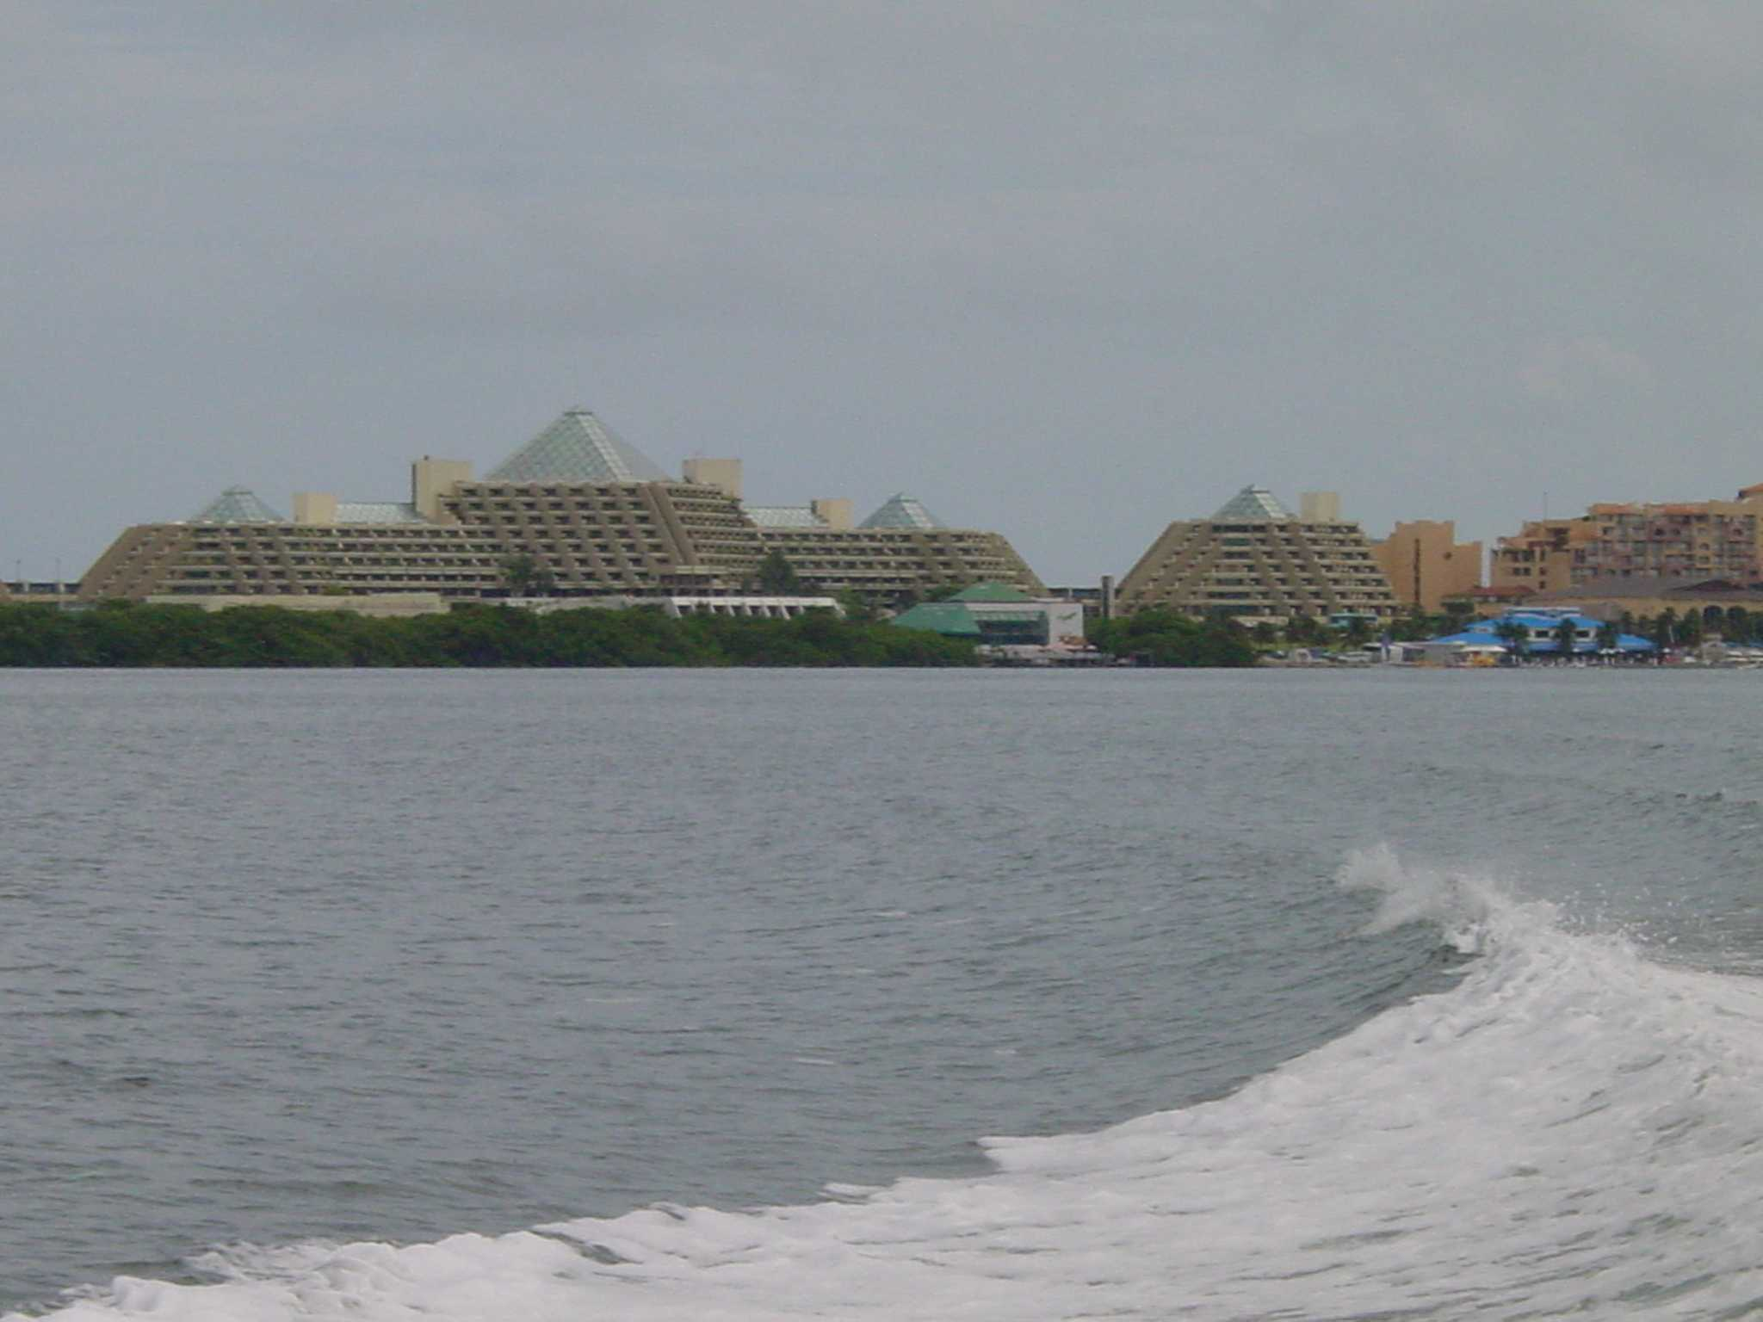

IV. Measuring our Success in the MAR

Description of Our Goal
Our Goal represents what we ultimately want to achieve in MAR. As such, measuring and monitoring it is crucial. It is against the measurement of our Goal that we will assess our attainment of our specific objectives to determine if our actions are as successful as we hope. In order to measure and monitor our Goal, we have developed a monitoring plan just as we have done for each one of our objectives (see Appendix for monitoring plans related to objectives).

The Mesoamerican Reef Ecosystem is a part of an interconnected system of diverse coastal habitats that extend for approximately 1,000 km from the northern tip of the Yucatán Peninsula in Mexico, through Belize’s Barrier Reef Complex and Guatemala’s Caribbean coast, to the Bay Islands in Honduras. What is significant about this region is the overall extent and variety of reef types and associated habitats, its high biodiversity and the relative integrity of the ecosystems. The Mesoamerican Reef System contains the longest barrier reef system in the Western Hemisphere. Hosting over 66 stony coral species and over 500 fish species, this ecoregion contains one of the most diverse coral reefs in the western Atlantic.

Underpinning WWF’s conservation strategies in the MAR is the goal of enhancing the health of this ecosystem. However, one of our most challenging tasks is to understand/elucidate exactly what we mean by ‘reef health’ in order to promote it, design strategies to reduce the threats to it, and finally to adequately measure it. Reef scientists have had great difficulty in gaining consensus on the key indicators of reef health and have thus not established standard benchmark values or norms for key indices.

WWF has been working along with partners to develop a holistic framework to measure reef health in the MAR, which has evolved into the ‘Healthy Mesoamerican Reef Initiative” (HMRI), which has reviewed and established benchmark and target values for almost 50 indicators of reef health. A brief sub-set of these indicators has been incorporated into this plan, based on our conservation strategies and the availability of existing datasets. They were selected from a top-ten list developed at the HMRI experts meeting in Miami in June 2004.

Benthic community composition
The community structure (benthic composition) of coral reefs is a major force shaping reef communities. Competition for the limited supply of prime ‘reef real estate’, particularly the ongoing battle between macroalgae and corals, has received much scientific and popular attention. Benthic Cover is an indicator of overall reef health, a proxy for competition among benthic organisms, and a proxy for reef growth. Benthic cover or community composition is measured in terms of the percent cover of various functional groups. Several case studies have depicted the overall shift from coral to algal domination in many Caribbean reefs, including some in the MAR. However, algal or sponge domination can be an opportunistic consequence of corals dying (which leaves space available) and not necessarily the cause of coral death. However, once established, a dense cover of macroalgae, turf algal/sediment mats, or sponges greatly reduces available substrate for coral recruitment/recovery and can have lasting effects on community structure, function and ultimately the existence of reef frameworks themselves.

Coral recruitment
Reproduction and recruitment are among the most critical processes governing reef communities. Runoff from land decreases water quality and introduces chemicals that can negatively affect reproduction and recruitment of corals and other species. Early life phases are often the most sensitive to environmental stress. If coral populations are not replenished through processes of reproduction and recruitment, then the reef framework will eventually degrade, having a cascading affect on the entire reef community. The abundance of “recruits” is an important indication of a reef’s potential for growth and for recovery after major disturbances, and more monitoring programs have begun to include measurement of coral recruitment in recent years.

Key herbivore density
Herbivory is probably the most important factor influencing interspecific interactions on Caribbean reefs, producing significant and rapid effects on reef community structure. Fishes and sea urchins are the two most important groups of herbivores that control the abundance and species composition of both corals and algae. Grazers like parrotfishes and surgeonfishes are especially effective herbivores because they occur in large numbers. Perhaps the most influential herbivore on Caribbean reefs is the long spined sea urchin, now considered to be a ‘key species’ affecting coral reef structure and composition. Censusing of the main groups of herbivorous fish and Diadema sea urchin is relatively easy, and is included in several monitoring programs. It serves as a proxy indicator of herbivory.

Carnivorous fish density
A variety of predatory fish (mainly snappers and groupers) have high commercial value and have become depleted within the region. The complexity of food web interactions has important implications for energy transfer and trophodynamics within the ecosystem. The ecological stress from overfishing is often not readily apparent due to a time lag between the onset of overexploitation and the ultimate disruption of ecological processes. In addition, the ecological mechanisms for cascading effects from the loss of top predators have not been fully elucidated for the complex reef ecosystem. The snapper-grouper complex has formed the basis for commercial and recreational fisheries in the region for decades. Traditionally exploited during spawning periods, their populations have declined dramatically from historic levels. Thus monitoring of their abundance serves both as a proxy of the extent of overfishing and also a measure of the integrity of food webs.

Mangrove Extent
Much of the region’s coastline and cayes are still intact with large forests of mangrove and some littoral forest cover. Coral reefs are closely tied to these surrounding ecosystems, particularly seagrasses and mangroves. These ecosystems interact to form a complex and dynamic mosaic of habitats that serve as foraging areas, nurseries, and physical and chemical buffers. These critical linkages can be altered by coastal degradation or by direct destruction of these habitats. The extent of critical habitats, like mangroves, is a key indicator of habitat structure and can provide an indication of how much “habitat” is still available versus how much has been lost (when historic data are available). It can be relatively easily measured with satellite imagery and serves as an indicator of both ecosystem integrity and coastal development.

Accumulation of Pollutants
The most far-ranging and persistent stressor resulting from commercial agriculture in the MAR is pollution from agrochemicals (fungicides, insecticides and herbicides and fertilizers). Reefs are subjected to various forms of pollution from multiple sources. While industrial and agricultural activities may be located at a great distance from coastal areas, they still make their way downstream to impact the coastal estuaries, lagoons, seagrass beds and reefs. Some of these chemicals are very persistent in the environment and bioaccumulate in organisms. Toxic chemicals may interfere with physiological processes, including growth and reproduction, and generally decrease an organism’s overall fitness or increase susceptibility to disease. Accumulation can be monitored in both tissue samples from organisms and from sediments. Sampling methods are fairly easy although lab analysis can be moderately expensive.

Water Quality
Reefs depend on highly specific environmental conditions. In addition, corals and many of their inhabitants have adapted to tolerate relatively narrow ranges of these conditions. Several key factors are important for controlling modern reef types, including temperature, salinity, and water clarity. Optimal coral growth occurs when water temperatures are between 25-29°C, with elevated temperatures causing coral bleaching events. Temperature is the most widely available environmental variable in the region. Salinity can be used as a proxy indicator of fluvial (or groundwater in areas lacking surface runoff) influence on reef areas, and is measurable in automated stations or with refractometers. A simple proxy indicator of light is water clarity, or transparency. Equations can calculate the effective light at various depths of interest. Transparency is also linked to nutrients, as they promote the growth of phytoplankton that reduce transparency. These data are available from several research stations in the MAR and are generally indicative of the overall ambient water quality.

Human dimensions and Socio-economics
The MAR Ecoregion sustains nearly 2,000,000 people from four neighboring countries (Mexico, Belize, Guatemala, and Honduras), with a large proportion living along the coasts and islands. Indigenous Garifuna, Miskito, and Mayan communities depend heavily on the reefs for subsistence. The rich resources in the region have important ecological, aesthetic, and cultural value to its inhabitants. In fact, coastal human populations that depend on the marine resources for their livelihoods are often natural supporters of conservation, as long as it is coupled with sustainable use. Productive fishing grounds support valuable commercial and artesanal fisheries. Millions of tourists are attracted to the sandy beaches and teeming reefs, providing important economic revenue to the people and their governments. Unfortunately, these same economic activities are also the major threats to the integrity of this unique ecoregion. Additional reef health indicators are currently being developed to incorporate socio-economic aspects. Several of these indicators will be added to our monitoring plan in the near future.

Monitoring Plan for MAR Goal
Given the limited WWF staff time available for engaging in monitoring activities or even compiling monitoring data, we have included in this list only indices that other organizations will collect (through, for example, monitoring MPA effectiveness and the MBRS synoptic monitoring program).

Goal (WWF Vision): To enhance the health of the Mesoamerican Reef's diverse ecosystems, providing sustainable livelihoods for local people, while preserving one of the world’s great natural treasures.
Indicators | How | When | Where | Responsible
benthic community (% cover of each component; coral:algal ratio) | benthic transects | annual | key sites, inside and outside MPAs - representative coverage | Melanie McField coordinates with data from MPA Network, MBRS, WWF fill in gaps; country POs help obtain data
coral recruitment (#corals<10cm/m2) | benthic transects (w/quadrats) | annual | key sites, inside and outside MPAs - representative coverage
herbivore density (#urchins&fish/m2) | belt transects | annual | key sites, inside and outside MPAs - representative coverage
carnivore density (#fish/ms) | belt transects | annual | key sites, inside and outside MPAs - representative coverage
extent of mangroves (km²) | available satelite data | annual | regional cover | Shalini
pollutant accumulation (ppb) | samples of biota and sediments | annual | ‘sink’ areas for major run-off and outer ‘control’ sites | Melanie McField coordinates with Jose and data MBRS, WWF fill in gaps and target BMP areas/run-off
water quality (salinity, turbidity) | collect from data centers | daily, monthly summaries | Carrie Bow and other automated stations available | Shalini

Conclusion
The MAR strategic planning document is a “living document” that will be periodically reviewed and updated. It provides ample detail on the planning process, descriptions of each priority strategy and expected results, as well as the monitoring plans. A question currently not addressed through this strategic plan is the overall budget required to implement it. WWF recognizes that developing the detailed and overall cost figures for the successful implementation of this plan is an important next step to guide our institutional fundraising efforts. With focused program priorities, WWF is now in a stronger position to develop the budget for this five year plan, articulate a fundraising strategy and work with the WWF network and outside donors to attract the necessary resources (technical, human, and financial) for its successful implementation in the field.

The combination of our pollution, fisheries and protected area network strategies represent an ambitious and results-oriented package of actions that will go a long way to assure long-term vitality of the MAR’s coral reef ecosystems. However, to guarantee that the MAR is healthy and productive in 50 years, WWF recognizes the need to build alliances and influence other major players. The Tulum+8 process represents the best opportunity to accomplish this. As active participants in Tulum+8, WWF will engage other NGOs and the private sector to identify the best ways to address other threats such as tourism. We will work to bring these groups as well as, donors and governments towards a renewed affirmation of the need to save the MAR through the adoption of a comprehensive set of strategies and outcomes reflected in high-level political commitments that can attract additional financial support and transform development in the MAR.

V. Appendices

1. Workplan and monitoring plans for commercial agriculture
- Workplan: objectives and activities

Objectives | Activities | Benchmark 1 | Benchmark 2
Ag1. By the end of 2009, achieve a 20% reduction in the fungicides with highest presence in MAR organisms and highest use in Honduras, Guatemala and southern Belize (chlorothalonil, mancozeb), especially in banana plantations. | 1. Establish partnerships with Dole and Chiquita  2. Establish partnership with Fyffes  3. Establish monitoring program with local partners to gather data on usage of chlorothalonil and mancozeb in watersheds draining into the MAR  4. Monitoring of toxic bioaccumulation in marine organisms  5. Toxicology studies to assess biological impacts of agrochemicals (consultancy)  6. Research, financial analysis and documentation (where possible) of better management practices  7. Dissemination and promotion of better management information via personal contact and workshops with industry representatives and web site  8. Develop high-level agreements with Dole, Chiquita, and Fyffes to adopt better management practices at regional level  9. Conduct legal analysis of agrochemical regulations in Honduras, Guatemala and Belize, in relation to CAFTA | By the end of 2007, achieve a 5% reduction in the fungicides with highest presence in MAR organisms and highest use in Honduras (chlorothalonil, mancozeb), especially in banana plantations. | By the end of 2008, achieve a 10% reduction in the fungicides with highest presence in MAR organisms and highest use in Honduras, Guatemala and southern Belize (chlorothalonil, mancozeb), especially in banana plantations.
Ag2. By the end of 2009, achieve a 25% reduction in the total volume of 4 priority insecticides (deltamethrin, malathion, fipronil, and imidachloprid), especially in pineapple and banana plantations in Honduras, Guatemala, and Belize. | 1. Establish partnerships with Dole and Chiquita.  2. Establish partnership with Fyffes.  3. Establish monitoring program with local partners to gather data on usage of deltamethrin, malathion, fipronil, imidacloprid in watersheds draining into the MAR.  4. Monitoring of toxic bioaccumulation in marine organisms.  5. Toxicology studies to assess biological impacts of agrochemicals (consultancy)  6. Research, financial analysis and documentation (where possible) of better management practices  7. Dissemination and promotion of better management information via personal contact and workshops with industry representatives and web site  8. Develop high-level agreements with Dole, Chiquita, and Fyffes to adopt better management practices at regional level | By the end of 2007, achieve a 10% reduction in the insecticides with highest presence in MAR organisms and highest use in Honduras (deltamethrin, malathion, fipronil, and imidachloprid), especially in pineapple and banana plantations in Honduras, Guatemala, and Belize. | By the end of 2008, achieve a 15% reduction in the insecticides with highest presence in MAR organisms and highest use in Honduras (deltamethrin, malathion, fipronil, and imidachloprid), especially in pineapple and banana plantations in Honduras, Guatemala, and Belize.
Ag3. By the end of 2009, achieve a reduction in the herbicides with highest presence in MAR organisms and highest use in Honduras, Guatemala, southern Belize, and Chetumal Bay - Mexico (35% reduction in propanil, 10% in glyphosate and 2-4D and 5% in Paraquat), especially in sugar cane, banana and pineapple plantations. | 1. Establish partnerships with Dole and Chiquita  2. Establish partnership with Fyffes and The Association of Sugar Producers (Honduras, Southern Belize and Chetumal Bay - Mexico)  3. Establish monitoring program with local partners to gather data on usage of propanil, glyphosate, 2-4D and Paraquat in watersheds draining into the MAR  4. Monitoring of toxic bioaccumulation in marine organisms  5. Toxicology studies to assess biological impacts of agrochemicals (consultancy)  6. Research, financial analysis and documentation (where possible) of better management practices  7. Dissemination and promotion of better management information via personal contact and workshops with industry representatives and web site  8. Develop high-level agreements with Dole, Chiquita, Fyffes, and Sugar Producers to adopt better management practices at regional level | By the end of 2007, achieve a reduction in the herbicides with highest presence in MAR organisms and highest use in Honduras, Guatemala, southern Belize and Chetumal Bay - Mexico (15% reduction in propanil, 3% in glyphosate and 2-4D and 1% in Paraquat), especially in sugar cane, banana and pineapple plantations. | By the end of 2008, achieve a reduction in the herbicides with highest presence in MAR organisms and highest use in Honduras, Guatemala, southern Belize and Chetumal Bay - Mexico (25% reduction in propanil, 6% in glyphosate and 2-4D and 3% in Paraquat), especially in sugar cane, banana and pineapple plantations.
Ag4. By the end of 2009, reduce soil erosion in all Dole pineapple plantations in Honduras to a maximum of 7 tons per hectare per year. | 1. Establish partnership with Dole  2. Establish monitoring program with Dole to gather soil erosion data in pineapple plantations  3. Research, financial analysis and documentation (where possible) of better management practices  4. Dissemination and promotion of better management information via personal contact and workshops with industry representatives and web site  5. Develop high-level agreements with Dole to adopt better management practices at regional level | By 2005 monitoring plan with Dole to gather soil erosion data in its pineapple plantations in Honduras has been established. | By 2006 research, financial analysis and documentation of better soil conservation practices in pineapple production have been established.
Ag5. By the end of 2009, reduce soil erosion in all Dole, Chiquita, and Fyffes banana plantations in Honduras, Guatemala and Southern Belize to a maximum of 5 tons per hectare per year. | 1. Establish partnerships with Dole and Chiquita  2. Establish partnership with Fyffes  3. Establish monitoring program with Dole, Chiquita, and Fyffes to gather soil erosion data in banana plantations  4. Research, financial analysis and documentation (where possible) of better management practices  5. Dissemination and promotion of better management information via personal contact and workshops with industry representatives and web site  6. Develop high-level agreements with Dole, Chiquita, and Fyffes to adopt better management practices at regional level | By 2005 monitoring plans with Dole, Chiquita, and Fyfees to gather soil erosion data in their banana plantations in Honduras, Guatemala and Southern Belize have been established. | By 2006 research, financial analysis and documentation of better soil conservation practices in banana production have been established.

- Monitoring plans for each objective

Objective Ag1: By the end of 2009, achieve a 20% reduction in the fungicides with highest presence in MAR organisms and highest use in Honduras, Guatemala and southern Belize (chlorothalonil, mancozeb), especially in banana plantations.
Indicators | How | When | Where | Responsible
Outcome
# of liters of active ingredient of chlorothalonil used per year | reviewing companies' records of rate, volume and timing | every 3 months | Dole and Chiquita headquarters in La Lima and La Ceiba and headquarters of Fyffes in Big Creek, Belize | José Vásquez
# of kg and/or liters of active ingredient of mancozeb used per year
Output (Process) | Responsible | By When
Activities | Responsible | By When
1. Establish partnerships with Dole and Chiquita | José Vásquez and Jason Clay | end of Nov 2004
2. Establish partnerships with Fyffes | José Vásquez and Jason Clay | end of February 2005
3. Establish monitoring program with local partners to gather data on usage of chlorothalonil and mancozeb in watersheds draining into the MAR | José Vásquez | end of April 2005
4. Monitoring of toxic bioaccumulation in marine organisms to establish baseline levels | Melanie McField Mcfield (with Jason Clay and José Vásquez) | December 2004
5. Toxicology studies to assess biological impacts of agrochemicals (consultancy) | Melanie McField Mcfield and José Vásquez, under Jason Clay’s guidance | November 2004
6. Research, financial analysis and documentation (where possible) of better management practices | José Vásquez | June 2006
7. Dissemination and promotion of better management information via personal contact and workshops with industry representatives and web site | José Vásquez | March 2007
8. Develop high-level agreements with Dole, Chiquita, and Fyffea to adopt better management practices at regional level | Jason Clay and WWF-US | June 2008
9. Conduct legal analysis of agrochemical regulations in Honduras, Guatemala and Belize, in relation to CAFTA | José Vásquez | December 2006

Objective Ag2. By the end of 2009, achieve a 25% reduction in the total volume of 4 priority insecticides (deltamethrin, malathion, fipronil and imidacloprid), especially in pineapple and banana plantations in Honduras, Guatemala and Belize.
Indicators | How | When | Where | Responsible
Outcome
# of liters and/or kg of active ingredient of deltamethrin used per year | reviewing companies' records of rate, volume and timing | every 3 months | Dole and Chiquita headquarters in La Lima and La Ceiba and headquarters of Fyffes in Big Creek, Belize | José Vásquez
# of liters and/or kg of active ingredient of malathion used per year
# of liters of active ingredient of fipronil used per year
# of kg of active ingredient of imidacloprid used per year
Output (Process) | Responsible | By When
Activities | Responsible | By When
1. Establish partnerships with Dole and Chiquita | José Vásquez and Jason Clay | end of Nov 2004
2. Establish partnerships with Fyffes | José Vásquez and Jason Clay | end of February 2005
3. Establish monitoring program with local partners to gather data on usage of deltamethrin, malathion, fipronil, imidacloprid in watersheds draining into the MAR | José Vásquez | end of April 2005
4. Monitoring of toxic bioaccumulation in marine organisms to establish baseline levels | Melanie McField (with Jason and Jose) | December 2004
5. Toxicology studies to assess biological impacts of agrochemicals (consultancy) | Melanie McField and José Vásquez, under Jason’s guidance | November 2004
6. Research, financial analysis and documentation (where possible) of better management practices | José Vásquez | June 2006
7. Dissemination and promotion of better management information via personal contact and workshops with industry representatives and web site | José Vásquez | March 2007
8. Develop high-level agreements with Dole, Chiquita, and Fyffes to adopt better management practices at regional level | Jason Clay and WWF-US | June 2008

Objective Ag3. By the end of 2009, achieve a reduction in the herbicides with highest presence in MAR organisms and highest use in Honduras, Guatemala and southern Belize (35% reduction in propanil, 10% in glyphosate and 2-4D and 5% in Paraquat), especially in sugar cane, banana and pineapple plantations.
Indicators | How | When | Where | Responsible
Outcome
# of liters of active ingredient of propanil used per year in Honduras, southern Belize and Chetumal Bay - Mexico |  |  | Dole and Chiquita headquarters in La Lima and La Ceiba and headquarters of Fyffes in Big Creek, Belize. Headquarters of the Sugarcane Association in San Pedro Sula, Honduras; Big Creek, Belize and Chetumal Bay, Belize. | José Vásquez
# of liters and/or kg of active ingredient of glyphosate used per year in Honduras, southern Belize and Chetumal Bay - Mexico | reviewing companies' records of rate, volume and timing | every 3 months |  | José Vásquez
# of liters of active ingredient of 2-4D used per year in Honduras, southern Belize and Chetumal Bay – Mexico | reviewing companies' records of rate, volume and timing | every 3 months |  | José Vásquez
# of liters of active ingredient of Paraquat used per year in Honduras, southern Belize and Chetumal Bay - Mexico |  |  |  | José Vásquez
Output (Process) | Responsible | By When
Activities | Responsible | By When
1. Establish partnerships with Dole & Chiquita | José Vásquez & Jason Clay | end of November 2004
2. Establish partnership with Fyffes &The Association of Sugar Producers (Honduras & Southern belize) | José Vásquez & Jason Clay | end of February 2005
3. Establish monitoring program with local partners to gather data on usage of propanil, glyphosate, 2-4D and Paraquat in watersheds draining into the MAR | José Vásquez | end of April 2005
4. Monitoring of toxic bioaccumulation in marine organisms to establish baseline levels | Melanie McField (with Jason & Jose) | December 2004
5. Toxicology studies to assess biological impacts of agrochemicals (consultancy) | Melanie McField & José Vásquez, under Jason’s guidance | November 2004
6. Research, financial analysis and documentation (where possible) of better management practices | José Vásquez | June 2006
7. Dissemination and promotion of better management information via personal contact and workshops with industry representatives and web site | José Vásquez | March 2007
8. Develop high-level agreements with Dole, Chiquita, Fyffes and Sugar Producers to adopt better management practices at regional level | Jason Clay & WWF-US | June 2008

Objective Ag4. By the end of 2009, reduce soil erosion in all Dole pineapple plantations in Honduras to a maximum of 7 tons per hectare per year.
Indicators | How | When | Where | Responsible
Outcome
# of tons of soil erosion per hectare per year in Dole pineapple plantations in Honduras | review company data of parameters for soil erosion (rainfall, slope, groundcover and conversion factor) | every crop cycle (15 months) | La Ceiba, Honduras pineapple plantation | José Vásquez
Output (Process) | Responsible | By When
Activities | Responsible | By When
1. Establish partnership with Dole | José Vásquez and Jason Clay | November 2004
2. Establish monitoring program with Dole to gather soil erosion data in pineapple plantations | José Vásquez | September 2005
3. Research, financial analysis and documentation (where possible) of better management practices | José Vásquez | December 2006
4. Dissemination and promotion of better management information via personal contact and workshops with industry representatives and web site | José Vásquez | June 2007
5. Develop high-level agreements with Dole to adopt better management practices at regional level | Jason Clay and WWF-US | June 2008

Objective Ag5. By the end of 2009, reduce soil erosion in all Dole, Chiquita, and Fyffes banana plantations in Honduras, Guatemala, and Southern Belize to a maximum of 5 tons per hectare per year.
Indicators | How |  | When | Where | Responsible
Outcome
# of tons of soil erosion per hectare per year in Dole, Chiquita, and Fyffes banana plantations in Honduras, Guatemala, and Southern Belize | review company data of parameters for soil erosion (rainfall, slope, groundcover and conversion factor) |  | every crop cycle (12 months) | La Ceiba and La Lima, Honduras, and Big Creek, Belize banana plantations | José Vásquez
Output (Process) | Responsible | By When

Activities
1. Establish partnerships with Dole and Chiquita | José Vásquez and Jason Clay | November 2004
2. Establish partnership with Fyffes | José Vásquez and Jason Clay | end of February 2005
3. Establish monitoring program with Dole, Chiquita, and Fyffes to gather soil erosion data in banana plantations | José Vásquez | September 2005
4. Research, financial analysis and documentation (where possible) of better management practices | José Vásquez | September 2006
5. Dissemination and promotion of better management information via personal contact and workshops with industry representatives and web site | José Vásquez | March 2007
6. Develop high-level agreements with Dole and Chiquita to adopt better management practices at regional level | Jason Clay and WWF-US | June 2008

2. Workplan and monitoring plans for commercial fishing

  - Workplan: objectives and activities

Objectives | Activities | Benchmark 1 | Responsible
Fs1. By the end of 2009, WWF-trained fishermen reduce on average 50% of their time spent fishing, due to involvement in alternative economic activities. | 1. Support socio-economic studies on economic alternatives in demonstration sites.  2. Provide technical training and financial support for fishers for alternatives  3. Sign a MOU with fishermen in some demonstration sites agreeing that once a fisherman is involved in ecotourism, he will reduce his fishing. | By the end of 2006, WWF-trained fishermen reduce on average 30% of their time spent fishing, due to performing alternative economic activities. | Alvaro Hernández, working with assistance from Melanie McField
Fs2. By the end of 2009, Best Management Practices for lobster, conch, and finfish are adopted and used by 60% of all fishers in the WWF focal areas, and used to develop new regulations. | 1. Produce publications on BMPs developed by WWF, showing the ecological, social and economic benefits of using BMPs.  2. Develop a campaign to educate fishermen about the advantages of using BMPs.  3. Conduct a sociological study to determine the feasibility of some fishermen group to adopt BMPs.  4. Train fishermen's organizations and fisheries authorities in BMPs.  5. Organize workshops and fishermen exchanges in those demonstration sites that have adopted BMPs for lobster. | By the end of 2007, 30% of fishermen in the WWF focal areas use BMPs for lobster, conch, and finfish. | Alvaro Hernández working with assistance from Melanie McField, Sandra Andraka and Moisés Mug.
Fs3. By the end of 2009, there are 3 new areas under formalized agreements (e.g., concessions, leases) limiting fishing access | 1. Conduct an awareness campaign targeting fishermen, cooperatives and policy makers from three areas on the benefits of implementing limited fishing access and promoting concessions instead of permits.  2. Perform a sociological study to determine the feasibility of some fishermen groups to adopt limiting access and built capacity of those with best chances for potentially limiting access.  3. Design a system of shares in the cooperatives to define fishermen rights.  4. Provide support to rangers to reduce illegal fishing in three WWF focal areas. | By the end of 2006, there is 1 area under agreement limiting fishing access. | Alvaro Hernández in Mx and Melanie McField in Bz.
Fs4. By the end of 2009, there is no fishing of any species in 10 of the most important snapper/grouper spawning sites in MPAs. | 1. Work with universities, fishermen and authority to get consensus on the 10 most important spawning sites.  2. Design and implement a public campaign focused on educating fishermen on the importance of protecting spawning stocks.  3. Sign an agreement with governments and fishermen to ensure these 10 spawning sites are legally declared as no-take zones.  4. Provide support to rangers to re-enforce the spawning sites watching.  5. Set up a data monitoring system within the fisheries department and train rangers to use it.  6. Produce scientific publications providing evidence of finfish fisheries impacts on the community structure and healthy coral reef. | By the end of 2006, there is no fishing of any species in at least 3 snapper/grouper spawning sites in MPAs. | Alvaro Hernández ,Melanie McField, Sandra Andraka & Moisés Mug
Fs5. By the end of 2009, there are no reports of fishing of rainbow parrot fish in Mexico and Belize. | 1. Elaborate a scientific study demonstrating the relationship between herbivory and healthy reefs.  2. Design and implement a research project that enables compliance officers and fishermen to get field information.  3. Organize a scientific and technical meeting with PA's directors and the academy, to discuss this species’ importance.  4. Organize public campaigns to promote the ecological importance of rainbow parrotfish, including pamphlets, brochures and other printed materials targeting fishermen.  5. Promote new regulations banning rainbow parrotfish catch.  6. Train rangers in new regulations for rainbow parrotfish and design a monitoring program that enables rangers to collect data on rainbow parrotfish. | By the end of 2007, regulations are passed to protect the rainbow parrotfish in at least one of the two countries. | Alvaro Hernández for overall coordination with assistance from Melanie McField, and Sandra Andraka)

b. Monitoring plans for each objective

Objective Fs1. By the end of 2009, WWF-trained fishermen reduce on average 50% of their time spent fishing, due to involvement in alternative economic activities.
Indicators | How | When | Where | Responsible
Outcome
% of fishers’ time spend per category (fishing, ecotourism, other) | Formal survey of a sample of fishers | Annually (combine with other ongoing survey-based monitoring) | At coop meetings | Alvaro Hernández, working with assistance from Melanie McField
% of fishers’ income per category (fishing, ecotourism, other) | Formal survey of a sample of fishers | Annually (combine with other ongoing survey-based monitoring) | At coop meetings | Alvaro Hernández, working with assistance from Melanie McField
Output (Process)
# of fishermen involved in other economic activities | Formal survey of a sample of fishers | Annually (combine with other ongoing survey-based monitoring) | At coop meetings | Alvaro Hernández, working with assistance from Melanie McField
# of fishermen involved in other economic activities | Activities | By When | Where | Responsible
# of fishermen involved in other economic activities | Support socio-economic studies on economic alternatives in demonstration sites.  Provide technical training and financial support for fishers for alternatives  Sign a MOU with fishermen in some demonstration sites agreeing that once a fisherman is involved in ecotourism, he will reduce his fishing. | end 2005  end 2006  2009 | Belize & Mexico  Belize & Mexico  Belize & Mexico | Alvaro Hernández and Melanie McField

Objective Fs2. By the end of 2009, Best Management Practices for lobster, conch, and finfish are adopted and used by 60% of all fishers in the WWF focal areas, and used to develop new regulations
Indicators | How | When | Where | Responsible
Outcome
% of fishers who practice BMPs in focal areas | 1. Formal survey of a sample of fishers  2. Direct observation spot-check by law enforcement officers | 1. Annually (combine with other ongoing survey-based monitoring)  2. Twice a year - (January and June/July) - (coordinate w/ previous objective) | 1. At coop meetings  2. Fishing grounds | Alvaro Hernández, working with assistance from Melanie McField, Sandra Andraka and Moisés Mug
Output (Process)
# of groups officially adopting BMPs (Coops) | Evidence of MOU signed | annually | WWF offices in each country | Alvaro Hernández, working with assistance from Melanie McField, Sandra Andraka and Moisés Mug
# of groups officially adopting BMPs (Coops) | Activities | By When | Where | Responsible
# of groups officially adopting BMPs (Coops) | Environmental education and outreach  Training and exchanges to promote BMPs | end 2005 Belize and Mexico,  2009 other | Belize and Mexico | Alvaro Hernández and Melanie McField

Objective Fs3. By the end of 2009, there are three new areas under formalized agreements (e.g., concessions, leases) limiting fishing access.
Indicators | How | When | Where | Responsible
Outcome
# of cooperatives that sign MOUs to adopt limiting fishing access. | 1. Survey of the cooperatives in the Federation of Cooperatives in Mexico.  2. Survey of cooperatives in Belize. | Annually (combine with other ongoing survey-based monitoring) | At coop meetings | Alvaro Hernández, working with assistance from Melanie McField
Output (Process)
# of fishing concessions | Interviewing Fisheries Dept. officials | annually | Fisheries Departments | Alvaro Hernández, working with assistance from Melanie McField
# of fishing concessions | Activities | By When | Where | Responsible
# of fishing concessions | Develop awareness campaign for decision-makers  Support enforcement capacity  Training fishermen about limited-access fisheries mgmt options | end 2007  end 2007  end 2006 | Belize and Mexico | Alvaro Hernández working with assistance from Melanie McField

Objective Fs4. By the end of 2009, there is no fishing of any species in 10 of the most important snapper/grouper spawning sites in MPAs.
Indicators | How | When | Where | Responsible
Outcome
# of illegal fishing incidents reported per patrol-day, per SPAG site | Rangers collect data during routine patrols. WWF consults patrol logs.  Key informants of fisherman | Collected continuously, compiled monthly  End of January (end of Nassau gouper spawn) and May/June (end of snapper spawn) | MPA authority offices  Target villages | WWF program officer in each country  WWF program officer in each country
Output (Process)
# of laws and regulations passed to prohibit fishing in SPAGS in Mexico, Belize and Honduras | Review official gazette in each country | Annually | Mexico, Belize and Honduras | Alvaro Hernández working with assistance from Melanie McField, Sandra Andraka and Moisés Mug
 | Activities | By When | Where | Responsible
 | Facilitate science-based consensus on SPAGS to protect  Education & outreach to decision-makers and fishers  Provide support to rangers (training and resources) | End 2007  End 2007  End 2007 | Mexico, Belize and Honduras | Alvaro Hernández working with assistance from Melanie McField, Sandra Andraka and Moisés Mug

Objective Fs5. By the end of 2009, there are no reports of fishing of rainbow parrot fish in Mexico and Belize.
Indicators | How | When | Where | Responsible
Outcome
# of reports of fishing of rainbow parrot fish | In MPAs, rangers collect data during routine patrols. WWF consults patrol logs.  In general, authorities collect data during routine patrols.  Interview compliance officers | Every two months  Monthly  Every six months | In MPAs  In governmental offices  In the field | Alvaro Hernández working with assistance from Melanie McField
Output (Process)
# of regulations passed to prohibit fishing of RBPF | Reviewing red lists of species in Mexico and Belize | Annually | In Belize and Mexico | Alvaro Hernández working with assistance from Melanie McField
# of regulations passed to prohibit fishing of RBPF | Activities | By When | Where | Responsible
# of regulations passed to prohibit fishing of RBPF | Research and compilation of justification for RBPF protection  Education and outreach campaign for decision-makers and fishermen | In 2005  In 2005 | In Belize and Mexico  In Belize and Mexico | Alvaro Hernández working with assistance from Melanie McField

3. Workplan and monitoring plans for enhancing the system of marine protected areas
- Workplan: objectives and activities

Objectives (WWF Milestones) | Activities | Benchmark 1 | Benchmark 2 | Responsible
MPA1. By the end of 2009, at least 20% of all major habitat types, critical habitat for focal species (e.g., crocodiles, sea turtles, manatees, etc.) and key ecological processes are within legally established MPAs. | 1. GIS analysis of habitats, species and MPA boundaries within each MAR country  2. Incorporate connectivity and resiliency layers with best available science  3. Obtain conservation commitments from national governments (e.g., 20% coverage in MPAs)  4. Identify gaps and make recommendations for new MPAs  5. Work with local partners and governments to obtain legal designation of new MPAs needed to complete the network. | By 2006 Belize completes target MPA Network |  | Melanie McField - with assistance in data collection and implementation from Alvaro Hernández (Mx) Carlos Morales (Gt) and Sandra Andraka (Hn)
MPA2. By the end of 2009, of the 7 MPAs trained in evaluating the effectiveness of their management (using NOAA/WCPA/WWF Management Effectiveness guidelines), at least three demonstrate improved management. | 1. Provide financing and training in management effectiveness (ME) evaluations at Tier 1 & 2 MPAs  2. Conduct peer learning exchanges across sites/countries (and across other ecoregions) in Tier 1 & 2 MPAs  3. Support stakeholder coalitions (including gov’t) and functions of advisory committees  4. Provide financial support for on-site management to partner NGOs, community-based organizations, or government agencies (Tier 1)  5. Support community involvement in enforcement (e.g., watchdog program) and exclusive access rights to assist enforcement  6. Conduct public awareness campaign to explain value of conservation/rationale for regulations | By 2006 all Tier 1 MPAs have conducted ME evaluations | By 2009 All Tier 1 and 2 MPAs have conducted ME evaluations | Melanie McField for overall coordination and leading training - Shalini assistance with training. Partner relations/ implementation overseen by each country PO (Alvaro Hernández, Sandra Andraka, Carlos Morales)
MPA3. By the end of 2009, All Tier 1 and Tier 2 MPAs have 100% of core costs covered, as defined by the MAR MPA Network Financial Analysis. | 1. Complete financial plan for MPA Network (WWF-US sponsored project)  2. Complete Fundraising Strategy for MPA Network  3. Implement WWF component of MPA Network Fundraising Strategy  4. Support fundraising efforts of the MAR Fund | By 2005, MPA Network financial plan is completed. | By 2009, the MAR fund has achieved 10% of its target endowment based on the MPA Network Financial Plan. | 1&2.Carlos Morales - with assistance of US consultant team, Sylvia Marín and data collection assistance from Melanie McField (Bz) Alvaro Hernández (Mx) and Sandra Andraka (Hn)  3&4 Sylvia Marín with team
MPA4. By the end of 2009, as a demonstration model of sustainable financing, at least three water-using companies (beverage, hydroelectric and agro-industrial) contribute to upper watershed conservation in the Sierra de las Minas Biosphere Reserve. | 1. Establish partnerships with one beverage plant, one hydropower plant and one agroindustrial company.  2. Establish monitoring plans to gather data to structure the mechanism and to estimate the value of the hydrologic resource for these companies.  3. Establish benchmarks and project profile for the Payment for Environmental Services (PES) mechanism.  4. Structure the mechanism model and valuation methodology.  5. Feasibility analysis of the mechanism.  6. Implementation of the model by other industries in the Motagua-Polochic watershed.  7. Develop an outreach campaign with selected industries to promote voluntary contributions into the Water Fund for forest conservation and watershed management. | By 2005, one beverage plant, one hydropower plant and one agroindustrial company have signed MOUs with WWF. | By 2008, all three key companies involved in the development of the methodology adopt the model.  By 2009, an outreach campaign has been fully developed with selected industries to promote voluntary contributions into the "Water Fund" for forest conservation and watershed management. | Carlos Morales with assistance of US consultant team, Sylvia Marín and data collection assistance from consultant.

- Monitoring plans for each objective

Objective MPA1. By the end of 2009, at least 20% of all major habitat types, all critical habitat for focal species (croc, turtles manatees) and key ecological processes are within legally established MPAs.
Indicators | How | When | Where | Responsible
Outcome
% of each habitat/geographic zone included in MPA Network | GIS-based calculations (using habitat maps and MPA boundaries) | By 2005 Belize and by 2009 other areas | Regional assessments (by sub-network; Bz, Hn, Mx) | Melanie McField/Shalini with data collected by in-country staff
% critical sites included in MPA Network | GIS-based calculations (using critical area maps, results of prioritization workshop and MPA boundaries) | By 2005 Belize and by 2009 other areas | Regional assessments (by sub-network; Bz, Hn, Mx) | Melanie McField/Shalini with data collected by in-country staff
Output (Process)
# People trained in Marxan | TNC sponsored training course (Bz) - again for other or Mel/Shalini | end 2004 Belize,  2009 other | Belize, HN, Mx? | Melanie McField/Shalini with other POs in other countries
# MPA Network Design Options produced | workshop held to discuss options | end 2004 Belize,  2009 other | Belize, HN, Mx? | Melanie McField/Shalini with other POs in other countries
New MPAs declared | lobby governments and stakeholders | 2005 Belize,  2009 others | Belize, HN, Mx? | Melanie McField/Shalini with other POs in other countries

Objective MPA2. By the end of 2009, of the 7 MPAs trained in evaluating the effectiveness of their management (using NOAA/WCPA/WWF Management Effectiveness guidelines), at least three demonstrate improved management.
Indicators | How | When | Where | Responsible
Outcome
% of MPAs trained that continue to use MEE protocol | interview manager and review annual reports | Annual | within MPAs and similar locations outside MPA (for all Tier 1 & 2) | Melanie McField (coordinates) with Alvaro Hernández (mx) and Sandra Andraka (Hn) overseeing sub-contracts to MPA managers who conduct the evaluations
% of MPAs that have completed all of the steps of the adaptive management cycle (design, planning, monitoring, analysis, communication of results, and adaptation) | interview manager and advisory committee / stakeholders and review annual reports | Annual | within MPAs and similar locations outside MPA (for all Tier 1 & 2)
biophysical, socioeconomic and governance indicators illustrate sound management | specific indicators selected for each MPA - surveys conductes, as per protocol | Annual, or as recommended for each specific indicator | within MPAs and similar locations outside MPA (for all Tier 1 & 2)
avg decrease in high priority illegal activities per enforcement day | summarized monthly from daily/routine patrol logs | summarized monthly, calculated annually | Tier 1 and 2 MPAs | Melanie McField compiles data, which is obtained from local managers by Alvaro Hernández (Mx) Sandra Andraka (Hn)
Output (Process)
# of MPAs and # of staff trained in methodology | collected in training records | annual assessment |  | Melanie McField/Alvaro Hernández/Sandra Andraka/Carlos Morales

Objective MPA3. By the end of 2009, All Tier 1 and Tier 2 MPAs have 100% of their core costs covered as defined by the MAR MPA Network Financial Analysis.
Indicators | How | When | Where | Responsible
Outcome
$ available for management of each Tier 1 & 2 MPAs | review of annual budgets/funding for each MPA | Annual | Regional Network | Carlos Morales coordinates data provided by each country PO
% of each Tier 1 & 2 core budget covered (core budget defined by MAR MPA Network Financial Plan) | review of annual budgets/funding for each MPA | Annual | Regional Network | Carlos Morales coordinates data provided by each country PO
% of MAR Fund target endowment raised | Annual funding assessments | Annual | MAR Fund offices | Sylvia Marín, in collaboration with MAR Fund and partners
Output (Process)
Complete Financial Plan for Network | Consultancy report - Large Project Management Initiative | 2005 | regional | Carlos Morales/Sylvia Marín with data from country PO's
Complete Financial Sustainability Plan for MAR Fund | Consultancy report - Large Project Management Initiative | 2005 | regional | Carlos Morales/Sylvia Marín with data from country PO's

Objective MPA4. By the end of 2009, as a demonstration model of sustainable financing, at least three water-using companies (beverage, hydroelectric or agroindustrial companies) contribute to upper watershed conservation in the Sierra de las Minas Biosphere Reserve.
Indicators | How | When | Where | Responsible
Outcome
# of industries contributing to the water fund. | Checking the MOUs signed | Annual | Water fund headquarters in Guatemala. | Carlos Morales
Amount of money (US$) contributed to the water fund. | Checking the water fund account | Semi-annual | Water fund headquarters in Guatemala. | Carlos Morales
Output (Process) | Responsible | By When
Activities | Responsible | By When
1. Establish partnerships with one beverage plant, one hydropower plant and one agroindustrial company. | Carlos Morales | June 2005
2. Establish monitoring plans to gather data to structure the mechanism and to estimate the value of the hydrologic resources. | Carlos Morales | August 2005
3. Establish benchmarks and project profile for the Payment for Environmental Services (PES) mechanism. | Carlos Morales | December 2006
4. Structure the mechanism model and valuation methodology. | Carlos Morales | December 2007
5. Feasibility analysis of the mechanism. | Carlos Morales | June 2007
6. Implementation of the model by three companies in the Motagua-Polochic watershed. | Carlos Morales | June 2008
7. Develop an outreach campaign with selected industries to promote voluntary contributions into the "Water Fund" for forest conservation and watershed management. | Carlos Morales | June 2009

Threat ranking criteria: Urgency: the relative importance of this threat with regard to overall impact on the degradation of the MAR; Area: the relative importance of this threat in terms of total area affected in the MAR; more area affected implies greater importance; WWF Niche: the relative importance of this threat in terms of WWF’s institutional capacity to engage in the issue; e.g. experience, knowledge, and staff; Opportunity to Act: the relative importance of this threat in terms of external conditions, which could facilitate engagement in this issue, e.g. political will, presence of other organizations interested in partnering with WWF, funding opportunities, etc. Given that we analyzed six threats, the ranking considered scoring from 1-6, with 1 being lowest and 6 being highest.
Tier 1 includes Gladden Spit, Banco Chinchorro, Turneffe Islands, and Cayos Cochinos, based on the MAR ecoregional vision document. Tier 2 include Xcalak, South Water Caye, Hol Chan and a site in the Bay Islands (to be determined) and Punta de Manabique.
At this time, only data on concentrations of agrochemicals in marine organisms are available. All of the agrochemical objectives may change and the list of priority agrochemicals may change, as research results become available that relate chemical concentrations to biological disruptions.
Propanil was found in bioaccumulation study. The other herbicides were not found, but are included due to their high volume of usage in Honduras and their effect on reduction of vegetative cover; thereby, contributing to increased erosion.
Note: The focus here is on reducing soil erosion as part of a strategy for reducing agrochemical contamination. We are not trying to reduce the principal causes of erosion in general, which are probably primarily small farmers deforesting and planting subsistence crops on steep slopes.
High priority illegal actions include: fishing during closed seasons, undersized, fishing in no-take zones, without permits, gear regulations, etc. To be defined in more detail.

