Vietnam Yellowfin Tuna Fisheries Improvement Project (FIP)

Location: Vietnam (Binh Dinh, Phu Yen and Khanh Hoa provinces)
Species: Yellowfin tuna
Geographical Area: South China Sea, Western and Central Pacific Fisheries Ocean
Gear type: Longline and Handline
Key Markets: EU, Japan, US, Canada, Australia
Launch of the FIP: April 2014
Key Elements Full MSC Pre-assessment, Fisheries in Transition guidelines compliant, Multi- stakeholder FIP, Industry funded, traceability

Background

The Vietnam yellowfin tuna Fisheries Improvement Project (FIP) was launched in April 2014 and applied to handline and longline harvested yellowfin tuna in Vietnam – a fishery of approximately 2000 vessels with estimated 14,000 metric tons of annual landings and total export value of nearly 370 million USD.

The FIP is rooted in earlier projects by WWF Vietnam focused on bycatch best practices and capacity-building for other tuna management requirements such as research & monitoring and engagement with regional management bodies. These interventions helped pave the way for increased awareness and capacity among government and overall heightened support among all stakeholders for a comprehensive push towards improved management and ultimately MSC certification.

Preliminary FIP scoping and an MSC pre-assessment were completed in Q4 2013. After a stakeholder workshop and workplan development phase, a FIP Action Plan was completed and formally endorsed in January 2014. The Action Plan identified WWF and the national tuna industry group Vina Tuna as co-clients of the FIP. The FIP was formally launched in April 2014, having entered the Implementation stage, with activities commenced and slated to be tracked and audited annually through to 2018.

Figure 1 - MSC Principles and Performance Indicator Scoring for the Vietnam Yellowfin Fishery

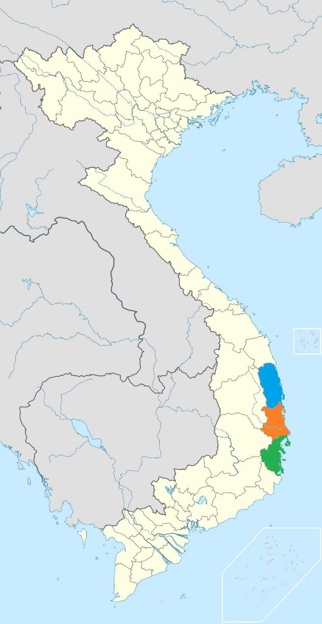
Current status
Implementation of the FIP Action Plan commenced in April 2014, and with Terms of Reference developed for government partners (i.e. MARD, DECAFIREP and provincial sub-Departments) and Vina Tuna, as well as for the Monitoring and Evaluation of the FIP via an independent and CAB-affiliated assessor.

Industry Partner Agreements - Nine international suppliers and exporters from five countries spanning most major markets have entered into FIP Partner Agreements to help ensure the effective implementation of the FIP Action Plan, including identification of on-the-ground activities taken up by industry. The Partner Agreements further aim to ensure that recognized industry partners are achieving appropriate standards for traceability, corporate communication and marketing in their FIP-related activities. Through annual fees paid by partners, these Agreements also help finance core FIP activities, and open other funding channels through diverse supply chains. Several WWF National Offices are likewise engaged in these corporate arrangements, including WWF-US, WWF Netherlands, WWF Germany and WWF Australia.

Binh Dinh
Phu Yen
Khanh Hoa
The FIP has also recently attracted interest from Japanese businesses concerning formal links with parallel projects on post-harvest quality and vessel energy efficiency.

Map 1 – Location Map of Vietnam yellowfin tuna FIP main provinces

Traceability - The FIP is prototyping the application of “Fit for FIP” traceability to ensure that Vietnam yellowfin tuna is differentiated in the marketplace. This requirement is particularly important in Vietnam where export volume exceeds domestic catch and over half of total exports (i.e. frozen yellowfin steak and loins) use foreign raw material which is re-exported. FIP Partners are required to have a traceability system in place within 1 year of signing their Agreement, and for this system to be audited by an independent 3rd party within 18 months. These measures will help ensure unqualified products do not dilute the marketplace with inappropriate “FIP” fish.

With technical and logistical support from the FIP Coordination Unit led by WWF, FIP Partners will work with their processors as well as downstream buyers to ensure shared understanding and support on traceability and related aspects. This includes sharing of business data used in verifying the trade flow of FIP products.

Action Plan - The FIP Action Vina Tuna Plan includes 3 goals with a total of 54 milestones to be achieved. Under each goal there are detailed activities, which are the focus of the more specific collaboration between WWF, industry partners and the Government of Vietnam. The Goals, Outcomes and indicated Activities for the Milestones are indicated below:

GOAL 1: To ensure that the tuna catches do not exceed sustainable levels

Outcome 1.1 Stock status improved and reference points applied in management
Activity 1.1.1 WCPFC would have to set explicit limit reference points which are consistent with the MSC definition of BLIM (0.2 B0), and for these to be applied to the harvest strategy (1.2.1)
Activity 1.1.2 Effective rebuilding strategy implemented for bigeye tuna (requires CCM and CNMs to implement effective measures, but to be achieved in the much longer term, i.e. 5-10 years, or greater)
Outcome 1.2 Data collection and Information systems strengthened
Activity 1.2.1 Continue to improve national data collection and monitoring at all levels
Outcome 1.3 Management strategies applied and supported by tools and the application of strong information and research
Activity 1.3.1 Implementation of a compatible harvest strategy in Vietnam waters (and compliance with CMMs), which would include longline, purse seine and other gears (including handline and gillnet) and would be consistent with Vietnam’s obligations developed through any future changes to 2012-01
Activity 1.3.2 Monitoring system in place (consistent with CMM 2010-03) which evaluates the effectiveness of the management measures
Activity 1.3.3 Establishing national harvest control rules (input and output restrictions) across the range of tuna fisheries which allow for limits to be implemented as reference points are approached

GOAL 2: To promote the ecosystem based approach to fisheries management

Outcome 2.1 Retained and bycatch species subject to a management strategy
Activity 2.1.1 Document the catch of bigeye tuna, shark, billfish, baitfish and other species in the handline and longline fisheries (See FIP action 2.1.3)
Activity 2.1.2 Undertake retained species and bycatch management strategy for all billfish and bait stocks and any other retained or bycatch species, if data shows catch rates to be 5% or more
Outcome 2.2 Shark management measures implemented
Activity 2.2.1 If certain sharks (silky, mako and thresher sharks) are found in fishery and retained, implement a partial strategy consistent with CMM 2010-07. Implement full strategy to prevent retention capture of oceanic whitetips (CMM 2011-03/CITES App 2) and scalloped, great and smooth hammerheads (CITES App 2). Establish shark NPOA
Outcome 2.3 Turtle management strengthened
Activity 2.3.1 Monitor and implement a turtle management mitigation policy; update turtle NPOA
Outcome 2.4 Habitats subject to a management strategy
Activity 2.4.1 Incorporate a requirement to record gear losses into the national observer programme
Outcome 2.5 Ecosystems and biodiversity assessments made for the Vietnamese and South China Sea region
Activity 2.5.1 Assess the ecosystem impact for the Vietnam EEZ /South China Sea Sub region

GOAL 3: Fisheries Governance strengthened

Outcome 3.1 Fisheries Law effectively implemented
Activity 3.1.1 Clarification of Vietnam's status within the convention, and extension of the convention area to the Vietnam
Activity 3.1.2 Implementation of the Fisheries Law containing core elements which prioritise sustainable fisheries, and provisions for implementation of international conventions including CMMs
Outcome 3.2 Roles and responsibilities and consultation processes fully implemented
Activity 3.2.1 Implementation of the Advisory Council through the National Tuna Management Plan (NTMP) process
Activity 3.2.2 Revise the a tuna fisheries strategy so that long term and short term objectives demonstrate effective implementation of sustainable fisheries management systems
Outcome 3.3 Positive incentives promoted
Activity 3.3.1 Review negative and positive incentives against the stock status for yellowfin and bigeye, as well as the impact on bycatch
Outcome 3.4 Fishery specific management objectives applied
Activity 3.4.1 Handline fishery is included along with the other tuna fisheries contained within the management plan
Outcome 3.5 Decision making process strengthened
Activity 3.5.1 Clarify decision-making structure defined with the NTMP
Outcome 3.6 Effective application of compliance systems
Activity 3.6.1 Strengthen the compliance monitoring system
Outcome 3.7 National research plan is in place
Activity 3.7.1 National research plan in place which addresses P1 and P2 requirements

Next steps

Priority activities/milestones identified to be executed over the next 12 month period include:

- Ensuring effective Government of Vietnam (GoV) participation in the Science Committee working groups (SC-10) and WCPFC-10 general session discussions on reference points
- Setting catch and/or effort limits for bigeye and yellowfin tuna consistent with WCPFC (i.e. 2001-2004 levels or alternative) and based on an historic reference point
- Ensuring compliance with CMM 2008-1, CMM 2012-1 and any subsequent measures, and appropriate reporting to WCPFC on effectiveness of the CMMs
- Organizing workshop(s) on options for input (effort) and output (quotas) for longline and handline fisheries based on WCPFC reference points (CMM 2012-1)
- Implementing shark CMMs 2010-07 and CMM 2011-03/CITES App 2, and ensuring shark monitoring objectives are harmonized with observer programs
- Establishing shark NPOA and revising/extending sea turtle NPOA
- Implementing effective management mitigation measures for turtles which are consistent with national and international (WCPFC) obligations
- Establishing fisher awareness programmes related to shark and sea turtle management interventions above
- Operationalizing a Tuna Fishery Management Council, with roles & responsibilities defined
- Developing work plans with key industry partners on direct field support, such as bycatch monitoring and observer program expansion (as per above)
- Developing and agreeing on (with industry and government stakeholders) the minimum standards for traceability and implementation road map
- Completing a FIP financing plan developed with industry and government partners, as well as continue to secure direct support through industry supply chains. The financing plan will clarify GoV parallel support and outline a range of financing options to be applied to Action Plan implementation

For more information contact:

Keith Symington
Vietnam Yellowfin Tuna FIP Coordinator / WWF Coral Triangle Programme
keithsymington@yahoo.ca
(+84)914435348

Especially the Western and Central Pacific Fisheries Commission (WCPFC) and Vietnam’s status therein

